Use of machine learning techniques for processing remotely sensed images of floods
Mohammad Zare, Snr Scientist, RSS Hydro, Luxembourg
Guy Schumann, Prin. Scientist, RSS Hydro, Luxembourg

Abstract
Changing hydrological conditions are occurring all over the world, owing mostly to phenomena of climate change that affect atmospheric and earth surface processes. Temporal and spatial changes in rainfall have caused fundamental variations in the water cycle, including extremes such as flood events. Losses due to all types of floods are not only of economic nature (several billions of EUR every year at global level) but there is also considerable loss of lives. Responding appropriately to these threatening situations necessitates the use of innovative flood management techniques and technologies more than ever. The main priority of any flood management solution is to find suitable methods and models in order to manage floods better and to prepare facing this natural hazard and risk phenomenon and minimizing losses. Decision making and planning for the prediction of flood events and their generating processes require the use of adequate models and methods. In recent years, appropriate models and algorithms such as machine learning (ML) and deep learning (DL) have been developed and used in many research projects dealing with flood mapping. In this regard, the main purpose of this study is to present a review of applying ML/DL methods to process remotely sensed images for generating flood maps. Moreover, the basic concepts of some ML data driven methods are presented. Three case studies with different ML algorithms have been selected and are illustrated to provide a better understanding of their application in flood studies. The findings of these case studies show that ML models are mostly applied to identify and predict flooded versus non-flooded pixels in images but important challenges remain. These challenges need to be solved if ML is to be valuable for decision making processes related to flood management.

Image
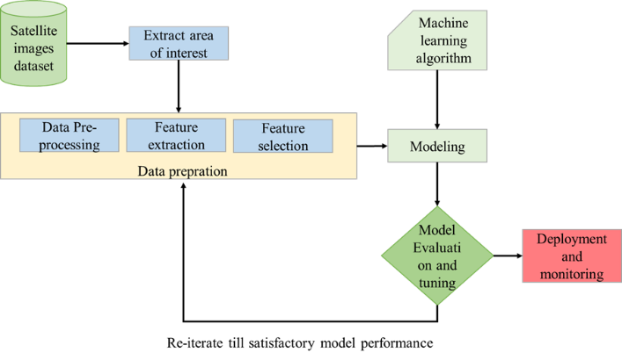
Machine learning standard workflow
Recent Publications (minimum 5)
- Bui, D.T. et al., (2019). A novel hybrid approach based on a swarm intelligence optimized extreme learning machine for flash flood susceptibility mapping. CATENA, 179: 184-196.
- Chaabani, C., Chini, M., Abdelfattah, R., Hostache, R., Chokmani, K., 2018. Flood Mapping in a Complex Environment Using Bistatic TanDEM-X/TerraSAR-X InSAR Coherence. Remote Sensing, 10(12).
- Dodangeh, E. et al., 2020. Integrated machine learning methods with resampling algorithms for flood susceptibility prediction. Science of The Total Environment, 705: 135983.
- Scholz, M., 2019. Chapter 11 - Classifying Adaptive Sustainable Flood Retention Basins. In: Scholz, M. (Ed.), Sustainable Water Treatment. Elsevier, pp. 279-299.
5. Yang, L., Cervone, G., 2019. Analysis of remote sensing imagery for disaster assessment using deep learning: a case study of flooding event. Soft Computing, 23(24): 13393-13408.

 Biography
Dr. Mohammad Zare is working as a senior scientist, with focus on flood simulation/prediction models applying machine learning (ML) and artificial intelligence (AI) techniques, spatial data management and developing remote sensing models at RSS-Hydro’s research and education department (RED), Luxembourg. He graduated from his PhD in July 2017 at the University of Kassel, faculty of Civil and Environmental Engineering, Germany. Dr. Zare has been working at several universities and research institutes in Germany and Luxembourg. During years past, his research ideas were funded through projects by different funding frameworks, including the German Academic Exchange Service (DAAD), EU-funded ICT-AGRI and the Luxembourg National Research Fund (FNR).

Email: mzare@rss-hydro.lu

Dr. Guy Schumann received his PhD degree in geography from the University of Dundee 2008. After spending some years at the University of Bristol as a professor, he joined NASA''s JPL in 2012 where he worked on various projects related to the upcoming NASA/CNES SWOT hydrology satellite mission. He then moved to UCLA where he continued his research on flooding. In 2015, he started R&D work on NASA-funded projects in the private sector by joining RSS in the US, and then shortly after he founded RSS-Hydro in Luxembourg. He is now active in the R&D sector in both US and Europe and holds research affiliations with the University of Bristol and the University of Colorado Boulder. He is also a scientific advisor to the UN WFP. His work focuses on flood hazard modeling and integration with remotely sensed data geared towards interoperability of products to better assist flood disaster response.
Email: gschumann@rss-hydro.lu

