Artificial Intelligence approach for Supply Chain Management (SCM) – how can AI improve the standard SCM?
Adrian Brezulianu, PhD, Greensoft and "Gheorghe Asachi" Technical University, Iasi, Romania
….

Abstract (300 word limit)
Statement of the Problem: With rising global oil prices, the supply chain management (SCM) employed by the oil industry may play a key role in reducing costs and increasing the company's profits. Current SCM limitations (operation disruptions with important deviations from plan and other supply, production, or demand uncertainties) may be significantly reshaped by the emerging artificial intelligence (AI) technologies. The integration of AI solutions could save the oil and gas industry $50 billion in the coming decade. Methodology: We propose an AI-based framework to be integrated across the entire supply chain (SC) of a refinery. Our solution implements tools for information sharing and decision support having separate modules for each SC department. The operations of each department are managed from three perspectives: planning, execution and key performance indicators (KPIs). The planning stage offers optimum scenarios based on business objectives and constraints, scenario analysis by calculating costs in order to meet business needs and quick solutions in case of unexpected events for both local (minimal changes) and global optimization (rescheduling the whole scenario). The execution stage monitors the schedule’s realization, calculates the deviation of the real-time events from the selected plan (fig. 1), issues alerts when exceeding acceptable limits, analyzes events and emits alerts for follow-up actions, anticipates order fulfillment feasibility and estimates time to finish by continuously analyzing the current status. KPIs are the measurements used to track SC performance. AI tools optimize the processes from each stage and contribute to the continuous improvement of the KPIs. Findings: The employement of the AI-based platform resulted in automatic capture of data from real-time operations that ensued more transparency, decision harmonization and improved KPIs of the SCM. Conclusion & Significance: AI solutions in oil industry have huge potential for optimizing and managing specific SC operations wielding major impact on overall economy.

Image
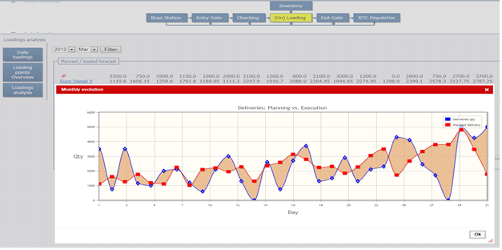
Figure 1. Planning versus execution: comparative graphical representation of deliveries’ deviation from planned delivery schedule.
Recent Publications
- Lisitsa S, Levina A, Lepekhin A (2019) Supply-chain management in the oil industry. E3S Web of Conferences 110, 02061.
- Toorajipour R, Sohrabpour V, Nazarpour A, Oghazi P, Fischl M (2021) Artificial intelligence in supply chain management: A systematic literature review. Journal of Business Research 122:502–517.
- Ghaithan AM (2020) An Optimization Model for Operational Planning and Turnaround Maintenance Scheduling of Oil and Gas Supply Chain. Applied Sciences 10, 7531.
- Grant Thornton, Manufacturing Leadership Council, National Association of Manufacturers (2020) 2020 Digital supply chain survey.
5. Srinivasan R (2007) Artificial intelligence methodologies for agile refining: an overview. Knowledge and Information Systems 12:129–145.

Biography (150 word limit)
Dr. Adrian Brezulianu has his AI expertise in both academic research and commercial solutions. He is acting as professor for more than 25 years at “Gheorghe Asachi” Technical University of Iasi, Romania and for more than 15 years as CEO at Greensoft Ltd – a software development company with governmental and corporate project references.
Email: adi.brezulianu@greensoft.com.ro

Notes/Comments:

