Smart City Platform: Scalability, Interoperability and Replicability Platform to manage Urban Applications
M. Chinnici¹, G. Ponti², G. Santomauro^{2*}
¹ ENEA, CR Casaccia, Via Anguillarese 301, ROMA 00123, Italy
² ENEA, CR Portici, Piazzale Enrico Fermi 1, 80055 Napoli, Italy
marta.chinnici @enea.it

Abstract (300 word limit)

In a smart city environment, the explosive growth in the volume, speed, and variety of data being produced every day requires a continuous increase in the processing speeds of servers and entire network infrastructures, platforms as well as new resource management models. This poses significant challenges (and provides attractive development opportunities) for data-intensive and high-performance computing, i.e., how to turn enormous datasets into valuable information and meaningful knowledge efficiently. The variety of sources complicates the task of context data management such as data derives from, resulting in different data formats, with varying storage, transformation, delivery, and archiving requirements. At the same time, rapid responses are needed for real-time applications. With the emergence of cloud infrastructures and platforms, achieving highly scalable data management in such contexts is a critical problem, as the overall urban application performance is highly dependent on the properties of the data management service. This means, continuously developing and adopting ICT technologies to create and use platforms for government, business and citizens can communicate and work together and provide the necessary connections between the networks that are the base for the services of the smart city [1]. The main features of a generic Smart City Platform (SCP) are in the following [2].

Make data, information, people and organizations smarter;

Redesign the relationships between government, private sector, non-profits, communities and citizens;

Ensure synergies and interoperability within and across city policy domains and systems (e.g. transportation, energy, education, health & care, utilities, etc.);

Drive innovation, for example, through so-called open data, living labs and tech-hub.

In this work, the authors propose an approach and describe a methodology and a modular and scalable multi-layered ICT platform called ENEA Smart City Platform (ENEA-SCP) to address the problem of cross-domain interoperability in the context of smart city applications. The ENEA-SCP is implemented following the Software as a Service (SaaS) paradigm, exploiting cloud computing facilities to ensure flexibility and scalability. Interoperability and communication are addressed employing web services, and data format exchange is based on the JSON data format. By taking into account these guidelines as references, this work provides a description of the SCP developed by ENEA and its potential use for smart and IoT city applications. The solution provided by ENEA SCP to exploit potentials in Smart City environments is based on four fundamental concepts: Open Data, Interoperability, Scalability, Replicability. In this scenario, the ENEA SCP is going to tackle the issues concerning these two aspects providing a reference framework of modular [2] specifications for stakeholders willing to implement ICT platforms to exploit the Smart City vision potentials and therefore offer new services for the citizen. The ENEA Smart City Platform exploits computational resources of the ENEAGRID infrastructure [3], as it is deployed in the cloud hosted in the Portici Research Center site. The creation of a customized environment ENEA cloud-based platform is possible thanks to the virtualization technologies of VMWARE platform, which allows hosting the management, the transportation and the processing of project data services, ensuring their availability and protection over time. More in detail, the SCP is composed by six Virtual Machines (VMs), and each of them hosts a component with a specific role (Fig. 1).

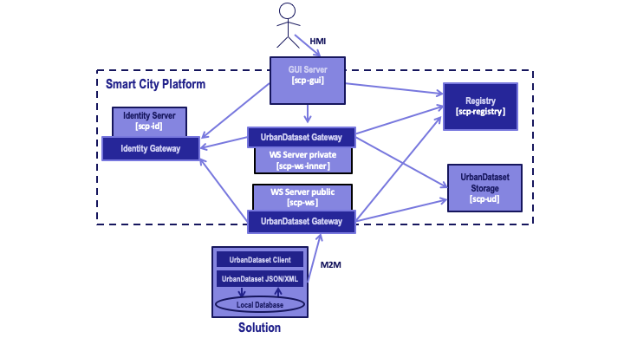

Fig. 1. Scheme of ENEA-SCP architecture based on VMs.
Recent Publications (minimum 5)
M. Chinnici, S. De Vito: IoT Meets Opportunities and Challenges: Edge Computing in Deep Urban Environment, in Dependable IoT for Human and Industry. Modeling, Architecting, Implementation. River Publishers Series in Information Science and Technology, 2018.
A. Brutti, P. De Sabbata, et al.: Smart City Platform Specification: A Modular Approach to Achieve Interoperability in Smart Cities, Chapter book in The Internet of Things for Smart Urban Ecosystems pp 25-50, Springer, 2018.
G. Ponti et al., “The role of medium size facilities in the HPC ecosystem: the case of the new CRESCO4 cluster integrated in the ENEAGRID infrastructure”, Proceedings of the 2014 International Conference on High Performance Computing and Simulation, HPCS 2014, art. no. 6903807, 1030-1033.


She is currently a senior researcher at the Italian National Agency for New Technologies, Energy and Sustainable Economic Development (ENEA) in the Energy Technology Department, where she works on ICT for energy efficiency issues. She received her master’s degree in mathematics in 2004, and her PhD in applied mathematics and computer science in 2008 from the University of Naples, Italy, with a thesis on stochastic self-similar processes and application in non-linear dynamical systems. Prior to her appointment with ENEA, she was a fellow and research assistant at the University of Salerno and a postdoctoral research fellow at ENEA. Marta has held different professorship positions while at ENEA, including Adjunct Professor in Qualitative Methods and Mathematics for Economic and Business, and Professor in Mathematics and Economics for the MBA course at the Link Campus University, Rome, where she has also been a member of the assessment board from 2013 to 2015. She is involved in many national projects and international research projects (also as project leader). She is active reviewer for several Journals and she act as Guest Editor for book and several special issues. Her current research interests include energy efficiency in data centres including metrics and standards, computer science, big data analytics, complex networks, and smart cities. She has published widely in the above fields, jointly authoring of important papers in international journal and peer-reviewed conferences and has regularly presented her research findings to international audiences, including several invited keynote lectures. She serves as a regular reviewer for numerous international journals. She has also been editor and managing guest editor for the book Energy Efficient Data Centers edited by Springer. She is a member of the organizing and technical program committees of several national and international conferences/workshops while also acting as session chair and/or co-chair. She works widely with international research institutions and industries in the fields of ICT, computer science, and energy efficiency. In addition to her research work, she also serves as a supervisor for master and PhD candidates and is a guest lecturer for measuring energy efficiency at the University of Leeds, UK. Aside from this, Marta is a member of the Italian Society of Industrial and Applied Mathematics (SIMAI), the Activity Group on Complex Systems (SisCo), and a member of the Italian Mathematical Union (UMI). She is finally a reviewer / evaluator for several European programmes in the fields of ICT, smart grid and smart cities, including HORIZON2020, Cost Action, Marie Curie (EC) and the Caixa Foundation (Spain).

Email: marta.chinnici@enea.it

