Deep Convolutional Neural Networks (DCNN) for 1D/2D EEG signal input

Ali Al-Saegh,Shefa A. Dawwd, Jassim M. Abdul-Jabbar, Computr Engineering Department, College of Engineering, University of Mosul, Mosul, Iraq

Abstract
The DCNNs can be suitable models for processing different types of signals: 1D audio, 2D image, 3D videos, and 1D/2D EEG as a specific type of signals. Specifically, The hierarchical structure of information within these signals can be learned deeply using CNN throughout learning simple or local features, then higher-level features can be composed of lower-level features. Deep Learning (DL) is a subfield of machine learning seeking to mimic the operation of the human brain by establishing complex interconnected neural construction and hence retrieving a generic model with the ability to handle various data types and covering whole information within a training dataset.
The non-invasive Electroencephalogram (EEG) signals enable humans to communicate with devices and have control over them in what is normally called a Brain-Computer Interface (BCI) system. Such a system requires precise classification and identification of those signals. Motor Imagery (MI) signals are EEG spontaneous signals because they are generated based on the user’s imagination of moving a body limb without external stimulation. Nowadays, the MI EEG-based BCI technology is becoming favorable due to its massive applications in both medical and non-medical implementations such as environmental control for disabled persons using artificial devices like a robot.
The recent revolution of Deep Learning (DL) has empowered both feature extraction and classification jointly for the analysis of different data types. However, DL is a data learning, also described as a data hungry, an approach that demands a large number of training samples to train large-scale neural networks that are composed of more than two layers of neurons. Whilst, the EEG research field lacks a large amount of data which restricts the use of DL within this field.
This research proposes a novel data augmentation method for enlarging already available EEG datasets. The proposed CutCat augmentation method generates EEG trials from inter- and intra-subjects and trials. The method relies on cutting a specific portion from an EEG trial and concatenating it with another portion from another trial from the same subject or different subjects. The method has been tested on shallow and Deep Convolutional Neural Networks (DCNN) for the classification of motor imagery MI EEG data. Two types of input formulations namely 2D images and 1D time-series have been used as input to 2D and 1D CNN respectively. Short-Time Fourier Transform (STFT) is used for generating training 2D images from the time-series signals.
2D input DCNN: Forming training images from EEG signals requires some knowledge about the effect of performing imagery tasks on the scalp and accordingly on the signals captured via the recording electrodes. In this study, STFT is adopted for creating 2D images (spectrograms). Trials of 4 seconds length were selected which means a total number of 1000 samples for each of the signals in a trial. STFT with a window size of 64 samples and an overlap equals to 50 samples was applied to each of the signals. This procedure produced an image capturing the Power Spectral Density (PSD) of the signals recorded by the electrodes. The size of the image is 250×67, where 250 and 67 correspond to the frequency and time axes, respectively. Such that, we will have three images for a trial in case of a dataset recorded by three electrodes. After that, the images corresponding to the electrodes were combined.
This type of training (by images) has been applied using the BCIC IV 2b dataset. As this dataset has been recorded by three electrodes, the size of the final generated image is 96×67. The test images were formed exactly in the same explained procedure, except that the signals were the original ones i.e., without CutCat. A pair of a convolutional-max-pooling layer was used in the shallow CNN (SCNN), Figure 1 illustrates this network with the input training image. The generated training images preserve information about the locations of electrodes, time, and frequency. The selected size of kernels determines which information to capture during the convolution process. Hence, to capture information related to both locations of electrodes and frequency, the selected height of the 2D kernels equals the height of the training image, i.e., 96. While the width of the kernels is equal to 3. The rectified linear unit (ReLU, 𝑓(𝑥)=𝑚𝑎𝑥(𝑥,0)) was used as the activation function for the convolutional layer output. Then a subsampling with a factor of 10 was applied using the max-pooling layer. The last layer is an FC SoftMax classification layer that has two neurons to classify the two MI classes left hand and right hand.
1D input DCNN: It has been shown that EEG signals inherit the property of correlation over time and also among the recorded signals. Hence, the trend of using raw time-series EEG signals can also be adopted in training different deep classifiers. In this case, the DL technique uses both amplitude and time information contained within the signals in extracting features. This deep training style can be accomplished with neither pre-processing on the raw signals nor a priori feature extraction. In this study, the proposed CutCat method was also used for generating new training trials. Unlike other input formulations, raw time-series input signals do not expose to a loss in the contained information due to further processing. This training procedure delivers full end-to-end classifiers.
The implemented deep CNN (DCNN) consists of four pairs of convolutional-max-pooling layers. Figure 2 illustrates this network with the training input trial. Actually, the first convolutional layer performs time-frequency convolution and spatial convolution on the raw signals throughout two convolutional layers, then followed by a max-pooling layer. The time-frequency convolution is accomplished by 1D kernels applied along each of the signals. Whereas, the spatial convolution is accomplished by 1D kernels applied across all of the signals. The other three pairs of layers are standard convolutional-max-pooling layers. The last layer is an FC SoftMax classification layer that has four neurons to classify the four MI classes left hand, right hand, feet, and tongue. The distribution of feature maps can be changed during training following the tuning of the network’s parameters. This is called internal covariate shift and it imposes selecting a small value for the learning rate which in turn slows down the learning process [96]. Batch normalization is a useful technique for tackling that problem by normalizing the intermediate activations of each mini-batch of training samples. The normalization to zero mean and unit variance forces the inputs to the upcoming layers to be within a normal distribution; this enhances the training process and accelerates it. Batch normalization was applied after the convolutional layers.
In order to prevent the classifier from focusing only on the most discriminative features and to prevent the overfitting problem as well, dropout was applied with a probability equal to 50% after the max-pooling layers except the last one. Such an end-to-end decoder is capable of extracting various and general features because there is no loss in the data caused by pre-processing techniques such as the removal of artifacts.
The experimental results demonstrate that the proposed augmentation method is a promising strategy for handling the classification of small-scale datasets. Classification results on two EEG datasets show advancement in comparison with the results of state-of-the-art researches.
Moreover, there exist two main restrictions encounter in the adoption of DL in real-world applications. First, DL requires intensive matrix Multiply-And-Accumulate (MAC) operations for a network to be trained and for an input sample to be inferred. Second, the complexity of the trained model is high and hence inference process could be slow.
Hence, this study aims to reduce those two complexities of computations using data reduction and quantization techniques. Data reduction leads to a smaller size of a training batch, thus expediting the training process. Quantization means fewer bits are used for representing the learnable parameters of the trained DCNN. This method is first applied to the adopted DCNN in this study and has proved its usefulness. Training elapsed time has been reduced by 28% with a negligible classification accuracy drop (0.6%). Moreover, converting the learnable parameters of the trained network from 32-bit floating-point data type to 8-bit fixed-point data type improved the inference speed and reduced the memory overhead of the implementation platform. Whereas, a speedup of 2.7x and a storage memory reduction of 75% are gained by using an 8-bit fixed-point data type.
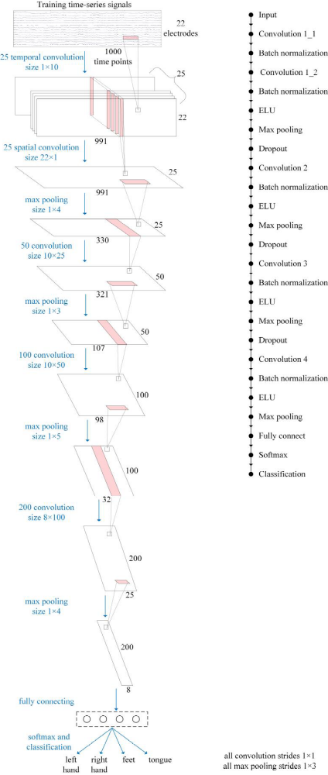
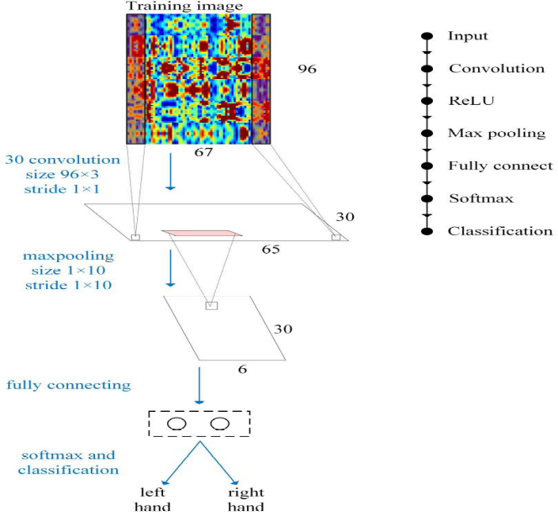
Figure 1: The shallow CNN (SCNN) with 2D(image) EEG signal.

Figure 2: The DCNN with 1D (time sries) EEG signal.

Recent Publications
- Ali Al-Saegh, Shefa A. Dawwd, Jassim M. Abdul-Jabbar, " CutCat: An augmentation method for EEG classification", Neural Networks, 141(2021) 433-433.
- Ali Al-Saegh, Shefa A. Dawwd, Jassim M. Abdul-Jabbar” Deep Learning for Motor Imagery EEG-based Classification: A Review”. Biomedical Signal Processing and Control Journal 63(2021) 102172.
- Amin, S. U., Alsulaiman, M., Muhammad, G., Bencherif, M. A., & Hossain, M. S. (2019). Multilevel weighted feature fusion using convolutional neural networks for EEG motor imagery classification. IEEE Access, 7, 18940–18950. http://dx.doi.org/10.1109/ACCESS.2019.2895688.
- Amin, S. U., Alsulaiman, M., Muhammad, G., Mekhtiche, M. A., & Shamim Hossain, M. (2019). Deep learning for EEG motor imagery classification based on multi-layer CNNs feature fusion. Future Generation Computer Systems, 101.
- G., et al. (2019). A deep transfer convolutional neural network framework for EEG signal classification. IEEE Access, 7, 112767–112776. http://dx.doi.org/ 10.1109/access.2019.2930958.

 Biography

Shefa A. Dawwd: is a professor of computer engineering at the Computer Engineering Department-University of Mosul. He received the B.Sc in Communication Engineering, the M.Sc and the Ph.D in Computer Engineering. He has authored about 42 international journal, conference papers and one chapter book. His research focus is on the processing acceleration of 1D, 2D and 3D signals , real time applications, deep learning ,Convolutional Neural Networks, and hetrogeneous computing. He is a regular reviewer of IEE , Elsevier and other Scopus journals.
Email: shefa.dawwd@uomosul.edu.iqil.com

Notes/Comments:

Presenting author details
Full name: Shefa Abdulrahmad Dawwd
Contact number:+9647707404377
Twitter account:
Linked In account:
Session name/ number:
Category: (Oral presentation)

