Public Twitter Sentiment Analysis due to COVID-19 Pandemic: A Case Study from India
VIVEK RAJA, B.E Computer Science and Engineering, Mepco Schlenk Engineering College, Sivakasi, India

Abstract (300 word limit)
Statement of the Problem: People are experiencing a prolonged state of physical isolation from their friends, as well as teachers, extended family, and community networks due to COVID-19 lockdown. While quarantining adults has generally led to negative psychological effects, including confusion, anger, and post-traumatic distress, it is unknown how these measures have impacted children. High levels of depression are observed among frontline healthcare workers and people in communities with high infection rates. Such anticipatory stress and anxiety, along with loneliness, could not only affect mental health but lead to a decline in lifestyle quality and, ultimately, one’s health choices. Depression is a known risk factor for sleep disorders and eating disorders. This is a really huge social and economic impact and this is due to poor sentiments across industries and people which has resulted in heavy laws of jobs and blow to many businesses across the globe. Depression is faintly visible too but we certainly don't want to go there and governments are trying really hard to address this impact to bring their respective nations back on feet to go towards economic growth. Driving the consumer sentiments as opposed to reacting to them the current pandemic the only way the governments can connect with people is through social media and with a given time we've considered twitter for sampling of people sentiment to identify the emotion and sentiment of people in different geographical location. The solution is to make analysis based on real-time social sentiment powered by Natural Language Processing. The twitter consumer sentiment is the most common text classification tool that analyzes an incoming tweet and conveys if the underlying sentiment is positive negative or neutral from the public. This is implemented using the various NLP based packages that extracts sentiment and sentiment derived plot arcs from text using a variety of sentiment dictionaries and for NLP modeling. Different methodologies such as topic modeling, which is an unsupervised statistical model building approach used to discover the latent abstract bunch of words called topics in large clusters of text it is a repeating pattern of co-occurring terms in a corpus latent allocation was applied for topic modeling to infer the different topics of discussion and to determine the overall feelings. By identifying the emotion based on series of time and geographical location can help us understand the effect of lockdown and thus provide remedies to improve the lifestyle.

Image
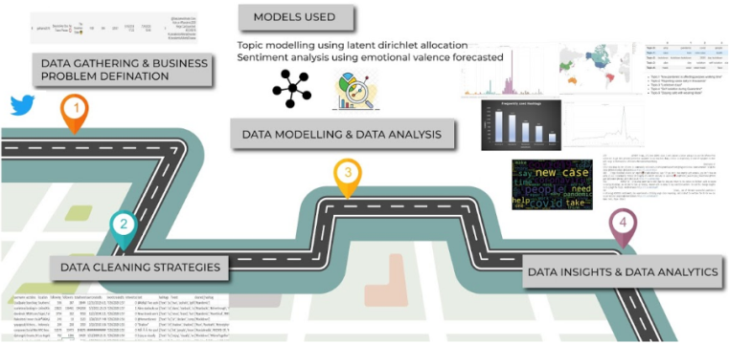
Figure 1: The figure shows the roadmap for performing sentimental analysis of tweets. It involves four main steps 1. Data Gathering 2.Data Cleaning 3. Data Modelling 4. Data Analysis
Recent Publications
- Samuel, J.; Ali, G.G.M.N.; Rahman, M.M.; Esawi, E.; Samuel, Y. COVID-19 Public Sentiment Insights and Machine Learning for Tweets Classification. Information 2020, 11, 314.
- Dubey, Akash Dutt, Twitter Sentiment Analysis during COVID-19 Outbreak (April 9, 2020).
- Jianlong Zhou, Shuiqiao Yang, Chun Xiao, Fang Chen; Examination of community sentiment dynamics due to covid-19 pandemic: a case study from Australia (June 2020)
- Pokharel, Bishwo Prakash, Twitter Sentiment Analysis During Covid-19 Outbreak in Nepal (June 11, 2020
- Barkur, Gopalkrishna, and Giridhar B. Kamath Vibha. "Sentiment analysis of nationwide lockdown due to COVID 19 outbreak: Evidence from India." Asian journal of psychiatry (2020).

Biography


Vivek Raja P S is pursuing final year B.E Computer Science and Engineering at Mepco Schlenk Engineering College. He is Microsoft Certified Data Scientist, AI Engineer Data Engineer Associate and also Oracle Certified Developer and Solution Architect Associate, He is also Chairperson of Microsoft Campus Club, Google Students Club. His areas of research interest are Artificial Intelligence, Cloud Computing and an active mentor, a speaker in this domain. He has won 15+ International and national hackathons. He has published 3 research papers in various International journals.
Email: vivekraja98@gmail.com

