Title: Deep learning approach for predicting outcomes after hypofractionated stereotactic radiosurgery (SRS) for large brain metastases
Hyeong Cheol Moon^{1,2}, Young Seok Park^{1,2}, Hong Rae Kim¹
¹Department of Neurosurgery, Chungbuk National University Hospital, Cheongju, South of Korea
²Department of Medical Neuroscience, Chungbuk National University, Cheongju, South of Korea

Abstract

Predictions of patient outcomes after radiotherapy are essential to medical practice with the neurosurgeon, oncologist, and medical physicist. Stereotactic radiosurgery (SRS) is commonly used for brain metastases that are 3 cm or smaller in maximum diameter. Fractionation was introduced that the total dose of radiation is divided into small doses over a period of several days, there are fewer toxic effects on healthy cells. However, LINAC-based SRS have reported some studies, but Gammaknife Radiosurgery (GKRS) based has been rarely reported. We employed neural network approach towards predicting the outcomes after hypofractionated GKRS to large brain metastatic brain tumors (> 3cm). Features engineering in this database included standard clinical and GKRS treatments parameters. A neural network consists of feed-forward which is the most well-known many applications in the functional approximation and back-propagation network is used for training. Our training process was performed Keras tools of categorical cross-entropy in lost function and stochastic gradient descent (SGD) for optimization. A learning rate of 1.0 x 10⁻⁶. The best accuracy had around 95%, and error under 0.05 in multi-layer neural networks. And single neural networks showed around 90 % accuracy. This neural network approach was able to provide the best prediction of large brain tumor outcomes under hypofractionated treatment. Furthermore, we could demonstrate a paradigm for personalized treatments for further development tools in medical care.

Image (If Any)
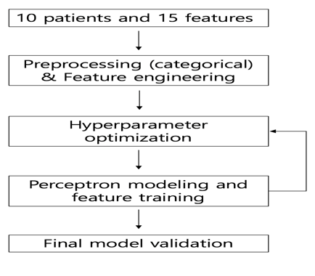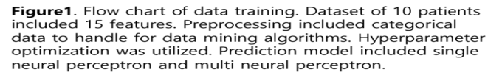
Recent Publications (If Any)
1. Lee, D and Moon, H.C., et al., Characterization of Tetrodes Coated with Au Nanoparticles (AuNPs) and PEDOT and Their Application to Thalamic Neural Signal Detection in vivo. Exp Neurobiol, 2018. 27(6): p. 593-604.
2. Moon, H.C., et al., 7 Tesla magnetic resonance imaging of caudal anterior cingulate and posterior cingulate cortex atrophy in patients with trigeminal neuralgia. Magn Reson Imaging, 2018. 51: p. 144-150.
3. Moon, H.C., et al., 7.0Tesla MRI tractography in patients with trigeminal neuralgia. Magn Reson Imaging, 2018. 54: p. 265-270.

Biography (150 word limit)
Hyeong Cheol Moon is a medical physicist and Ph.D. course student at Chungbuk National University Hospital. He joined the department of Neurosurgery at CBNUH in March 2018 from Chungbuk National University, where he received his master’s degree in medical neurosurgery and neuroscience. His research interests are the areas of physics, data science, and basic neuroscience. He published 10 papers for 2 years. He currently focuses on developing extended approaches to clinical outcomes after radiosurgery using deep learning.

Name: Mr. Hyeong Cheol Moon
Email: jimmun@cbnuh.or.kr, jimmun@chungbuk.ac.kr
Phone Number: 82-43-269-7408

Meetings Int. Pte Ltd

Company Registration No: 201524282R,28 MAXWELL ROAD, #03-05 RED DOT TRAFFIC, SINGAPORE
Web: https://www.meetingsint.com/conferences/artificialintelligence
E-mail: artificialintelligence@annualmeetings.net
Contact: +6531080483

Copyright © 2016-2018 Meetings Int PTE Ltd, All Rights Reserve

