Effects of replacing fishmeal with dietary soybean protein concentrate (SPC) on growth, serum biochemical indices, and antioxidative functions for juvenile shrimp Litopenaeus vannamei
Gyan Watson Ray, Researchgate: https://www.researchgate.net/profile/Watson_Gyan, ORCID No.: 0000-0002-6381-2300, Web of Science: AAE-9876-2019, Tel.: +8618814254925, Guangdong Ocean University, Fisheries College, Laboratory of Aquatic Animal Nutrition and Feed, China.

Abstract

This experiment was conducted to assess the possibility of replacing fishmeal (FM) with Soybean Protein Concentrate (SPC) at different levels (Diet 1 (0%), Diet 2 (3.08%), Diet 3 (6.16%), Diet 4 (9.24%), Diet 5 (12.32%), Diet 6 (15.40%), Diet 7 (18.48%)), its effects on growth, serum biochemical indices and antioxidant activities, body composition, histology, intestinal flora and disease resistance in Litopaeneaus vannamei. There were three replicates in each group in the experiment (Initial mean weight = 0.23±0.00g) and were fed their respective diets for 8 weeks. Growth performance in Diet 6 compared to Diet 1, significantly increased (P < 0.05) and the survival rate ranged from 90% to 95%. No significant difference was observed among the groups in terms of crude protein, moisture, and ash content. There was an increase in serum acid phosphatase, alkaline phosphatase, High-Density Lipoprotein Cholesterol, Total Antioxidant capacity, Glutathione peroxidase. Significant decreases (P < 0.05) in Glucose and Total Cholesterol were observed in the shrimp. Also, no significant difference was observed in serum Alanine Aminotransferase, and Total protein (P ˃ 0.05). Histology of the intestine showed Villus height and intestinal wall thickness significantly increased (P < 0.05) with increasing inclusion of SPC, 15.40% had the highest value. In intestinal flora, replacement of FM with SPC in the shrimp intestine had positive effects on several beneficial bacteria such as Pseudoalteromonadaceae among the treatment groups with 15.40% having the highest value as compared to 0% at the family level. Furthermore, diversity indices and richness estimates increased with increasing SPC levels. Disease resistance was increased in shrimp among treatment groups, 15.40% recording the lowest mortality percentage of 40.22% after the challenge test. In conclusion, regarding all the parameters, the replacement of FM with SPC at 15.40% could be used to cater for shrimps’ dietary needs.

Image
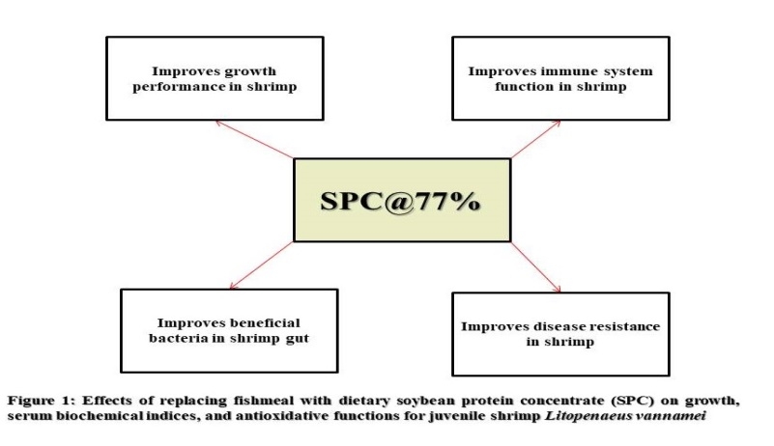
Recent Publications
- Effects of replacing fishmeal with dietary soybean protein concentrate (SPC) on growth, serum biochemical indices, and antioxidative functions for juvenile shrimp Litopenaeus vannamei
- Effects of antimicrobial peptides on growth, feed utilization, serum biochemical indices and disease resistance of juvenile shrimp, Litopenaeus vannamei
- Effects of different dietary levels of soybean protein hydrolysates on the growth performance, antioxidant capacity and relative mRNA expression levels of juvenile hybrid grouper (Epinephelus fuscoguttatus ♀ × Epinephelus lanceolatus ♂)
- Assessment of postharvest fish losses: The case study of Albert Bosomtwi-Sam fishing harbor, Western Region, Ghana
- Effects of yeast antimicrobial peptides in aquaculture
- Effects of Soybean Products in Fish and Crustaceans

 Biography
I am a dynamic and ambitious professional author and scientific researcher combining a strong academic background with valuable experience in the fisheries and aquaculture industry around the world. Possess excellent written skills and oral communication acquired from exposure to the academic and scientific environment and I’m adept at liaising with scientific researchers and stakeholders of the aquaculture industry at various levels. I also thrive best in a team-based role and display the initiatives, worked on replacing fishmeal with plant proteins and well as studying antimicrobial peptides effects in fish and shrimp. My objective is to keep learning and improve myself every day to bring out the best in me and help others. My vision is to learn new skills and to bring out new scientific knowledge to improve the aquaculture industry in the world and use aquaculture as a tool to eliminate poverty in our society.

