Title: Study of major reef fish families and their feeding types with relation to different size variations in three major coral reefs in Southern Province of Sri Lanka

A.G.G.C. Bandara¹ and V.S. Gunasinghe²
¹Department of Fisheries and Marine Sciences, Ocean University of Sri Lanka
²Department of Coastal and Marine Resource Management, Ocean University of Sri Lanka
Keywords: Reef fish, Stationary point count, feeding type, size variation, Sri Lanka

- Abstract Body
Reef fish are vital for reef health as their feeding types disturb the benthic environment (Choat, 1982; Floeter et al., 2007). Studies on reef fishes have supported to conserve and manage both reef fishes and reef (Lieske and Myers, 2002). But studies on reef fish are rarely conducted in Sri Lanka. The present study was done at the Paraiwella, Polhena and Hikkaduwa coral reefs at Southern Province in Sri Lanka with the objective of studying the major reef fish families, their feeding habits and size variations. Stationary Point Count method (SPC) with 5m radius water column was used for survey the reefs (Colvocoresses and Acosta, 2007). Data were collected between September 2018 to January 2019. Reef fish families, their feeding habits (herbivores, carnivores and omnivores) and their size classes (Small, Medium, and Large) were observed. Reef fish were identified using field guides and photographs were taken whenever possible. Twenty five families were recorded and among them four families (Acanthuridae, Pomacentridae, Labridae and Monodactylidae) showed dominance throughout the reefs. Paraiwella had the highest diversity of reef fish followed by Polhena and Hikkaduwa reefs. But the highest abundance of fish were recorded in Hikkaduwa reef. Omnivore was the feeding type of more than 50% of fish followed by herbivores and carnivores. Medium size fish were the most abundant. As there were some breeding grounds among the reefs, small size fish were the second most abundant. Study recorded four species of the Chaetodontidae family which is considered as a bioindicator for reef health.

- Image:

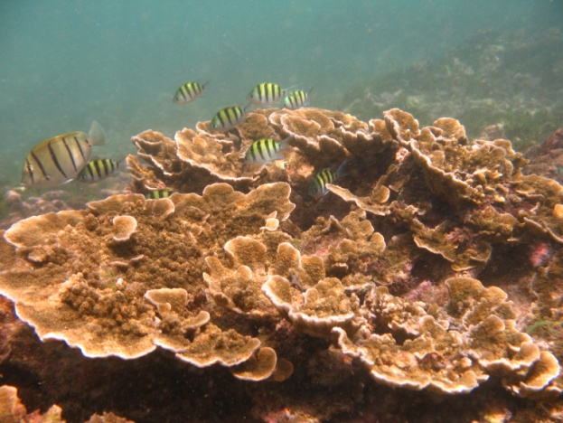

- Refrences

- Choat, J.H., 1982. Fish feeding and the structure of benthic communities in temperate waters. Annual review of ecology and systematics, 13(1), pp.423-449.
- Colvocoresses, J. and Acosta, A., 2007. A large-scale field comparison of strip transect and stationary point count methods for conducting length-based underwater visual surveys of reef fish populations. Fisheries Research, 85(1-2), pp.130-141.
- Floeter, S.R., Krohling, W., Gasparini, J.L., Ferreira, C.E. and Zalmon, I.R., 2007. Reef fish community structure on coastal islands of the southeastern Brazil: the influence of exposure and benthic cover. Environmental Biology of Fishes, 78(2), pp.147-160.
- Lieske, E. and Myers, R., 2002. Coral reef fishes: dynamics and diversity in a complex ecosystem. Academic Press.

- Biogeography

Aldeniyagoda Gedara Gayathra Charuka Bandara currently studying at the Faculty of Fisheries and Ocean Sciences, Ocean University of Sri Lanka. Gayathra completed his industrial training at the Marine Biological Resources Division, National Aquatic Resources Research and Development Agency, Colombo, Sri Lanka where he analysed the ichthyoplankton samples collected by Dr. Fridtjof Nansen Ecosystem survey 2018. Also he works as a voluntary research assistant for Blue Resources Trust. His undergraduate project focuses on biology, sex and maturity of shark and ray species landed in Sri Lanka.

- Presenting author details
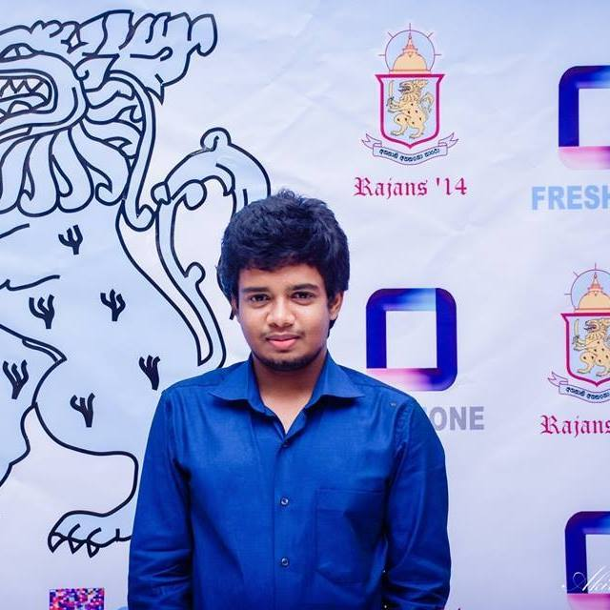

Full name: Aldeniyagoda Gedara Gayathra Charuka Bandara
Contact number: +94712572181
Linked In account: https://lk.linkedin.com/in/gayathra-bandara-9ba62457
Session name/number: Coral reefs
Category: Oral presentation
Passport number: N5621199

