Sub lethal effects of Endosulfan on Hematological and Histopathological Profile of Rohu (Labeo rohita) during acute toxicity
Muhammad Fiaz Khan^{1,} Shezad Gayyour¹
¹Department of Zoology, Hazara University, Mansehra, Pakistan
Keywords: Pesticides; Cypermethrin toxicity; Labeo rohita; Pakistan
Abstract
Present study was conducted to evaluate the sub lethal effects of commercial Endosulfan on haematological and histopathological parameters of fresh water fish Labeo rohita. The fishes were segregated into five groups where first group was considered as control while other groups were considered as treated. In treated groups fish were exposed to sub-lethal concentration of Endosulfan (0.25 ppb, 1.0 ppb 2.0 ppb & 3 ppb) for 96 hours. The obtained results indicated significant alteration in haematological and histopathological parameters of Labeo rohita due to Endosulfan intoxication. There was significantly (p < 0.05) increased number of platelets and white blood cells (WBCs) observed in treated groups, while significantly (p < 0.05) decreased in number of red blood cells (RBCs), haemoglobin (Hb), mean corpuscular volume (MCV), mean corpuscular haemoglobin concentration (MCHC) and mean corpuscular haemoglobin (MCH) were observed in treated group compared to control group. In experimental groups the Histopathological alterations were observed including disturbance of cartilaginous core, atrophy, shortening of secondary gills lamellae, gills epithelial lifting, lamellar disorganization, hyperplasia and vacuolations in liver, while necrosis, haemorrhages, loss of secondary lamellae, blood congestion, secondary gills lamellae fusion, closure of cell membrane, curling, pyknosis, blood congestion and necrosis in villi, whereas excessive goblet cells formation, detachment, fusion and shortening in villi of intestine were reported. It was concluded that as the concentration of Endosulfan was increased, there was an effect of Endosulfan on increased number of haematological and histopathological parameters. This study could be useful for measuring possible environmental risk to aquatic life.
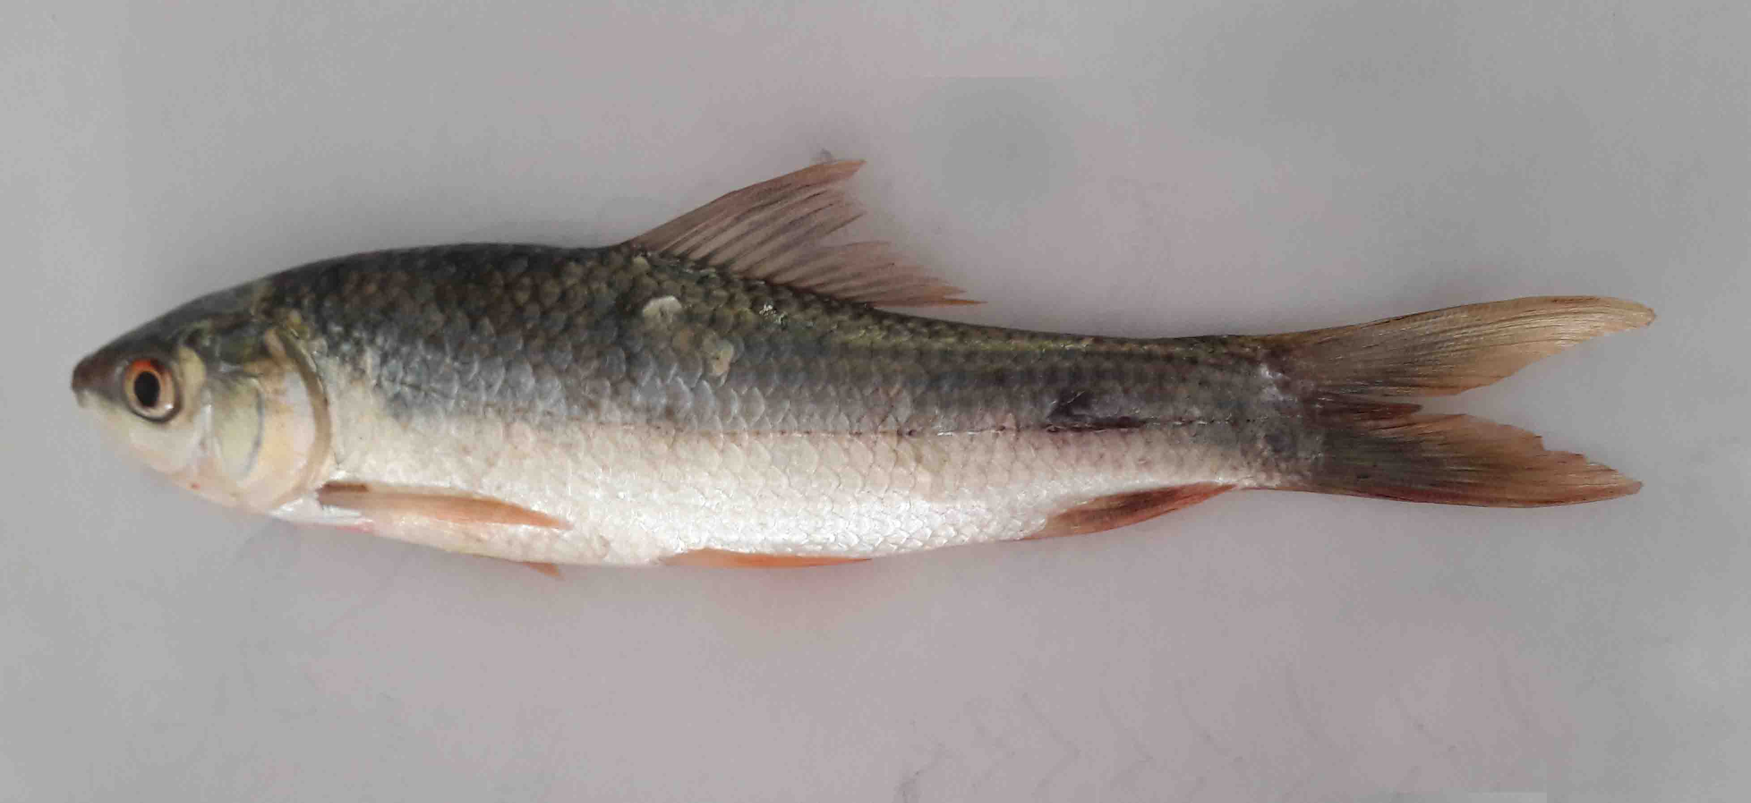
Fig: Rohu (L. rohita)
Biography:
My name is Dr. Muhammd Fiaz Khan, gelong from Pakistan, I had completed PhD from Hazara University Mansehra Pakistan at the age of 30 years. So far, I have published 18 papers in well reputed national and International journals. I am serving in Hazara University in the past 7 years.
Presenting author details

Father name. Muhammad Afzal Kahn
Date of Birth: 12-04-1986
Nationality: Pakistani.
NIC #: 13302-4371281-7
Email: fiazkhanhu333@gmail.com/fiazkhanhu333@hu.edu.pk
Category Oral presentation
Passport Number: UQ4102813

