Title: Tilapia culture in the province of Punjab, Pakistan

ZAFAR IQBAL

Department of Zoology, University of the Punjab, Quaid-i-Azam Campus, Lahore. Pakistan.

Key Words: Tilapia, monosex, polyculture, semi intensive, fish farming.

- Abstract

Tilapia culture is growing gradually in the province of Punjab, Pakistan. The monosex culture of tilapia, Oreochromis niloticus is practiced on semi-intensive fish farming system. Both locally produced and imported monosex tilapia seed is stocked in earthen ponds (stocking density 6250-10000 fry/ha). The fish is fed on high quality floating tilapia feed (30% protein). The fish is reared from April onwards and harvested in winter. The fish yield varies from 4400-7000kg/ha. This yield variation may be due to fish farm management and input administrated by the farmers. The tilapia has high local demand. The price of fresh iced fish depends on size of the fish. This year fish (600-700g) fetched good price (US$ 2.0/kg). However, last year the price of fish was almost half than this year price. The polyculture of monosex tilapia with major carp; Labeo rohita is also practiced by some fish farmers. The yield of these two species in polyculture was very high (average weight 900g and 3100g for tilapia and L. rohita respectively). Tilapia (Fig.1) culture is growing fast in Southern and Central Punjab. Yet, fish farmers have raised the issues of high priced fish feed, low fry survival, fish health issues, fish processing and marketing. The aspects of tilapia culture in the province of Punjab, Pakistan are discussed.

- Image:

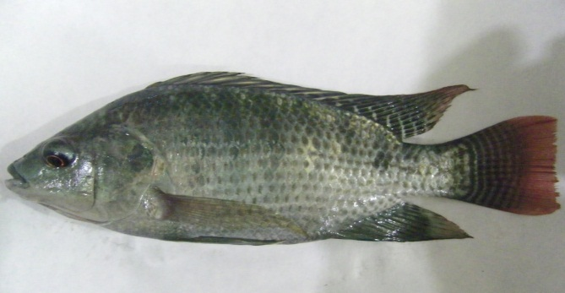

Fig. 1. A tilapia, Oreochromis niloticus from a commercial fish farm in central Punjab, Pakistan.

III. References:

1. Janjua, R.S.N., Fitzsimmons, K., Shoaib A and Woiwode, J. 2015. Development of Tilapia Aquaculture Industry in Pakistan. SoyPak (ASH/WISHH), Karachi, Pakistan (https://www.was.org/meeting /mobile/MG_Paper.aspx? i= 35636)

2. Menaga, M and Fitzsimmons, K. 2017. Growth of the Tilapia Industry in India. www.was.org. World Aquaculture, Sept. 2017. Pp 49-52.

3. Veverica K, L and Janjua, R.S.N. 2015. A Manual forTilapia. SoyPak (ASH/WISHH), Karachi, Pakistan. PP. 73

IV. Biography:

Dr. Zafar Iqbal has completed his PhD at Institute of Aquaculture, University of Stirling, Scotland in 1992. His area of interest is Aquaculture and fish health management. Currently he is serving as Associate Professor of Zoology in University of the Punjab, Lahore since 2003. He has supervised over 65 postgraduate research students including 3 PhDs. He has Published 60 research papers in the journals of international repute. He also reviews research articles for international Journals and also serves as Associate Editor of “Punjab University Journal of Zoology”.
V. Presenting Author



Name: Dr. Zafar Iqbal
Cell No: + 92 302 4304692
Email: zafar_iqbal.zool@pu.edu.pk
Session name/Number:
Category: Oral presentation
Passport No: EA 1336062

