Organochlorine Pesticides in Lithorina lithorea, Mercinaria mercinaria, Callinectes pallidus and Penaeus monodon from Cross River Estuary, Imo River Estuary, Qua Iboe River Estuary, Lagos Lagoon and Badagry Creek
CLARKE, Edwin O¹., ADEBOYEJO, Akintade O¹. and JAMIU Shittu¹
¹Department of Fisheries, Faculty of Science, Lagos State University, Lagos-Nigeria. E-mail: claralgae5@yahoo.com

Keywords: Organochlorine Pesticides, lagoon, Environment,

- Abstract:
Organochlorine pesticides (OCPs) has been known to be persistent in the environment and bio-accumulates in aquatic organisms. The OCP levels were measured in water, sediment and shell fishes (Panaeus monodon, Callinectes pallidus, Mercinaria mercinaria and Lithorina lithorea) from three (3) state: Lagos State (Lagos lagoon and Badagry creek), Cross River State (Cross river estuary), Akwa Ibom State (Imo river estuary) and (Qua iboe river estuary), between November 2015 to June 2016, using Gas chromatography with electron capture detector. The highest mean concentration of OCPs were recorded in Lagos lagoon and Badagry creek. The levels in sediment ranged from 0.150 ± 0.012 µg/kg (Alpha HCH) in Lagos lagoon to 243.500 ± 138.000 µg/kg (ppDDT) in Badagry creek. The Concentration in shell fishes ranged from 0.250 ± 0.009 µg/kg (Alpha HCH) in Lagos lagoon to 67.380 ± 22.860 µg/kg (Endosulfan II) in Badagry creek for Callinectes pallidus and from 1.310 ± 0.210 µg/kg (alpha HCH) to 143.500 ± 71.892 µg/kg (Eldrin Aldehyde) in Badagry creek for Penacus monodon. Aldrin was detected in all the samples from the five water bodies. The results showed that OCP levels in all shellfish samples analysed were above the maximum acceptable limits of 0.01ppm (10 µg/kg) set by EU and Federal Ministry of Environment for aquatic life protection.

II. Image
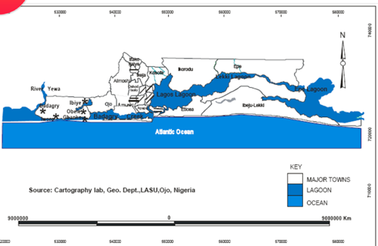
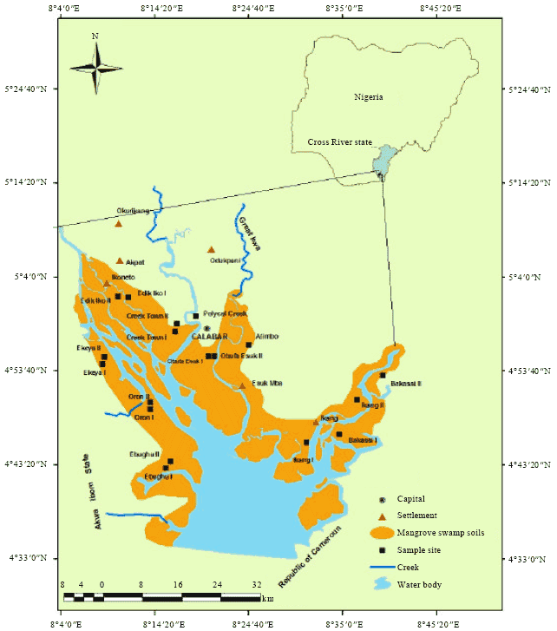
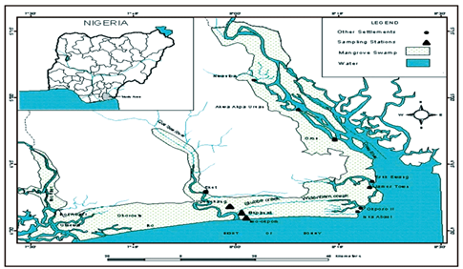
Maps Showing Lagos lagoon Complex, Cross river and Qua Iboe river estuaries

III. Reference

- Agency for Toxic Substances and Disease Registry (ATSDR) (2002b). Public Health Statement
- Chevrier, J., Eskenazi, B., Holland, N., Bradman, and Barr, D.B (2008). “Effects of Exposure to polychlorinated Biphenyls and Organochlorine Pesticides on Thyroid Function during Pregnancy”, American Journal of Epidemology, vol. 168(3), pp. 298-310.
- Clarke, E.O., Aderinola, O.J. and Adeboyejo, O.A. (2013). Persistent organochlorine pesticides (POPs) in water, sediment, in fish and shell fishes from Ologe Lagoon, Lagos, Nigeria. American journal of research communication 16: pp. 122-135
- Thomas, G.O., Wilkinson, M., Hodson, S. and Jones, K.C. (2006). Organohalogen chemicals in human blood from the United Kingdom. Environmental Pollution, 141(1), pp30-41.
- USEPA. (2005). Suspended, canceled, and Restricted Use Pesticides. Office of Compliance Monitoring, Office of pesticides and Toxic substances, US EPA, Washington, DC

IV. Biography
Dr. Clarke, Edwin O., was awarded his Ph.D. at the age of 43years old from the Lagos State University, Ojo-Lagos State, Nigeria and has been a lecturer in Lagos State University, Lagos, Nigeria since 1998. He is currently a senior lecturer and specializes in Plankton Dynamics Aquatic Pollution, & Ecotoxicology. He has published more than 30 scientific papers in reputable journals and was the immediate past Head of the Department of Fisheries and Aquatic Biology, within the University. He is member of Fisheries society of Nigeria and other professional associations
- Author details



Clarke, Edwin O
Contact number: 08183725593
E-mail: claralgae5@yahoo.com
Session name/number:
Category: Oral presentation
Passport Number: A06271703

.

