Acute Toxicity and Hematological Responses of 2-2-Dichlorovinyl Dimethyl Phosphate (Dichlorvos) On Fingerlings of Clarias gariepinus
ADEBOYEJO, O. A¹, LAWAL, T. ¹and ADARAMOYE, O. R¹
Department of Fisheries, Lagos State University, Lagos, Nigeria. Email: adeboyejoakintade@yahoo.co.uk

Keywords: Water quality, acute toxicity, haematology, dichlorvos and fish behaviour.

- Abstract
The study investigated lethal toxicity effects of Dichlorvos on Clarias gariepinus fingerlings (Mean weight 8.02±2.56g and length 10.15±1.02cm) in a static renewable bioassay during 96hours exposure period. Treatment were in triplicates with concentrations 0.0, 1.0, 2.0, 3.0, 4.0 and 5.0µg/l. Data on fish mortality and physico-chemical water parameters (Dissolved oxygen, Carbondioxide, pH and Temperature) were taken and subsequently subjected to one way analysis of variance (ANOVA) at P<0.05. Duncan Multiple Range Test (DMART) was used to separate differences between means. The mean lethal concentration (LC₅₀) was determined by Probit analysis. The water quality parameters of the control showed mean Temp. 29.0±0.1⁰C; pH 7.27±0.3; CO₂ 0.41±0.1mg/L; and DO 5.83±0.4mg/L. However, the treatment showed significant variations from the control (at P<0.05) except for temperature. Behavioural responses of the fish included frequent surfacing, erratic swimming, mucus secretion, bleeding, skin bleaching, colouration of the abdomen and shivering. 96- Hours LC₅₀ value was 1.51µg/L. The derived hematological indices of White Blood Cell, Lymphocytes, Red Blood Cell, Hemoglobin (HB), Packed Cell Volume, Neutrophil, Mean Corpuscular Hemoglobin Concentration etc; varied significantly from the control at P<0.05. The changes observed indicated that hematological parameters can be used as bio- indicators to illicit stress responses in fish after exposure to different concentrations of DDVP.

- Image
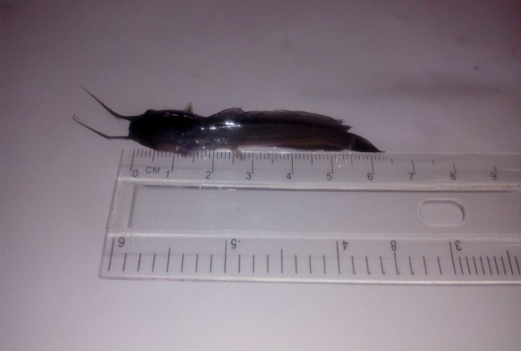
Fingerling of Clarias gariepinus

- References

- Agbon, A. O., L.T. Omomniyi and Teko, A.A(2002): acute toxicity of tobacco (Nicotiana tobaccum) leaf dust on Oreochromis niloticus and heamatological changes resulting from sub-lethal exposure. Journal of Aquatic Sciences, 17(1); 5-8.
- EPA, (2004). Overview of freshwater and marine toxicity tests: A technical tool for ecological risk assessment. alifornia. Environmental health hazard assessment in the Department of Environmental toxicology, University of California. Davis. 147pp
- Rahman, M. Z., Hossain, Z., Mollaqh, M. f. A. and Ahmed, G. U. (2002): Effect of Diazinon 60EC. On testudineus (C.punctatus and B. gonionotus). The ICLARM Quarterly, 25(2):8-12.
- Rogers JT, Richards JG, Wood CM (2003). Ion regulatory disruption as the acute toxic mechanism for lead in the rainbow trout. Aquat. Toxicol. 64(2): 215-234.
- Umar, M., Stephen, S.H., Abdullahi, M. and Garba, M.(2010): Dichlorvos concentrations in locally formulated pesticide (Ota-piapia) utilized in Northeastern Nigeria. Scientific Reasearch and Essay, 5(1): 049-054.
- Witeska M (2003). The effects of metals (Pb, Cu, Cd, and Zn) on hematological parameters and blood cell morphology of common carp. Rozprawa naukowa nr 72, Wydawnictwo Akademii Podlaskiej Siedlce [In Polish].

- Biography
Dr. Adeboyejo, Akintade completed his Ph.D. at the age of 45years old from the Federal University of Technology, Akure, Ondo state, Nigeria and has been a lecturer in Lagos State University, Lagos, Nigeria since 1998. He is currently a senior lecturer and specializes in Fish Biology & Ecotoxicology. He has published more than 28 papers in reputed journals and has been serving as course coordinator of entrepreneurial studies within the University. He is member of Fisheries societies home and abroad.
- Author details

Full Name: Adeboyejo Olamiwaye Akintade
Contact number: 08038763329
E-mail: adeboyejoakintade@yahoo.co.uk
Session name/number:
Category: Oral presentation
Passport Number: A06785096

