Abstract

Title: 3D Design and Simulation of Magnetic Field Tapering on Whistler Pumped FEL

Mr. Prateek Srivastava,¹ Dr. Manish Kumar,²
¹Punjab Engineering College, Chandigarh, India
²Indian Institute of Technology (BHU), Varanasi, India

Keywords: Wiggler, Whistler, Tapering

- Abstract Body
FEL designed with innovative scheme of linear tapering of magnetic field using cutting edge technology and with application of enhancement in the field of plasma. 3D design and simulation of Whistler Pumped FEL having a linear tapered magnetic field configuration in the interaction region with the length Ls has been analysed. This analysis is done on ANSYS platform with desired material for tapering, current excitation, thermal impact and plasma confinement for determining it's economic viability, efficiency and real life production. Using high-temperature superconductor stranded structure available in the ANSYS software is simulated for magnetic field generation up to 5T also the variation of magnetic field along radial direction is analysed so as to reduce the fringing effect losses to increase efficiency. The simulation predicts the confinement, behaviour of magnetic field due to tapering, whistler pumped wiggler-beam particle interaction and the shielding of electron with speed near to light. Other parameters have been observed like magnetic flux, flux leakage, average magnetic field, inductance, divergence of filed etc. Analytical result of this design and simulation on ANSYS will provide opportunity for designing of the FEL device which will be very cost effective with its application in Laser particle acceleration, Bio-medical, surgery, military grade weapon system and to find the traces of dark energy in the outer space.

- Image:

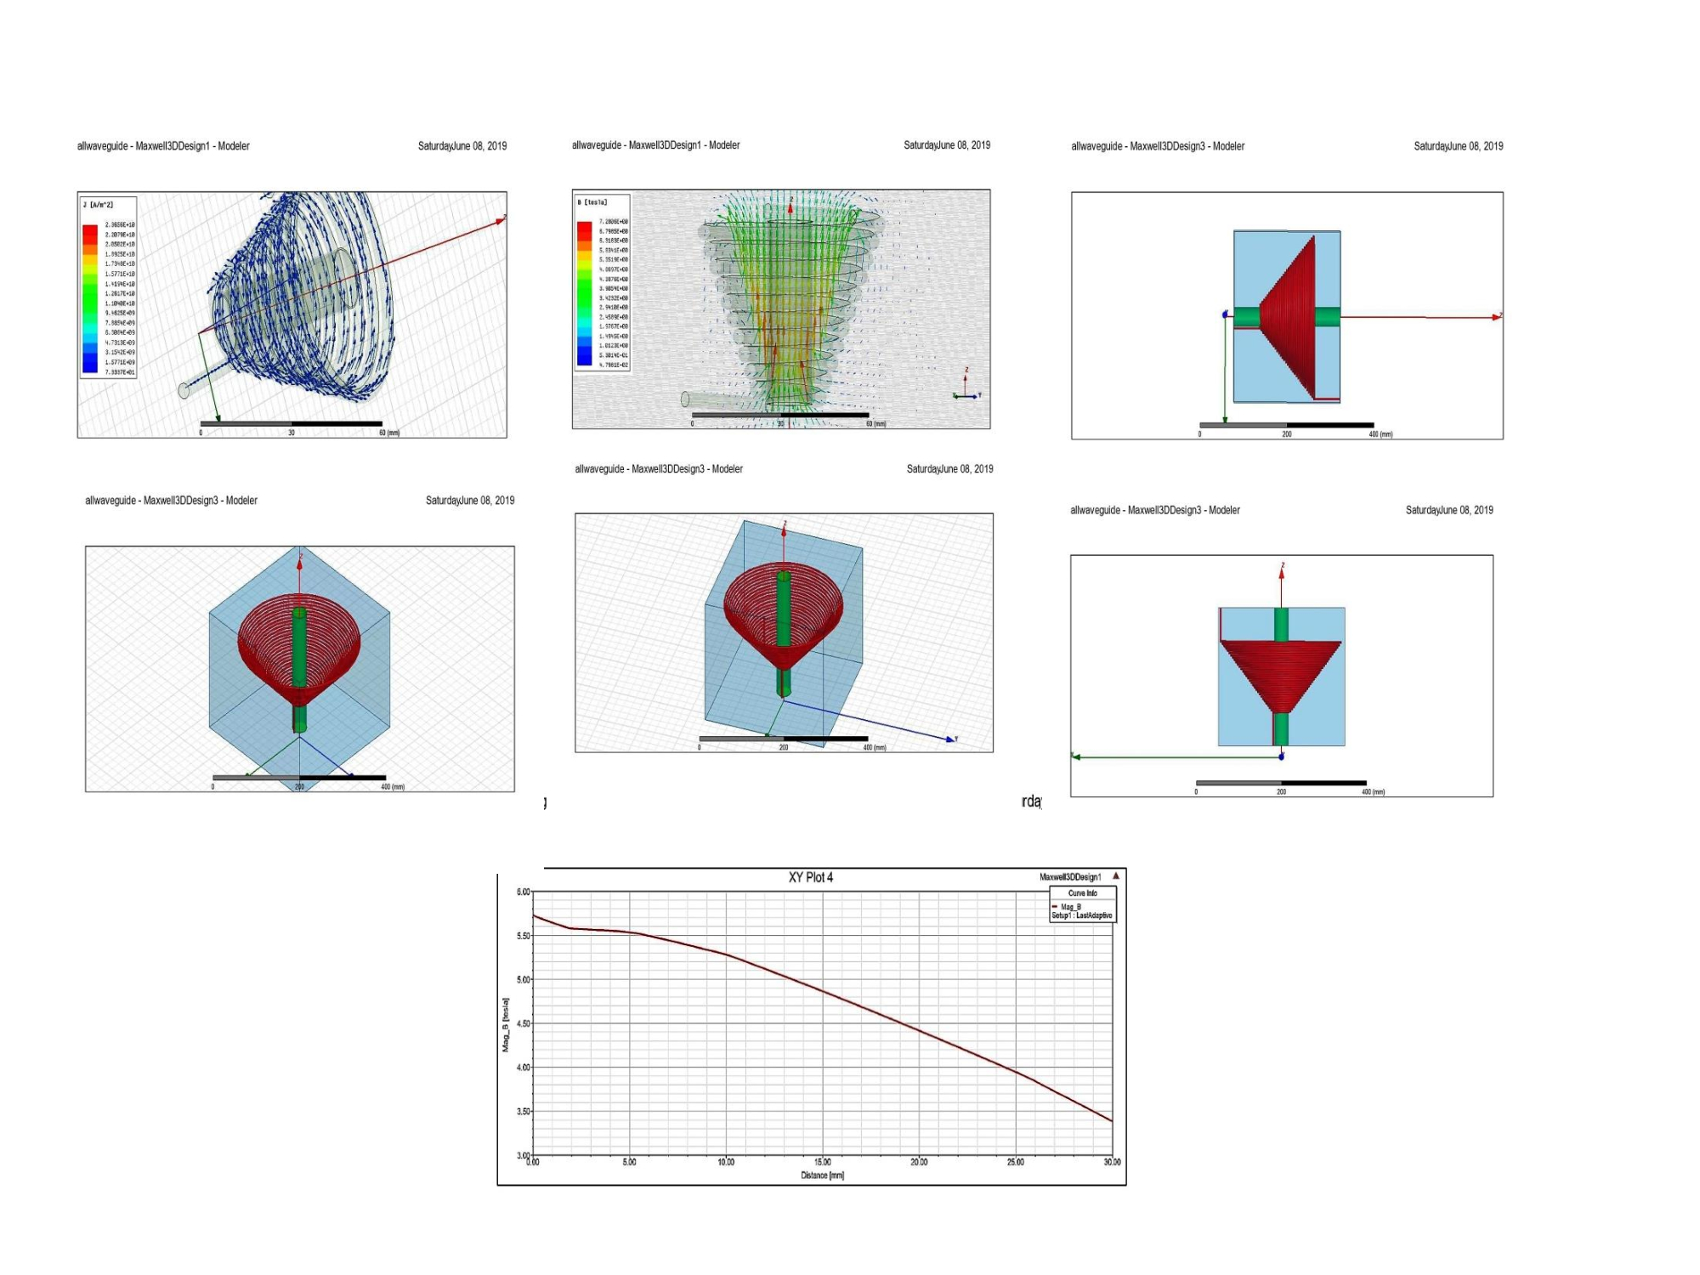

- Reference:
- M. Kumar, “Effect of magnetic field tapering on whistler pumped free electron laser,” AIP Advances 9, 025207 (2019)
- M. Kumar, L. Bhasin, and V. K. Tripathi, Phys. Scr. 81, 045504 (5pp) (2010).
- A. Sharma and V. K. Tripathi, “A whistler pumped free electron laser,” Phys. Fluids 3I, 3375–3378 (1988).

Biography: Prateek Srivastava currently pursuing B.Tech (Electrical Engineering). He has gained experience of research under supervision of Dr. Manish Kumar on enhanced and advanced FEL Technologies. He is also Invited for presenting his work on FEL in International Conference of repute in Paris, France organized by Scientific Federation Nuclear Engineering - 2019.
- Presenting author details


Full Name: Mr. Prateek Srivastava
Contact number: +919415216837
Twitter account: prateekks.pk@gmail.com
Linked In account: prateeksrivastava.beele16@pec.edu.in
Session name/ number: 2
Category: Oral Presentation
Passport Number: M5862078

