Random walk modelling in the high-energy ball milling
Vyacheslav S Kalnitsky, PhD,
Oleg V Rusakov, PhD,
Saint-Petersburg state university, Russia

Abstract
The dispersion model. Consider a random walk in a regular m-polygon inscribed in the unit circle. The movement of the point to a randomly selected vertex determines the position of the point. The point passes a prescribed distance and stops. For such a process, there is a limit distribution of the probabilities of the position of the point. This algorithm was used for modelling different processes [1-4]. Now we applicate it for describing the distribution density of grinding elements in a high-energy ball milling [5]. Basic assumptions: 1) the displacement of one grinding element is considered in the projection on the base of the cylindrical body of the mill; 2) consider the motion of the element rectilinear between impacts; 3) the direction after the impact will be considered a normally distributed vector; 4) the mean free path μ for a particle has a fixed length in fractions of the radius of the drum; 5) the individual trajectory of a particle is assumed to be common for all grinding elements; 6) the density of the distribution of the particle stops is taken as the density of collisions of the particle collective.
Numerical modeling. For the numerical simulation of the process we set the following parameters: m = 1000, the number of steps was up to 30 million. The calculated densities are figured (Figs 1-4). Color scale from small (green) to large (red) density.
The length of the run outside the red zone will be greater than in the red. Thus, it can be assumed that, some part of the substance will experience less impact from the milling elements. The real granulometric analysis of the material shows the presence of two distinct peaks in the size histograms. This can be explained by the model.

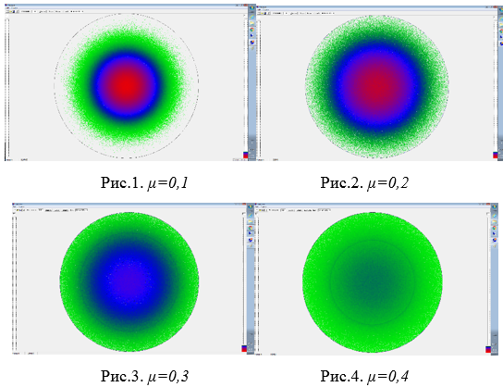
Recent Publications
- Rusakov O, Karlitskaya A (2005) Fractal structure of rates and one generalization of the Cantor staircase function. Survey of applied and industrial mathematics. 12(4): 870-871.
- Rusakov O, Laskin M (2017) A stochastic model for stationary dynamics of prices in real estate markets. AIP Conference Proceedings 1836, 020087
- Rammal R, Toulouse G (1983) Random walks on fractal structures and percolation clusters. Journal de Physique Lettres. 44 (1): 13–22.
- Codling E, Plank M, Benhamou S (2008) Random walk models in biology. Journal of The Royal Society Interface. 5 (25): 813–834.
- Gusev A, Kurlov A (2008) Production of nanocrystalline powders by high-energy ball milling: model and experiment. Nanotechnology. 19(26): 265 302.

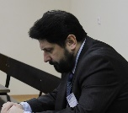 Biography  Vyacheslav Kalnitsky has his expertise in geometry modelling of milling process. His research concerns such aspects as scaling of models, geometrical density evaluation etc. This model is based on key idea of corresponding between individual and collective behavior of particles. The constructed model allowed explaining the important aspects of the grinding process.  Email: st006987@spbu.ru | 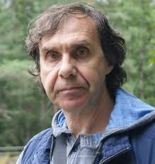 Biography  Oleg Rusakov has his expertise in stochastic analysis. He is generalized the random walk on polygons. Created the computer program for stochastic modelling in plane. He described many applications of it in financial mathematics.  Email: st006987@spbu.ru

Notes/Comments:

