Battle-damage Tolerant Automatic Controls
Scott Y. Nakatani, Major, United States Air Force, USA

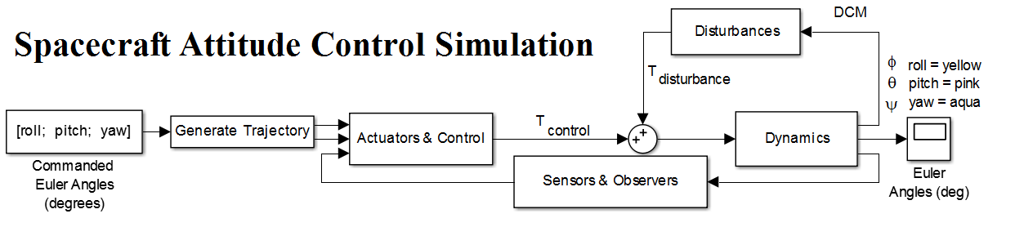
Abstract (300 word limit)

In the 1950s and 1960s, the North American X-15 rocket powered aircraft was pioneering the concepts and principles that would come to define modern powered flight. Among the ground-breaking ideas proposed was a system of adaptive controls, or a controller that would take into consideration the changing operational environment to deliver appropriate control to the operator. Limitations of current technology abounded, leaving the X-15 with a successful, but severely limited adaptive control system. Since then, many limitations have fallen away, allowing for the first-time employment of adaptive controls on a large scale.

The nature of adaptive controls, or controls for unpredictable systems, lends itself naturally to the concept of damage tolerant controls in high performing systems, such as aircraft and spacecraft. Recent technical demonstrations of damage tolerant aircraft prove the concept of adaptive controls in an operational environment. Research covered by this paper expands on the topic by discussing the application of adaptive controls to spacecraft and theory behind simulating damage tolerant control implementation. Simulation is then used to demonstrate the stability of adaptive controls when experiencing sudden mass loss and rapid changes in inertia.

The development of adaptive controls and the enabling technology for them has reached a point where new and innovative uses are now becoming possible. The purpose of this research was to determine the plausibility of damage-tolerant control in satellites. By introducing a modified adaptive Proportional Integral Derivative (PID) controller with adaptive feed forward control to this simulated spacecraft, it is demonstrated that the controls have achieved significant damage tolerance. This comes at a time where the need for such tools has never been greater, and the dangers associated with space operations grow daily.

Image

Figure 1. Spacecraft Attitude System Block Diagram

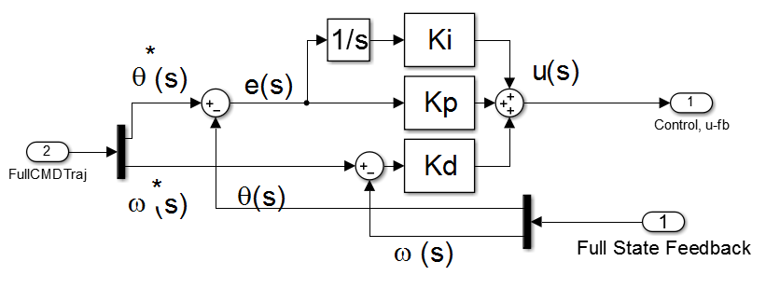
Figure 2. Modified Proportional Integral Derivative (PID) Controller
Recent Publications (minimum 5)
- Nakatani S, Sands T (2018) Battle-damage Tolerant Automatic Controls. Electrical and Electronic Engineering Vol 8(1): 10-23
- Sands T (2018) Space Mission Analysis and Design for Electromagnetic Suppression of Radar. International Journal of Electromagnetics and Applications 8(1): 1-25.
- Heidlauf P, Cooper M, Sands T (2017) Controlling Chaos – Forced Van Der Pol Equation. Mathmatics 5(4), 70.
- Nakatani S, Sands T (2016) Autonomous Damage Recovery in Space. International Journal of Automation, Control and Intelligent Systems Vol 2(2): 23-26.
- Nakatani S, Sands T (2014) Simulation of Spacecraft Damage Tolerance and Adaptive Controls. 2014 IEEE Aerospace Conference Proceedings, 1-16.

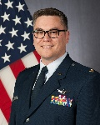Biography (150 word limit)
Scott Nakatani received a B.S. in Physics from the United State Air Force Academy in 2007, and a M.S. in Space Systems Operations from the Naval Postgraduate School in 2013. He has been a commissioned officer in the United States Air Force for 11 years. In that time, he led mission operations and range testing for Delta II, Delta IV, and Atlas V missions from Cape Canaveral AFS, FL, in addition to standing up the USAF mission assurance center for Falcon 9 missions at Vandenberg AFB, CA. Following his graduation from the USAF Space Superiority Weapons Instructor Course, he led space integration and space plans at the 607 Air Operations Center, Osan AB, Republic of Korea, then served as the Chief of Weapons and Tactics for 14 AF, Vandenberg AFB, CA. He is currently assigned as Student, Schriever Scholars Advanced Studies Group, Air Command and Staff College, Maxwell AFB, AL.
Email: scott.nakatani.1@us.af.mil

Notes/Comments:

