On the Laplace Transform Solutions of Partial Differential Equations Arising from Hydromagnetic Flow
Mustafa Alper Gunes, Robert College Istanbul, Turkey

Abstract (300 word limit)

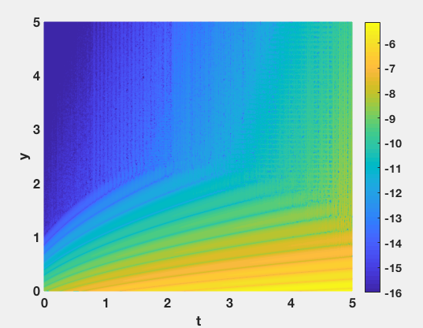
This paper investigates the use of the Laplace Transform method for solving partial differential equations that describe hydromagnetic flow. Various cases of hydromagnetic flow where the governing PDEs were solved by the method are described through examples from literature. Furthermore, the insufficiency of the method in finding exact solutions analytically due to the difficulty in taking inverse Laplace transforms is demonstrated with a specific example of hydromagnetic flow that was previously studied, and the exact temperature solution of the case is represented with an integral that uses the Green's function of the PDE. Afterwards, the integral is evaluated numerically for the only case where a closed form solution can be obtained using the Laplace Transform method, and numerical values obtained via numerical integration are shown to be in high agreement with the values obtained from the exact function.
Figure
Fig. 1 Log(abs(error)) for the numerical integration

Recent Publications (minimum 5)
- Seth, G., Ansari, M., &Nandkeolyar, R. (2011). Unsteady hydromagneticCouette flow within a porous channel. Tamkang Journal of Science and Engineering,14(1), 7-14. Retrieved July 22, 2018, from http://www2.tku.edu.tw
- Seth, G., Sarkar, S., &Nandkeolyar, R. (2015). Unsteady hydromagnetic natural convection flow past an impulsively moving vertical plate with Newtonian heating in a rotating system. Journal of Applied Fluid Mechanics,8(3), 623-633. Retrieved July 22, 2018.
- Sidda Reddy, K., &Raju, G. (2018). Chemical reaction effect on MHD radiating flow over an infinite vertical surface bounded by a porous medium with heat source. International Journal of Current Research in Life Sciences,7(2), 960-968. Retrieved July 24, 2018.
- Sreekanth, S., Saravana, R., Venkataramana, S., &Hemadri Reddy, R. (2011). Unsteady Hydromagnetic Flow of viscoelastic fluid down an open inclined channel. International Journal of Innovative Technology& Creative Engineering,1(4), 29-41. Retrieved July 23, 2018.
- Wanja, I. J. (2010, July). Laplace Transform Solution ofHydromagnetic Steady Flow of Viscous Incompressible Fluid Between Two Parallel Infinite Plates. Retrieved July 22, 2018, from http://erepository.uonbi.ac.k


Biography (150 word limit)
Mustafa Alper Gunes is a high school student who previously worked as a research assistant in Bogazici University with a graduate student on her Master’s Thesis on chaos control. He also participated in a research program in Koc University in July 2017, working on the properties of EEG signals, mainly on MATLAB. He has very high academic achievement in areas of math and science, and he received a certificate of distinction from University of Waterloo for his achievement in Euclid Math Contest.
Email: gunmus.19@robcol.k12.tr

