The sequential transmission model of two strains influenza virus A with antigenic drift mechanism
Fajar Adi Kusumo, Universitas Gadjah Mada, Indonesia
Dianita Putri Army, Institut Teknologi Bandung, Indonesia

Abstract (300 word limit)
Flu is one of the respiratory diseases caused by influenza virus A. Antigenic drift mechanism changed the virus’s structure in phase and created two strains of influenza virus A which is simultaneously infected humans. Mathematical modeling can be applied to explain epidemiology of two strains of influenza virus A infection. Here we discuss the sequential transmission model of two strains influenza virus A with antigenic drift mechanism. There are six equilibrium points obtainable from the model and we analyze the stability of each equilibrium points. The explanation of the model equipped with simulation which described each equilibrium points in face portrait.

Image
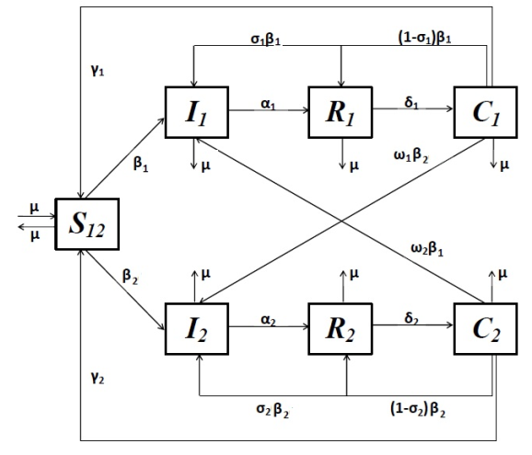
Figure. Compartment Diagram of Sequential Transmission Model of Two Strains Virus Influenza A
Recent Publications (minimum 5)
-

Biography (150 word limit)
Dianita Putri Army is magister student at Institut Teknologi Bandung and had her bachelor degree at Universitas Gadjah Mada. Her research interest is applied mathematics especially in nonlinear dynamics of mathematical biology. She had been a paper presenter at the 7th SEAMS-UGM International Conference in 2015 as a paper presenter. Furthermore, in magister, she learn about control systems that can be applied in mathematical biology problems.

Email: dianita.putri.a@gmail.com

Notes/Comments:

