Prediction of Latitude and Longitude of Earthquakes at Global Level using The Regressive Objective Regression Method.
Ricardo Osés Rodríguez. CMP Villa Clara, Cuba
Carmenate Ramírez, Anai, CMP Villa Clara, Cuba.
Alfredo Pedraza Martinez, CMP Villa Clara, Cuba.
Rigoberto Fimia Duarte, Health Technological Institute Medical Sciences Villa Clara, Cuba

Abstract
Objective: To model the series of data of a set of earthquakes at a global level included in the period from 2014-08-27 23.22.23 UTC until 2014-08-27 04.47.36 UTC, there were 50 earthquakes taken globally and it was determined a model to predict the longitude and latitude of these events. Methods: The Regression Objective Methodology, ROR, is used. Two models are calculated, the first for latitude and the second for longitude, the models are determined in a short term. Results: The correlation coefficients are obtained between the real value and the forecast of 0.716 for model 1 with an error of 25.09 significant degrees at 99% and, for model 2, R = 0.637 with an error of 74.64 degrees significant at 90%. Earthquakes for latitude depends on the value 1.16.12 earthquake behind, the parameter returned 16 steps back is significant at 99%. For this model the trend is 0.118 not significant, model 2 depends on 1, 2, 11, 21 steps back, earthquakes 1 step back is significant at 90%, the trend of the series for model 2 is a rise in length by 4,637 significant at 95%. Discussion: Our work shows the longitude and latitude of earthquakes occurrence are perfectly predictable parameters similar to the variable wind, so a careful attention must be paid to the prevention planes of these phenomena to reduce vulnerability in cities. Conclusions: It is concluded that model 1 is the least error while trend in model 2 has a significant increasing. Global earthquakes are regressive events at planet level and what happens in one place has repercussions in another, not randomly or due to chance, but rather a well-determined phenomenon.
Keywords: Global modeling | Earthquakes | Prediction | Length | Latitude

Recent Publications (minimum 5)
- Modeling of Equivalent Effective Temperature and its possible incidence on larval density of Anopheles mosquitoes (Diptera: Culicidae) in Villa Clara province, Cuba Rigoberto Fimia Duarte, Pedro María Alarcón-Elbal, Ricardo Osés Rodríguez, George Argota Pérez, José Iannacone Oliver & José Capote Cabrera1 Rev. Biol. Trop. (Int. J. Trop. Biol. ISSN-0034-7744) Vol. 65 (2): 565-573, June 2017
2.Osés Rodríguez, Ricardo ; Rigoberto Fimia Duarte; Pedraza Martínez, Félix Alfredo; Dra. Florencia Jimenez Lorenzo. Muestra Independiente de la modelación matemática con un año de antelación de infecciones respiratorias Agudas ( IRA ) y crisis agudas de Asma bronquial (CAAB) con la metodología ROR. Convención UCLV.2017.ISBN: 978-959-312-258-0.

3.Osés Rodríguez, Ricardo ; Dominguez Hurtado Ismabel Maria; Pedraza Martínez, Félix Alfredo; Dra. Florencia Jimenez Lorenzo. Modelación y Pronóstico de la Presión Atmosférica Tri-horaria a nivel del mar con 11 años de antelación de la Provincia de Villa Clara Cuba.. B. Convención UCLV 2017.ISBN: 978-959-312-258-0.

4. Long Term Forecast of Meteorological Variables in Sancti Spiritus. CUBA. 01/2014; 2(1):37-42. DOI:10.12691/aees-2-1-6

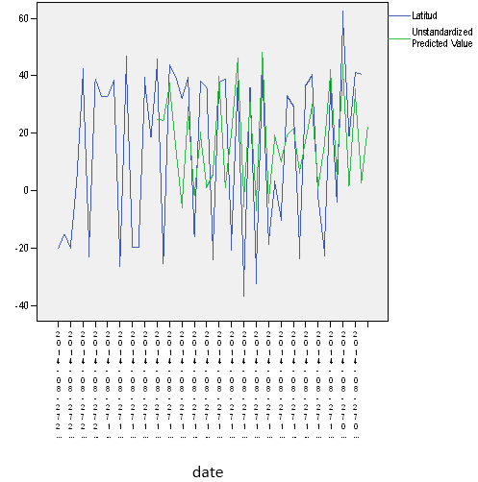
5.Ricardo Osés Rodríguez: Mathematical Modeling (ROR) applied to the forecast of earthquakes in the global level. Revista Electronica de Veterinaria 01/2014; volumen 15(No 08B). 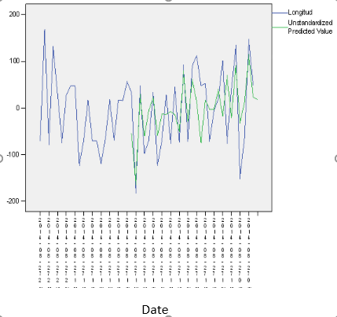

Figure 3 Actual and predicted values for the Length.
Figure 2. Real and predicted values for latitude.
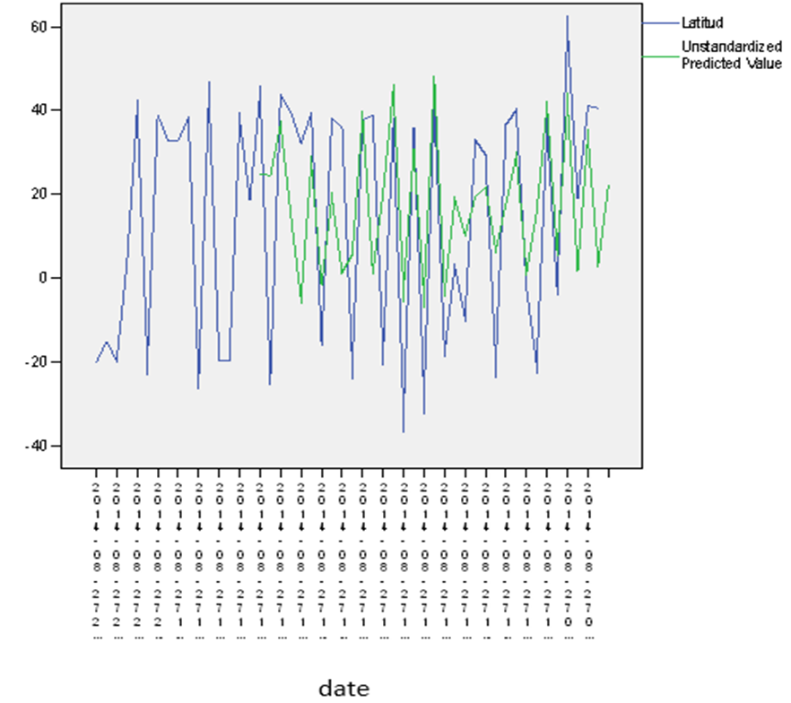



Biography
I direct science projects applied to different branches of the economy, I have developed a bulletin of climatic Surveillance where the rains and the extreme temperatures of the County are predicted besides it is extended to the two seasons in the province. I have imparted conferences of Statistic applied to the Meteorology and the Climatology, I am consultant of the Center in climatic applications and I carry out investigations on the presage and the climatic applications, I manage the software SPSS, as well as other software’s. I advise the technicians in Meteorology in the Provincial Meteorological Center. I have been boss of the department of Applied Meteorology and secretary of the Scientific Council of the Provincial Meteorological Center, I am memberer of the ONG Cuba solar in the County of Villa Clara that is devoted to the Promotion of the Sources of Renewable Energy in Cuba.
Email: ricardo.oses@vcl.insmet.cu

Notes/Comments:
Thanks , to the organizers of the Conference for my participation.

