The Self-Nonself Circulation Theory: New Perspectives of Advanced Future Studies
Masatoshi Murase, International Research Unit of Advanced Future Studies (IRU-AFS) and Yukawa Institute for Theoretical Physics (YITP), Kyoto University, Japan

Abstract

Globalization occurs due to advanced science and revolutionary technology. Despite our extensive efforts, it brings about contradictory situations such as the co-existence of benefits and wonders. Indeed, it has allowed us to solve simple problems, but it can increase the potential risks of systemic problems, leading to system-wide disruptions. Our efforts to solve systemic problems often cause further systemic problems, beyond our expectations.

What can we do to protect against such emerging systemic problems? We need a Copernican revolution for paradigm shifts in our cognition. We should apply the same systemic forces that generate the systemic problems in the original place. Ironically speaking, emerging systemic problems could be only approached by the same emerging systemic problems.

How can we do this? Let us think about nature as it is. Nature is full of self-similarities, known as fractals. In the seemingly complex fractals, particular characteristic patterns of structures appear successively at descending or ascending scales so that their parts, at any scale, are similar in shape to the whole. The resulting self-similar complex fractal nature has been fully understood on its own terms in the form of simple rules.

The present paper extends the idea of fractals from the “self-similar static structures view” to the “self-similar dynamic processes view” essential to “living” systems in order to explore simple principles beyond complexity. The only assumption is as follows: Simple principles of complex “living” dynamics can be deduced from the demand that the underlying principles must be “self-consistent”, regardless of the scale with which we are concerned. It is the “self–nonself circulation principle” originally given by Masatoshi Murase (2000) that governs the complexity of life.

Masatoshi Murase (2000) Life as History: Construction of Self-Nonself Circulation Theory. Kyoto University Press

Image
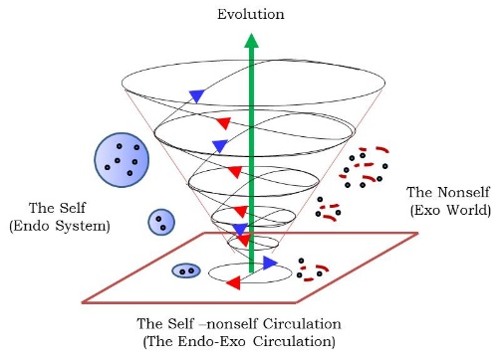

Recent Publications
- Murase, M. and Murase, T. (2013) Investigating polluted environment adaptation syndrome based on structuralism: A perspective of self-nonself circulation theory as a unified theory of life, Japanese Journal of Clinical Ecology, 22, 80-91.
- Murase, M. and Murase, T. (2014) Structuralism revisited: On the basis of self-nonself circulation theory, Journal of Quality Education, 6, 27-43.
- Murase, M. and Murase, T. (2015) Synchronization of Arts and Sciences: The Essence of Mind and Problem of Education, Journal of Quality Education, 7, 1-28.
- Murase, M. Murase, I. and Murase, T. (2017) Towards the Origin of Learning and Playing: From the Perspective of Self-nonself Circulation Theory, Journal of Quality Education, 8, 1-29
- Masatoshi Murase (2018) A Self-Similar Dynamic Systems Perspective of “Living” Nature: The Self–Nonself Circulation Principle Beyond Complexity. “Kyoto Manifesto” Springer.

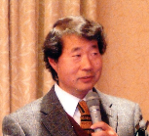

Biography
Masatoshi Murase is an Associate Professor of Yukawa Institute for Theoretical Physics at Kyoto University, and is the editor-in-chief of the Journal of Integrated Creative Studies (ISSN: 242-0370). He is also Director of Research Promotion Strategy Office at The International Research Unit of Advanced Future Studies of Kyoto University. He received a PhD from the University of Tokyo in 1987. Positions held overseas include a period as a Postdoctoral Fellow in the Physiology Department at Duke University Medical Centre from 1987 to 1988, and an Associate Professorship in the Department of Mathematics of the University of California at Davis from 1990 to 1991. He is the author of The Dynamics of Cellular Motility (Wiley, 1992), and is the author of Life as History: Construction of Self-Nonself Circulation Theory (Kyoto University Press, 2000).
murase@yukawa.kyoto-u.ac.jp

Notes/Comments:
Organizer of the Symposium on Advanced Future Studies

