New Perspectives of Advanced Nursing Theory
Tomoko Murase, Japanese Red Cross Toyota College of Nursing and International Research Unit of Advanced Future Studies (IRU-AFS), Kyoto University, Japan

Abstract

Nursing Science is one of the integrative human sciences. The nursing theories are considered to be the structures reflecting thinking ways or philosophical ideas, which can explain the mutual relationships among human beings within nursing phenomena in a unified manner. Most nursing theories so far have been proposed in order to understand such mutual relationships on the basis of the general system theory and the problem solving way according to Western scientific ideas.

The first nursing theory was presented by Florence Nightingale in her book, “Notes on Nursing: What it is and what it is not” published in 1859. She said that “Nursing is to alter the environment in such a way to obey the natural laws and at the least expense of vital power to the patient.” Nightingale’s vital power can be considered to be “resilient systems” in the present terminology. Resilient Systems have the Power that can rebuild autonomously and fluidly our own structure. In addition, the resilient systems have the meaning of recovery from the failure and/or recovery from the disability, illness, and some other dis-functions autonomously.

In the present study, the author proposed the new nursing model based on the Eastern Philosophy. The right-side figure shows the structure of new nursing model named “The Mandala Nursing Model”. It was constructed on the framework of the “Self-Nonself Circulation Theory” proposed by Masatoshi Murase (2000). The data obtained from 10 persons with depression were qualitatively analyzed in order to identify 5 cognitive characteristics: (1) inharmonic body v.s. harmonic mind-body, (2) limit of energy v.s. increasing energy, (3) introvert relationship v.s. extrovert relationship, (4) collapsing self v.s. redeveloping self, and (5) past life v.s. future life.

In addition, there were 5 different patterns of nursing care: (1) nursing care of inherent ability within denial, (2) nursing care of the discovery of the meaning of life, (3) nursing care from parts to wholeness, (4) nursing care of pro-care (sympathetic care), and (5) nursing care of con-care (critical care).

The present figure indicates one of the developmental stages on nursing care. As time proceeds, the structure develops in such a way that the whole structure and its parts are the same with each other. This is the important characteristics of the mandala structure. Because of this self-nested hierarchical structures, the mandala can indicate not only the goal of nursing care, but also its current stage. From such a point of view, the author believed that we have a hopeful future on human caring as well as its education.

Masatoshi Murase (2000) Life as History: Construction of Self-Nonself Circulation Theory. Kyoto University Press.

Image
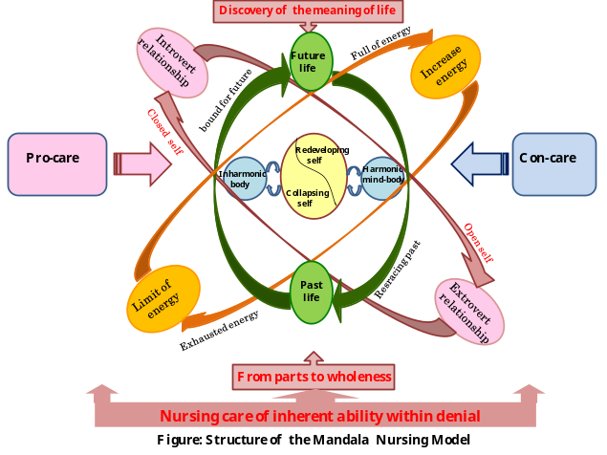

Recent Publications
- Murase, M. and Murase, T. (2013) Investigating polluted environment adaptation syndrome based on structuralism: A perspective of self-nonself circulation theory as a unified theory of life, Japanese Journal of Clinical Ecology, 22, 80-91.
- Tomoko Murase (2013) Proposition for the development of environmental nursing science, Japanese Journal of Clinical Ecology, 22, 92-101
- Murase, M. and Murase, T. (2014) Structuralism revisited: On the basis of self-nonself circulation theory, Journal of Quality Education, 6, 27-43.
- Murase, M. and Murase, T. (2015) Synchronization of Arts and Sciences: The Essence of Mind and Problem of Education, Journal of Quality Education, 7, 1-28.
- Murase, M. Murase, I. and Murase, T. (2017) Towards the Origin of Learning and Playing: From the Perspective of Self-nonself Circulation Theory, Journal of Quality Education, 8, 1-29

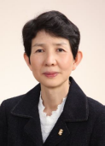 Biography
Tomoko Murase is the Department Dean of Japanese Red Cross Toyota College of Nursing, and is the Professor of Psychiatric Nursing. She is a collaborate member of The International Research Unit of Advanced Future Studies, Kyoto University. She received a PhD from Chiba University. Her major research topics cover a wide range of human relationships such as the fundamental nursing, structuralism, constructive cognition, systems dynamics of life, complex system sciences, and advanced nursing studies.
tmurase@rctoyota.ac.jp
Notes/Comments:
The Symposium on Advanced Future Studies

