EFGM simulation of sinusoidal heating on nanofluid filled square enclosure
Rama Bhargava, Professor, Dept. of Mathematics, IIT Roorkee, India. Email: rbharfma@iitr.ac.in
Rangoli Goyal, Ph.D. , Dept. of Mathematics, IIT Roorkee, India. Email: rangoligoyal@gmail.com

Abstract (300 word limit)

In the present paper, a numerical study is made for a two dimensional square cavity filled with nanofluid where the right wall is heated with temperature varying in sinusoidal mode and adiabatic on lower and upper wall. The sinusoidal temperature is symmetric about the middle plane. The governing partial differential equations are solved using Element free Galerkin method. The results are obtained for different values of Rayleigh number, Brownian motion parameter and Thermophoretic parameter. The efficiency of Meshfree method is established. An increase in the Brownian motion parameter Nb leads to significant changes in concentration of isotherm. The isotherm is pushed upwards with increase in value of Nb as random motion of nanoparticles increases. . As Rayleigh number increases, many secondary circulations appear at the bottom half of the cavity. The secondary circulations pushed the primary circulations towards the upper part of the cavity. The isotherm contours are hereby drawn to draw conclusion. Such problems, find application in chemical and pharmaceutical process and medical delivery.

Image
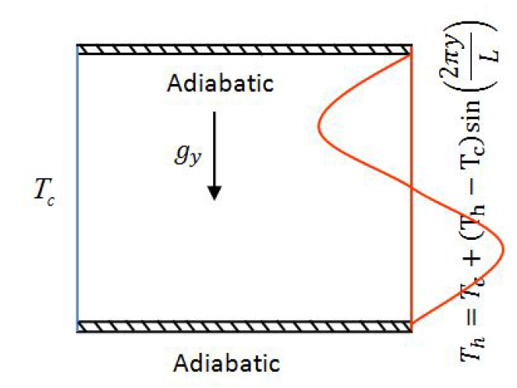
Physical domain of system
Recent Publications (minimum 5)
- Deng & Chang : Natural connection is rectangular enclosure Num. heat transfer A, 54, 507-524, 2008.
- Nield and Kuznetsov Natural Convection flow of a nanofluid Int. J. Thermal sci, 243 -247, 2010 a.
- Sheremp MA : Free convection in porous cavities, ASME J. heat transfer, 2014.
- Buongiorno J. (2006) Convective transport in nanofluids. Journal of Heat Transfer 128(3):240-250.
- Liu G.R., Mesh free method-Moving beyond the Finite element method, CRC Press,2003

Biography (150 word limit)
Prof. Rama Bhargava is the professor at Deprtment of Mathematics, IIT Roorkee, India. She is presently aslo the Dean, Administration of the institute. Her field of specialization are: Computational Fluid Dynamics, Finite Element, Meshfree methods, Computer Graphics. She has around 40 years of research and teaching experience. She has more than 170 publications in various International journals. She has presented papers and given invited talks in many national and international conferences. She has received many awards such as INSA exchange Award UK, Australian Endeavour Executive Award, Daad Scholarship Etc.
Email: rbharfma@iitr.ac.in

