Physical Laws Extracted from Statistical Analyses of Solar Magnetic Elements
Mohsen Javaherian, PhD in Solar and Astrophysics, ZNU, IRAN

Abstract (300 word limit)
Studying the emergence and disappearance of magnetic features on the solar surface is controversial. Two approaches were introduced to investigate the evolution of photospheric features. One way is magnetohydrodynamics, and the other is statistical analyses. The complexity of this system with lots of features proposes the statistical way can be adopted to carry out this kind of nonlinear systems.
The solar photosphere is the origin of magnetic elements observed in the visible and UV wavelengths. Using Helioseismic and Magnetic Imager (HMI) on board Solar Dynamic Observatory (SDO) telescope, the magnetic field of photosphere is measured in line-of-sight. Magnetic elements (patches) can be appeared on magnetograms. The code Yet Another Feature Tracking Algorithm (YAFTA). First, an area 400"×400" was picked up to study the magnetic characteristics over the year 2011. The correlation between filling factors of negative and positive polarities is 0.51. The relationship between the size [S] and flux [F] of elements has a power-law behavior as S $∝$ F ^{0.69}. Next, the area 100"×100" is selected from solar equatorial region to track patches in the quiet-Sun over three days with time lags of 45 seconds. It was included 5750 sequential frames to investigate lifetime of elements and its relationship with the flux and size. The code YAFTA detected 22,526 patches survived for more than one frame. More than about 95% of the magnetic features have lifetimes less than 100 minutes, and approximately 0.05% of the detected features had lifetimes of more than 6 hours with maximum lifetimes of 15 hours.
The relationships between S, lifetime [T], and F for patches bring in power-law behaviors as S $∝$ T ^{0.25} and F $∝$ T ^{0.38}, respectively. The DFA analysis suggests there is long-range memories in the system of patches which can give an information about the conditions govern on patches.

Image

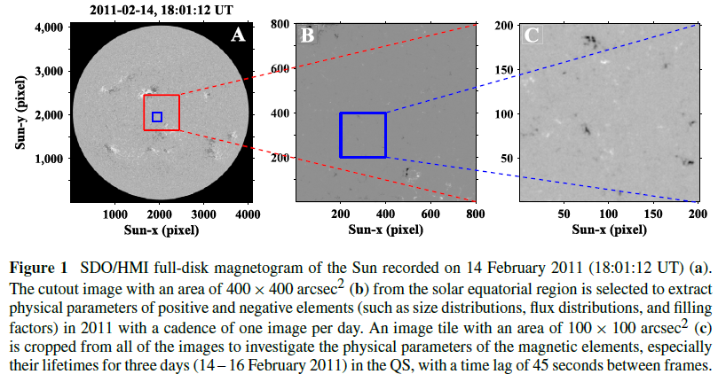

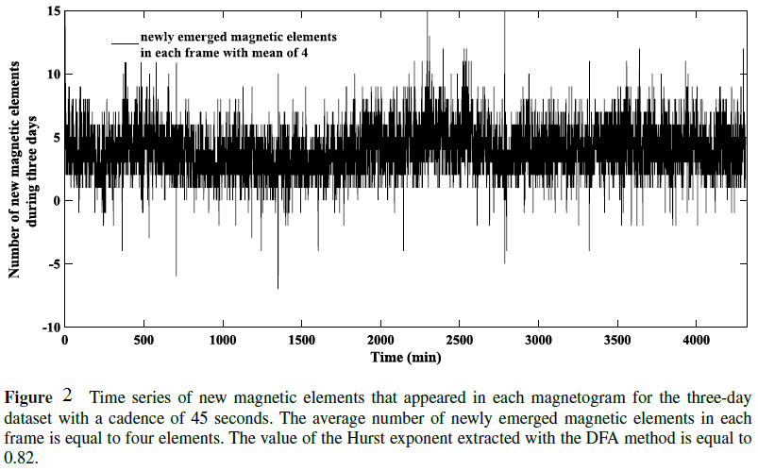
Recent Publications (minimum 5)
- Gosain S (2012) Evidence for Collapsing Fields in the Corona and Photosphere during the 2011 February 15 X2.2 Flare: SDO/AIA and HMI Observations. Astrophys. J. 749: 85-94.
- DeForest D E et al. (2007) Solar Magnetic Tracking. I. Software Comparison and Recommended Practices. Astrophys. J. 666: 676-587.
- Javaherian M et al. (2017) Statistical Properties of Photospheric Magnetic Elements Observed by HMI onboard SDO. Solar Phys. 292: 1-15.
- de Wijn A G et al. (2009) Small-Scale Solar Magnetic Fields. Space Sci. Rev. 144: 275-315.

Biography (150 word limit)

I have spent the last 6 years on studying Physics of the Sun, theoretically, and working on data recorded by different telescopes such as SDO/AIA, SDO/HMI, and SUNRISE. As one of my interests, I have focused on theoretical astrophysics, the Magnetohydrodynamics of the stellar plasma and phenomena related to complex systems and nonlinear phenomena with statistical view. This is an interesting area to extract regimes govern the phenomena.
The focus of works was centered on the development of image processing techniques and data classification to study evolution of the Sun. So, I tried to improve my programming knowledge in image processing, pattern recognition, and statistics. I tried to learn some computational software (e.g., MATLAB, and IDL) to facilitate my woks. I want to bridge between results that I extracted from data and theoretical results describing the evolution of the Sun. It leads to valid papers in high qualitative Journals.
.
Email: m_javaherian@znu.ac.ir

Notes/Comments:

