Broadband Night Vision by Chalcogenide Glass Circuits
P.Yupapin, PhD, Ton Duc Thang University, Vietnam

Abstract (300 word limit)
We have proposed an artificial eye model using the chalcogenide glass microring conjugate mirror(MCM). Th model uses a modified add-drop filter, where the object and reference light beams interfere and the image is constructed within the centre ring, such a construction is referred to as MCM. The 3D image construction and perception of eyes are manipulated by using the Optiwave and MATLAB programs. The simulation have shown that the 3D image is constructed at the center ring, which can be confirmed by the output of the MCM, where the four-wave mixing(FWM) output of the MCM port is obtained. The 3D image display can be generated by the display MCM. In application, the large area MCM can be constructed which is indicator of the potential for the artificial eye application. Moreover, the perception spectrum is wider than the visible light, which spans over ~0.85-2.6 µm. It is desireable for 3D wideband night vision applications.
Image
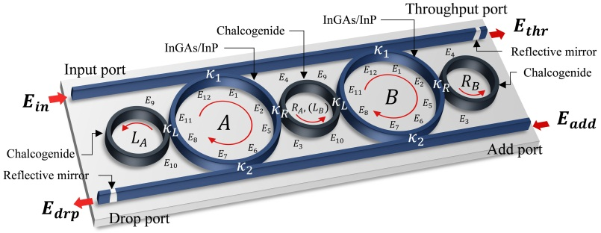

Figure 1: A schematic of the microring conjugate mirror, where $E_{in}$, $E_{thr}$, $E_{drp}$, and $E_{add}$ are the optical field of the input, throughput, drop, and add port, respectively. $R_{L}$: Left-hand ring radius, $R_{R}$: Right-hand ring radius, $R_{D}$: Center ring radius, $κ_{s}$: coupling constants, which is 0.5 for all $κ_{s}$. The center ring is the ChG material. In this case the the reflected coefficient is neglected.
Recent Publications (minimum 5)

[1] P. Yupapin et al, Micro-Current Source Generated by a WGM of Light Within a Stacked Silicon-Graphene-Au Waveguide, IEEE Photonics Technology Letters, 2017
[2] P. Yupapin et al, Manual control of optical tweezer switching for particle trapping and injection, IET-Micro and Nano Letters, 2018

[3] P. Yupapin et al, A Microring Conjugate Mirror Design and Simulation for Naked-Eye 3D Imaging Application, Microwave and Optical Technology Letters, 2018
[4] P. Yupapin et al., On-chip remote charger model using plasmonic island circuit, Results in Physics, 2018.
[5] P. Yupapin et al, Plasmonic op-amp circuit model using the inline successive microring pumping technique, Microsystem Technologies, 2018.


Biography (150 word limit)
Preecha Yupapin received the Ph.D. degree in electrical engineering from the City, University of London,UK in 1993. He is currently the Professor and a Principal Research Scientist in the Computational Optics Research Group (CORG), Advanced Institute of Material Science (AIMaS) and Faculty of Electrical & Electronics Engineering, Ton Duc Thang University, Ho Chi Minh City, Vietnam. Prof. Yupapin is a member of Thai Institute Physics (TIP), South East Asia Theoretical Physics Association (SEATPA) committee, South East Asian Collaboration for Ocean Renewable Energy (SEAcORE) committee and Optical Society of America (OSA). He has 300 ISI published papers, H-index-27. His current researches of interest are transparent electronic devices and circuits, microring resonator, naked-eye 3D imaging, soliton, optical motor, quantum and spintronic devices, drug delivery and therapy.

Email: preecha.yupapin@tdt.edu.vn

Notes/Comments:

