GC-MS analysis of LMW PAHs degradation by yeast Trichosporon cutaneum R57

GERGINOVA M., STOYANOVA K., PENEVA N., ALEXIEVA Z.*

Department of General Microbiology, Institute of Microbiology, Bulgarian Academy of Sciences, Sofia, Bulgaria

Keywords: Trichosporon cutaneum, biodegrdation, GC-MS, naphthalene, anthracene, phenanthrene

- Abstract
Among the most difficult to degrade chemical pollutants are known polyaromatic substances (PAH). A number of microorganisms capable to varying degrees to transform or degrade PAHs have been described (1). The yeast strain T. cutaneum R57 is known from previous research as a strain capable of degrading efficiently phenol and a number of derivatives thereof (2). Our recent studies have focused on its possibility to degrade three low molecular weight (LMW) compounds of this group: naphthalene, anthracene and phenanthrene.
The strain was grown at aeration and at 28°C in a culture medium containing each of the test compounds included as the sole carbon source. The following initial concentrations were used: naphthalene - 0.36 g/l; anthracene - 0.39 g/l; and phenanthrene - 0.37 g/l. In the same conditions, the influence of glucose (0.1 g/l) on the degradation process was also tested.
By gas chromatography-mass spectrometry (GC-MS) was determined different rates of degradation of the tested compounds. The strain T. cutaneum R57 degrades an average of 51 mgl⁻¹day⁻¹ of naphthalene, 16 mgl⁻¹day⁻¹of anthracene and 10 mgl⁻¹day⁻¹ of phenanthrene.
It was found that when using a low concentration of an additional carbon source such as glucose, the rate of degradation is delayed insignificantly, within 3-5%.

- Image:

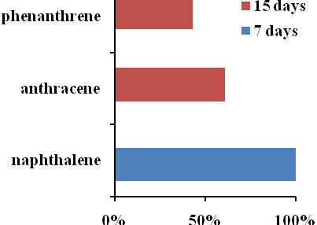
Percent biodegradation of phenanthrene, anthracene and naphthalene by T. cutaneum R57

- Reference:
- Peng, R.-H., A.-S. Xiong, Y.Xue, X.-Y.Fu, F.Gao, W.Zhao, Y.-S. Tian and Q.-H. Yao, 2008. Microbial biodegradation of polyaromatic hydrocarbons. FEMS Microbiol. Rev. 32, 927–955
- Gerginova M., P. Zlateva, N. Peneva and Z. Alexieva, 2014. Influence of phenolic substrates utilised by yeast Trichosporon cutaneum on the degradation kinetics. Biotech. Biotechnol. Eq., 28, 33-37
Acknowledgments This work was supported by the National Scientific Fund of the Ministry of Education and Science, Bulgaria (grant DH 17/4 - 2017)
- Biography:
Zlatka Alexieva has graduated in the specialty of Biochemistry and Microbiology from University of Sofia and has completed her PhD from Institute of Molecular biology, Ukrainian Academy of Sciences at 1985. She has specialized in molecular biology in University of Baltimore, for one year. Zlatka Alexieva was the head of Division of General Microbiology and Head of Dept. Microbial Genetics at the Institute of Microbiology, Bulgarian Academy of Sciences. She has published more than 120 scientific papers published in national and international journals and conference proceedings. The list of citations includes more than 700 citing publications.

- Presenting author details


Full Name: Zlatka Alexieva
Contact number: +359 2 9793114
Session name: Environmental Microbiology & Microbial Ecology
Category: Poster presentation

