Growth, yield and nutrient uptake by rice as influenced by diazotrophic bacteria

S. Islam, M.S. Alam and A.R.M. Solaiman
Department of Soil Science, Bangabandhu Sheikh Mujibur Rahman Agricultural University, Gazipur 1706, Bangladesh
Keywords: Rice, diazotroph, Rhizobium, Yield attributes, Nutrient uptake
Abstract
The association of diazotrophic bacteria with rice varieties is one alternative that has been strategically thought to replace part of the N fertilizer required by the plant. To this context an initial experiment was conducted in earthen pot at the Bangabandhu Sheikh Mujibur Rahman Agricultural University, Bangladesh to assess the influence of fifteen diazotrophic Rhizobium isolates viz. BU Ls 2, BU Ls 6, BU Ls 13, BU Ls 14, BU Ls 15, BU Ls 16, BU Ls 17, BU Ls 18, BU Ca 6, BU Ca 7, BU Ca 8, BU Le 9, BU Le 10, BU Ps 1 and BU Ps 2 on growth, yield and nutrient uptake by rice. Among the isolates BU Ls 6 performed best in recording plant height, root length, root volume, biomass and grain yields and nutrient uptake by shoot both at vegetative and harvesting stages of the crop. Isolate BU Ls 2 also performed more or less similarly in recording the plant parameters. A follow up experiment was conducted in the field to assess the influence of diazotrophic bacterial isolates in presence and absence of nitrogen and phosphorus supplied from chemical fertilizers on growth, yield and nutrient uptake by rice. Isolate BU Ls 6 in combination with recommended doses of 50%N +100%P supplied from chemical fertilizers significantly increased all the plant parameters including biomass (5.24 t ha⁻¹) and grain (4.916 t ha⁻¹) yields and nutrient uptake by shoot. Among the isolates BU Ls 6 was considered as the best diazotrophic bacteria.
Image:
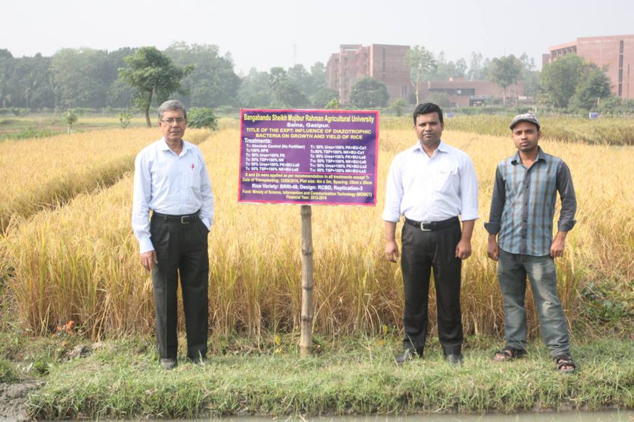
Fig. 1 Field view of the experiment

References:
- Biswas, J.C., J.L. Ladha, and F.B. Dazzo. 2000. Rhizobia inoculation improves nutrient uptake and growth of lowland rice. Soil Sci. Soc. Am. J. 164: 1644-50.

- Hussain, M.B., L. Mehboob, Z.A. Zahir, M. Naveed and H.N. Asghar. 2009. Potential of Rhizobium sp. for improving growth and yield of rice (Oryza sativa). Soil Environ. 1: 49-55.

- Mia, M.A.B. and Z.H. Shamsuddin. 2010. Rhizobium as a crop enhancer and biofertilizer for increased cereal production. Afr. J. Biotechnol. 9(37):6001-6009.
- Mia, M.A.B., Z.H. Shamsuddin, W. Zakaria and M. Marziah. 2012. Effects of rhizobia and plant growth promoting bacteria inoculation on germination and seedling vigor of lowland rice. Afr.J. Biotechnol. 11 (16), 3758-3765, DOI: 10.5897/AJB09.1337
- Solaiman, A.R.M., G.M.A. Hossain and M.A.B. Mia. 2011. Effect of Rhizobium on growth and biomass production of rice. Bangladesh J. Microbiol. 28(2): 64- 68.

Biography
Professor Dr. A. R. M. Solaiman did PhD from The Queen’s University of Belfast and Postdoctoral research in University of Aberdeen, UK. He has served as Visiting Scholar in Rhine-Waal University, Germany. Dr. Solaiman is involved in teaching and research for the last 38 years. He is a Professor of Bangabandhu Sheikh Mujibur Rahman Agricultural University, Bangladesh and holding the position of Director (International Affairs). He has served as Dean, Faculty of Graduate Studies and Director (Research). Dr. Solaiman has published 140 research articles in reputed journals. He has served as research supervisor for 15 PhD and 27 MS students.

Presenting author details
Full Name: Prof. Dr. A.R.M. Solaiman
Contact number: +88 01552495381
Session name/number: Agricultural, Soil and Forest Microbiology (Session number 9)
Category: Oral presentation
Passport Number: BP0869053

