Title: Value Added Products from Microalgae using Textile Wastewater: Waste to Wealth

Sourish Bhattacharyaª, Kamlesh Prasad^{b}, Sandhya Mishraª

Division of Biotechnology and Phycology, CSIR-Central Salt and Marine Chemicals Research Institute, Bhavnagar-364002, Gujarat, India.

Natural Products and Green Chemistry Division, CSIR-Central Salt and Marine Chemical Research Institute,

- References
- Bhattacharya, S., Bhayani, K., Ghosh, T., Bajaj, S., Trivedi, N. & Mishra, S. (2018) Stability of phycobiliproteins using Natural Preservative ε-polylysine (ε-PL). Fermentation Technology, 2018, 7, 149.
- Bhattacharya, S., Pramanik, S. K., Gehlot, P. S., Patel, H., Gajaria, T., Mishra, S., Kumar, A. 2017. Process for Preparing Value-Added Products from Microalgae Using Textile Effluent through a Biorefinery Approach. ACS Sustain. Chem. Eng., 5(11):10019-10028.
- 17. Sequeira, R.A., Singh, N., Pereira, M.M., Chudasama, N.A., Bhattacharya, S., Sharma, M., Mondal, D., Prasad, K. (2018) High concentration solubility and stability of ɛ-poly-l-lysine in an ammonium-based ionic liquid: A suitable media for polypeptide packaging and biomaterial preparation. International Journal of Biological Macromolecules, 120, 378-384.

- Biography
Sourish Bhattacharya has completed his B. Tech in Biotechnology from West Bengal University of Technology and M.Tech in Fermentation Technology from Institute of Chemical Technology, Mumbai. He completed his PhD from CSIR-Central Salt and Marine Chemicals Research Institute, India. He worked as Research Executive at Innovative Creations Business Modules Pvt. Ltd., India for 2 years. Presently he is working as Junior Scientist at Central Salt and Marine Chemicals Research Institute, Council of Scientific and Industrial Research, India. He has published 11 research works in reputed international journals. He also own one patent on Marine microalgal biofuel.
He is currently working on various areas involving microbial synthesis of ε-polylysine as well as involved in multi-Institutional projects on biofuel from marine microalgae.

- Presenting author details

Full Name: Sourish Bhattacharya
Contact number: +91-8017750689
Twitter account: https://twitter.com/sourish007
Linked In account: https://www.linkedin.com/in/sourish-bhattacharya-87179a14/
Session name/ number: Category: (Oral presentation/ Poster presentation): Young Scientist Award
Passport Number: M7265881

Abstract
A model was designed for effective utilization of textile effluent as the nutrient medium for the production of high-value products from Chlorella variabilis through a greener approach. Further, a novel integrated process was developed based on detergent (sodium dodecyl sulfate) based hydrolysis to convert the carbohydrates present in microalgal biomass to reducing sugars for microbial fermentation, while making available lipids for downstream processing of γ-linolenic acid, leaving the protein rich fragment behind. Our experimental data showed that from 495 g of microalgal biomass, 109.4 g total lipids was extracted containing 34.65 g γ-linolenic acid, and 1.3 g pure ε-polylysine from 36.68 g of reducing sugars. Further, a two-step efficient green process was developed for recovering ε-polylysine using ethylammonium nitrate having 74% recovery. In addition to value-added products, CSIR-CSMCRI’s Chlorella variabilis (ATCC PTA 12198) can remediate 100% of aluminum, 82.72% boron, 45.66% calcium, 100% cobalt, 14.5% potassium, 0.1% magnesium, 42.18% sodium, 100% nickel, 100% iron, 78.17% total phosphate and 25.22% total inorganic phosphate in the effluent. The revenues from selling the γ-linolenic acid at 1500 and 103 INR per gram along with protein powder and residual algal oil can generate a net gain of 44752 INR.
Pure ε-polylysine from Bacillus licheniformis was used for storage of Phycocyanin and Phycoerythrin in stable form. 0.02% ε-polylysine (w/v) was found to be optimum for storage of C-PC and C-PE at 4 ± 2°C and lesser loss of C-Phycocyanin and C- Phycoerythrin content as compared to citric acid for its storage up to 8 days without any change in colour and pH.
ɛ-poly-L-lysine based ionic gel was developed as a suitable media for polypeptide packaging and biomaterial preparation. Invitro studies were performed with pathogenic microorganisms and the developed gel demonstrated a promising gel for wound healing applications.II. Image
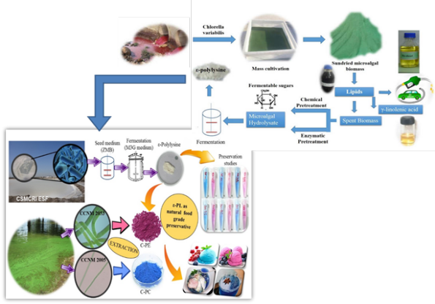
Fig.1: Process development for value added products from microalgae using textile effluent as nutrient medium

