Bioprospecting of marine resources for biopolymer production

Sourish Bhattacharya, Junior Scientist, CSIR-Central Salt and Marine Chemicals Research Institute, Gujarat, India.

Abstract
West coast of India can be considered as important area for collecting diverse marine microorganisms with biopolymer producing capacity. In this attempt, 200 marine isolates from west coast of India was obtained, out of which one strain CSMCRI’s Bacillus licheniformis PL26 was found to be potential for producing ε-polylysine and polyhydroxyalkanoate simultaneously in same fermentation medium. The PHA produced by Bacillus licheniformis was found to be poly-3-hydroxybutyrate (P3HB). Further, in order to improve the ε-polylysine production, the carbon source was replaced with glucose which yielded 1.2 g L⁻¹ ε-polylysine as oxygen transfer rate is very low in the medium containing crude glycerol. Further, an advanced modelling and optimization technique was applied to optimize medium parameters for enhanced ε-polylysine production by marine bacterium Bacillus licheniformis. The ANN topology of 4-10-1 was found to be optimum upon training the model with feed-forward back propagation algorithm and on application of the developed model to particle swarm optimization resulted in 3.56 ± 0.16 g L⁻¹ of ε-polylysine under the following optimal conditions: glucose, 34 g L⁻¹; yeast extract, 2.3 g L⁻¹; magnesium sulphate, 0.44 g L⁻¹ and ferrous sulphate, 0.08 g L⁻¹. Thus, this optimization technique could significantly improve ε-polylysine by 196.7 %, as compared to un-optimized medium.
ε-polylysine based ionic gel was prepared which may be used for biomedical applications.
II. Image
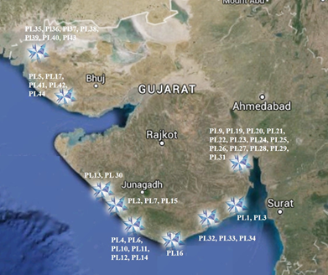
Fig.1: Distribution of ε-PL producing bacteria in sea water along west coast of India
- References
- Bhattacharya, S., Dineshkumar, R., Dhanarajan, G., Sen, R., Mishra, S., 2017. Improvement of ε-polylysine production by marine bacterium Bacillus licheniformis using artificial neural network modeling and particle swarm optimization technique. Biochem. Eng. J, 126: 8-15.
- Bhattacharya, S., Dubey, S., Singh, P., Shrivastava, A., Mishra, S., 2016. Biodegradable Polymeric Substances Produced by a Marine Bacterium from a Surplus Stream of the Biodiesel Industry. Bioengineering, 3(4): 34.
- Bhattacharya, S., Pramanik, S. K., Gehlot, P. S., Patel, H., Gajaria, T., Mishra, S., Kumar, A. 2017. Process for Preparing Value-Added Products from Microalgae Using Textile Effluent through a Biorefinery Approach. ACS Sustain. Chem. Eng., 5(11):10019-10028.

- Biography
Sourish Bhattacharya has completed his B. Tech in Biotechnology from West Bengal University of Technology and M.Tech in Fermentation Technology from Institute of Chemical Technology, Mumbai. He completed his PhD from CSIR-Central Salt and Marine Chemicals Research Institute, India. He worked as Research Executive at Innovative Creations Business Modules Pvt. Ltd., India for 2 years. Presently he is working as Junior Scientist at Central Salt and Marine Chemicals Research Institute, Council of Scientific and Industrial Research, India. He has published 11 research works in reputed international journals. He also own one patent on Marine microalgal biofuel.
He is currently working on various areas involving microbial synthesis of ε-polylysine as well as involved in multi-Institutional project on biofuel from marine microalgae as team member.

- Presenting author details

Full Name: Sourish Bhattacharya
Contact number: +91-8017750689
Twitter account: https://twitter.com/sourish007
Linked In account: https://www.linkedin.com/in/sourish-bhattacharya-87179a14/
Session name/ number: Category: (Oral presentation/ Poster presentation): Oral Presentation
Passport Number: M7265881

