TREATMENT OF EMERGING SKIN DISEASES USING A NEW LOTION (ORONSFRANKLO) ORONSAYE FE ,P I ORONSAYE, BOLAJI O AND S I ORONSAYYE (Mrs.) DEPARTMENT OF MEDICAL LABORATORY SCIENCE, COLLEGE OF MEDICAL SCIENCES, UNIVERSITY OF BENIN CITY, NIGERIA
Tel: +2347085424003
Email:sayfrankon@yahoo.com
1 AUTHOR .+ PROFESSOR FRANCIS ORONSAYE UNIVERSITY OF BENIN PMB1154 BENIN CITY NIGERIA.
2 AUTHORS;
2 S I ORONSAYE UNIVERSTY OF BENIN PMB1154
3ORONSAYE P IO,4 ODIGIE BOLAJI
BENIN CITY NIGERIA.
+CORRESPONDING/PRESSENTING AUTHOR.

Background: The emergence of new diseases of unknown aetiology is a common health challenge in developing countries. These diseases affect upper regions of the body, particularly the face, neck and the jaw.
Methods; One hundred subjects compressing 20 children,50 adults and 20 elderly subjects who were discovered having bumps’ (as it is often called by physicians) on the face, scalp and neck encountred in a rural community in Edo state Nigeeria were randomly recruited into the study Their consent was obtained verbally. And were assured of strict confidentiality: The subjects were given the lotion( oronfranklo which was applied to the affected areas using sterile cotton wool swabs twice daily, for aperiod of two weeks. The lotion is exclusively for external use. This lotion has been successfully tried for treating superficial infections in Benin city Nigeria
Results: Satisfactory clinical response was achieved at the end of treatment period.
CONCLUSION; We present in this study, the treatment of emerging disease using a new lotion.
KEY WORDS; EMERGING,SKIN DISEASES.

.

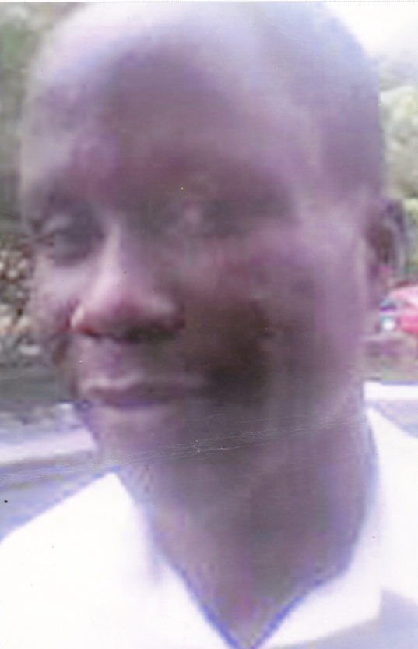
plate 1: Before Treatment


plate 2: After treatment

