Title: Management of Orbital Subperiosteal Abscess in Children
Mohamed A. Eldesouky
Department of Ophthalmology, School of Medicine Tanta University, Tanta, Egypt
Keywords: Ethmoiditis, Pansinusitis, endoscopic drainage, proptosis, gaze limitation.

- Abstract Body
Subperiosteal abscess in children is one of the most common forms of sinusitis related orbital infections. Today, despite antimicrobial and surgical management, 15% to 30% of patients with an SPA develop various visual sequelae. Treatment of an SPA remains controversial. The role of an initial therapeutic trial of intravenous (IV) antibiotics and the timing and methods of surgical drainage are not well established. This report presents some guidelines for the diagnosis and treatment of an SPA based on clinical, ophthalmologic, and radiographic findings, and evaluates the efficacy and safety of endoscopic drainage of an orbital SPA.

- Image:
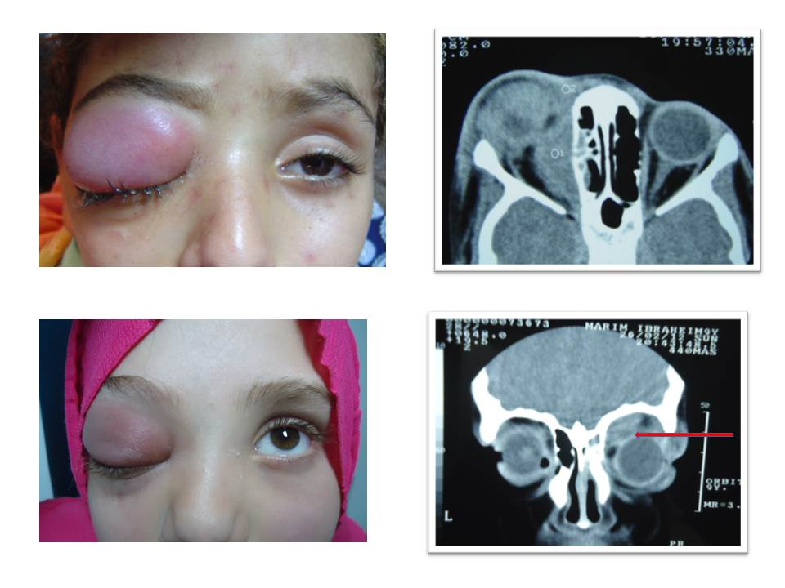

- Reference:
- Scott M. Goldstein, Jill A. Foster, James A. Katowitz. 2018. Pediatric Orbital and Periocular Infections. Pediatric Oculoplastic Surgery, pages 623-638.
- Theodora Tsirouki, Anna I. Dastiridou, Nuria Ibánez flores, Johnny Castellar Cerpa, Marilita M. Moschos, Periklis Brazitikos, Sofia Androudi. (2017) Orbital cellulitis. Survey of Ophthalmology.
- Adva Buzi, Mark Rizzi. 2018. Pediatric Otolaryngologic Considerations. Pediatric Oculoplastic Surgery, pages 169-182.

Biography:
Mohamed A. Eldesouky has completed his PhD at the age of 36 years from Tanta University and Postdoctoral Studies from School of Medicine, University of Tennessee, Memphis. He is the Director of oculoplasty, and ocular pathology service in Tanta University Eye Hospital. He has published more than 25 papers in reputed journals.
- Presenting author details

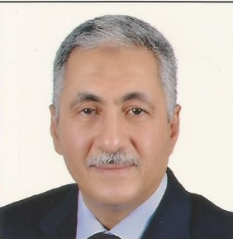
Full Name: Mohamed Ashraf Eldesouky
Contact number: 002 0123451082
E mail: ashrafdesouky@yahoo.com
Session name/ number: Medical and Clinical Microbiology
Category: (Oral presentation)
Passport Number: A08564927

