Title: Fungal orbital infections in a tertiary eye center in Egypt

Mohamed A. Eldesouky
Department of Ophthalmology, School of Medicine Tanta University, Tanta, Egypt
Keywords: Mucormycosis, Aspergillosis, Orbital apex syndrome, Fungal sinusitis.

- Abstract Body
Fungal infections of the orbit, although not as common as bacterial etiologies, still remain important causes of orbital inflammations and proptosis. The past decade has seen a resurgence of a variety of fungal agents involving orbits due to rising trends of HIV infections and other immunosuppressive comorbidities like diabetes; however the incidence may vary based on regional epidemiology. The modalities of orbital invasion can be contiguous from sinuses or oropharynx or through direct deposition from foreign bodies. Till now fungal orbital infections still deserve very poor prognosis. The present study would discuss the various microbial factors, specific symptomatology, clinical signs, investigative modalities, management, complications, and outcomes of fungal infections of the orbit.

- Image:
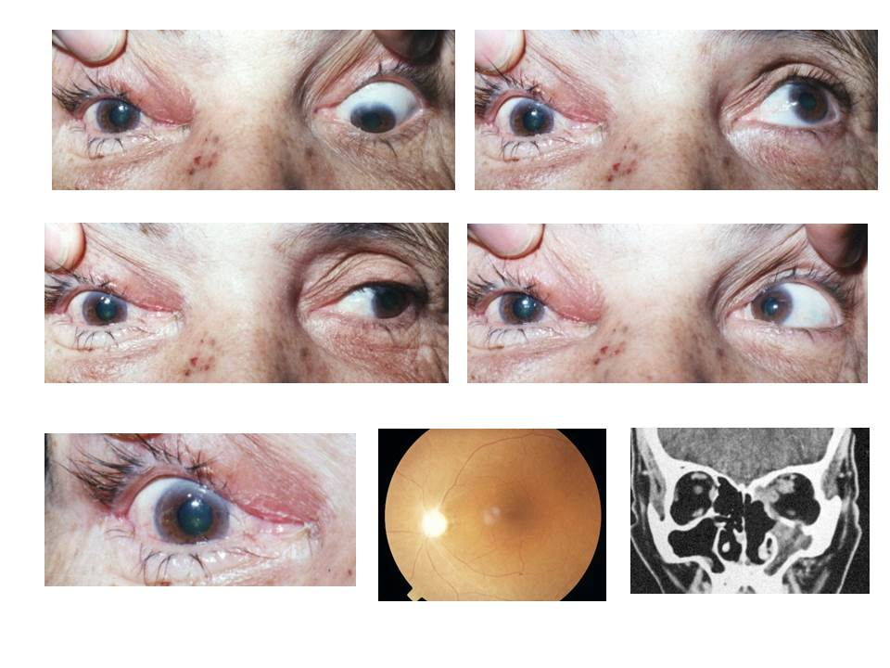

- Reference:
- Kirszrot J, Rubin PA. Invasive fungal infections of the orbit. Int Ophthalmol Clin. 2007;47:117–32.
- Johnson TE, Casiano RR, Kronish JW, Tse DT, Meldrum M, Chang W. Sino-orbital aspergillosis in acquired immunodeficiency syndrome. Arch Ophthalmol. 1999;117:57–64.
- Kauffman CA, Malani AN. Zygomycosis: an emerging fungal infection with new options for management. Curr Infect Dis Rep 2007;9(6):435-40.

Biography:
Mohamed A. Eldesouky has completed his PhD at the age of 36 years from Tanta University and Postdoctoral Studies from School of Medicine, University of Tennessee, Memphis. He is the Director of oculoplasty, and ocular pathology service in Tanta University Eye Hospital. He has published more than 25 papers in reputed journals.
- Presenting author details


Full Name: Mohamed Ashraf Eldesouky
Contact number: 002 0123451082
E mail: ashrafdesouky@yahoo.com
Session name/ number: Medical and Clinical Microbiology
Category: (Oral presentation)
Passport Number: A08564927

