Protein stability and subunit assembly of nylon hydrolase: structural basis discriminating correct subunit assembly, aggregation, and intracellular degradation of precursor protein
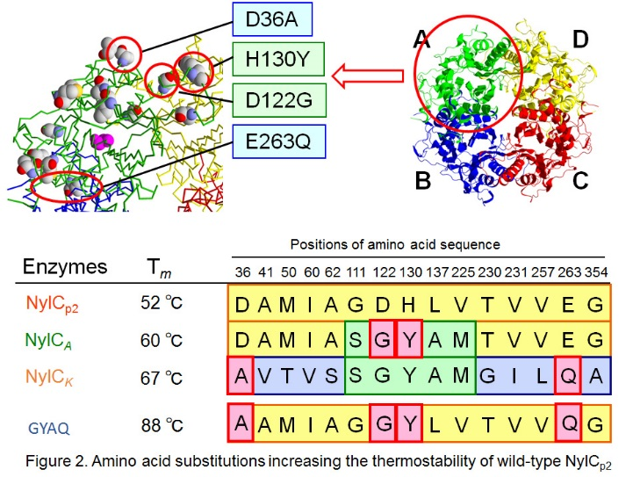
Seiji Negoro PhD, Department of Applied Chemistry, University of Hyogo, Japan

Abstract
Protein-protein interactions leading to correct subunit assembly play important roles in protein stability and/or various biological functions, which could include the following: i) regulation of enzyme activities by the allosteric effect, ii) generation of an active center by utilizing several catalytic/substrate-binding residues located in different subunits, and iii) generation of a multifunctional enzyme by integrating several functions initially compartmentalized in different enzyme subunits into a single oligomeric enzyme. In addition, the stability of a monomeric protein is generally improved by the oligomerization of the protein. Nylon hydrolase (NylC) is one of the three enzymes (NylABC) responsible for the degradation of the by-products of nylon-6 manufacture (cyclic and linear oligomers of 6-aminohexanoate (Ahx) with a degree of polymerization greater than three) and various aliphatic nylons (nylon-6, nylon-66, etc.) (Fig. 1) (1-8). NylC is initially expressed as an inactive precursor (36 kDa). However, the precursor is cleaved auto-catalytically at Asn266/Thr267 to generate an active enzyme composed of α (27 kDa) and β (9 kDa) subunits. Four αβ heterodimers (molecules A-D) form a doughnut-shaped quaternary structure (Fig. 2). In this study, the thermostability of the parental NylC was altered by amino acid substitutions located at the A/D interface (D122G/H130Y/D36A/L137A) or the A/B interface (E263Q) and spanned a range of 47 °C (5,6). From the analytical centrifugation data of the various mutant enzymes, we conclude that the assembly of the monomeric units is dynamically altered by the mutations. Considering structural, biophysical, and biochemical analyses, we discuss the structural basis of the stability of nylon hydrolase. Finally, we propose a model that can predict whether the fate of the nascent polypeptide will be correct subunit assembly, inappropriate protein-protein interactions causing aggregation, or intracellular degradation of the polypeptide.

Image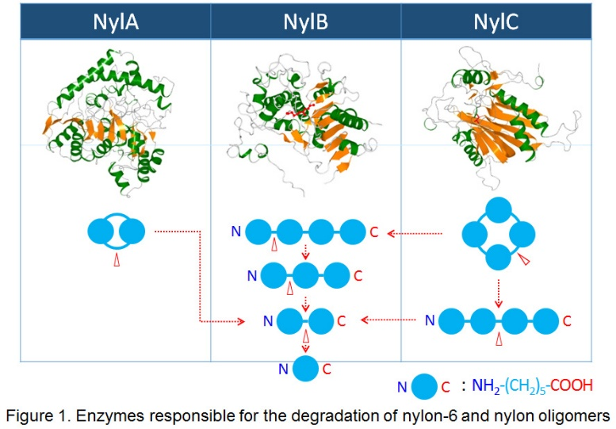

Recent Publications
1. Negoro S et al (2005) X-ray crystallographic analysis of 6-aminohexanoate-dimer hydrolase: Molecular basis for the birth of a nylon oligomer degrading enzyme. J. Biol. Chem. 280: 39644–39652.
2. Negoro S et al (2007) Nylon-oligomer degrading enzyme/substrate complex: catalytic mechanism of 6-aminohexanoate-dimer hydrolase. J. Mol. Biol. 370: 142-156.
3. Yasuhira K et al (2007) 6-Aminohexanoate oligomer hydrolases from the alkalophilic bacteria Agromyces sp. strain KY5R and Kocuria sp. Strain KY2. Appl. Environ. Microbiol. 73: 7099–7102.
4. Yasuhira K et al (2010) X-ray crystallographic analysis of the 6-aminohexanoate cyclic dimer hydrolase: catalytic mechanism and evolution of an enzyme responsible for nylon-6 byproduct degradation. J. Biol. Chem. 285: 1239–1248.
5. Negoro S et al (2012) Three-dimensional structure of nylon hydrolase and mechanism of nylon-6 hydrolysis. J. Biol. Chem., 287: 5079-5090.
6. Nagai K et al (2014) Enzymatic hydrolysis of nylons: quantification of the reaction rate of nylon hydrolase for thin-layered nylons. Appl Microbiol Biotechnol. 98: 8751-8761.
7. Negoro S et al (2016) Mutations affecting the internal equilibrium of the reaction catalyzed by 6-aminohexanoate-dimer hydrolase. FEBS Lett. 590: 3133-3143.
8. Takehara I et al (2018) Metabolic pathway of 6-aminohexanoate in the nylon oligomer-degrading bacterium Arthrobacter sp. KI72: identifi- cation of the enzymes responsible for the conversion of 6-amino-hexanoate to adipate. Appl Microbiol Biotechnol. 102: 801-81

 Biography
Current position: Professor, Department of Applied Chemistry, Graduate School of Engineering, University of Hyogo. Scientific field: Enzymology, Protein engineering, Environmental biotechnology. 1982, Graduate School of Engineering, Osaka University (PhD). 1982-1992, Research associate, Department of Biotechnology, Osaka University. 1992-1997, Associate professor, Department of Biotechnology, Osaka University. 1997- , Professor, Department of Applied Chemistry, University of Hyogo
Email: negoro@eng.u-hyogo.ac.jp

Notes/Comments:

