Talaromyces pinophilus a pioneering fungi strain as Phyto Intensification
Dhavalkumar Patel, Parul University, Gujarat, India.
Shreya Patel, St. Xavier’s College, Gujarat, India.
Sony Tekwani, St. Xavier’s College, Gujarat, India.
DK Acharya, Parul University, Gujarat, India.
Dweipayan Goswami, St. Xavier’s College, Gujarat, India.
Sudeshna Menon, St. Xavier’s College, Gujarat, India.
Sebastian Vadakan, St. Xavier’s College, Gujarat, India.

Abstract
Talaromyces pinophilus (MG011365) fungi belongs to family Trichocomaceae. The aim of current research was to explore different fungi as Plant Growth Promoting Fungi (PGPF). The study involves the isolation of different fungi from the rhizosphere of various agriculture farms. After isolation of T. pinophilus its’ ability to produce phytohormone was carried out (Indole Acetic Acid, IAA). IAA estimation was carried out using Salkowski reagent. T. pinophilus was allowed to grow in cultivation media (Potato Dextrose Broth, PDB) in which one was supplemented with tryptophan (TRP) and one without TRP (TRP a precursor for IAA production). Phosphate solubilization was carried out by growing T. pinophilus in pikovskaya’s media and latter estimated using stannous chloride method, showing decent solubilization of phosphate. Further enzyme assay for cellulase and chitinase were carried out. For cellulase enzyme production 1% carboxymethylcellulose (CMC) and for chitin enzyme production 1% colloidal chitin was used along with 1X MM9 agar media. Statistical analysis was carried out with Trichoderma longibrachiatum (MG011366) which is one of the most explored PGPF strain. Talaromyces pinophilus showed predominant effect as compared to Trichoderma longibrachiatum.

Image
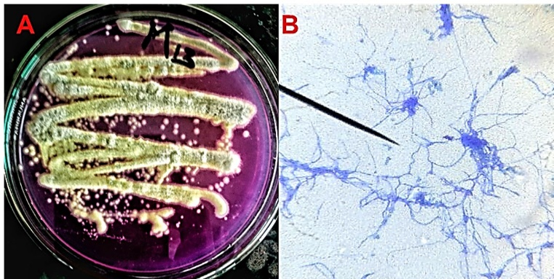
Figure 1 (A) Shows morphology of Talaromyces pinophilus growing on RBCA (B) Microscopic image of Talaromyces pinophilus.
Recent Publications (minimum 5)
- Patel Dhavalkumar, Arya Arun & Patel Vishal (2017). ‘Application of two soil Fungi as Phosphate Solubilizing agent and Assessing their Performance for better growth of Maize’. In International Science Symposium on Recent Trends in Science and Technology (8) pp 479-488.
- Springer Publication as Conference Proceeding paper at BIOSPECTRUM August’ 2017. ‘Profiling Indolic Auxins produced by the strains of Aspergillus using novel HPTLC technique’ (Communicated).
- Chapter in Book= Three
- Eccentricity in the behavior of Pencillium spp. as phytopathogen and phytoaugmentor Book series: Environmental Science Published by Eurasian Academic of Environmental Sciences (www.eaesci.org.in)
- Trichoderma species as foe and friend of plant. Book: Plant Growth Promoting Microorganism – Microbial Resources for Enhanced Agricultural Productivity Nova Science Publisher, Inc. USA
- Integrated disease management: an upgrade to the use of biofertilizers. Book: Plant Growth Promoting Microorganism – Microbial Resources for Enhanced Agricultural Productivity Nova Science Publisher, Inc. USA



Biography
Dhaval Patel has his expertise in plant fungi interaction in improving the health of agricultural soil. He deals with the biocontrol and phyto-enhancer activities of fungi and also has expertise in studies relating to phytohormones production, phosphate solubilization, ammonia production, siderophore formation, and also deals with cellulase and chitinase enzyme for biocontrol activity.
Email: dhaval8294patel@gmail.com

