Title: Numerical analysis of the adhesive interaction of bacterium and glass surface

Raimondas Jasevičius^{1, 2},
¹Institute of Mechanical Science, Vilnius Gediminas Technical University, Vilnius, Lithuania
²Department of Mechatronics, Robotics and Digital Fabrication, Vilnius Gediminas Technical University, Vilnius, Lithuania

Keywords: S. aureus bacterium, adhesion, mechanics, Interaction, Numerical modelling, Discrete element method

I. Abstract

Understanding of influence of bacterial adhesion opens a new possibility to analyze the bacterial mutual interaction as well as the interaction of bacterium with various surfaces. Contrary to their lower inertia, bacteria have the ability to stick to surfaces due to adhesive forces. This characteristic opens up the opportunity to understand adhesive ultrafine particles by numerical modelling the sticking ability. The interaction of adhesive spherical S. aureus under impact is investigated numerically by applying the discrete element method. An adhesive dissipative contact model is applied by implementing different interaction forces, such as the influence of electrostatic double layer force. Normal loading is represented by taking into account the elastic Hertz contact model as well as elastic-plastic Tomas model. Viscous damping is described by the modified nonlinear Tsuji model. Energy dissipation model related to change of influence of adhesion is given. This model is important to predict critical bacterial sticking velocity. The influence of deformation dependent adhesion forces for a bacterium is also illustrated during the deformation process. Elastic-plastic bacterium interaction model is given. This model is important to describe non-elastic deformation behavior of heterogeneous cell. The presented model also includes the ability to obtain sticking process for bacteria. Such model can be adapted for modelling of group of microorganism mutual interaction, such as biofilm formation or infection transmission. Dissipative interaction is described during bacterium interaction with a surface at a distance as well as during the deformation process.

II. Images:

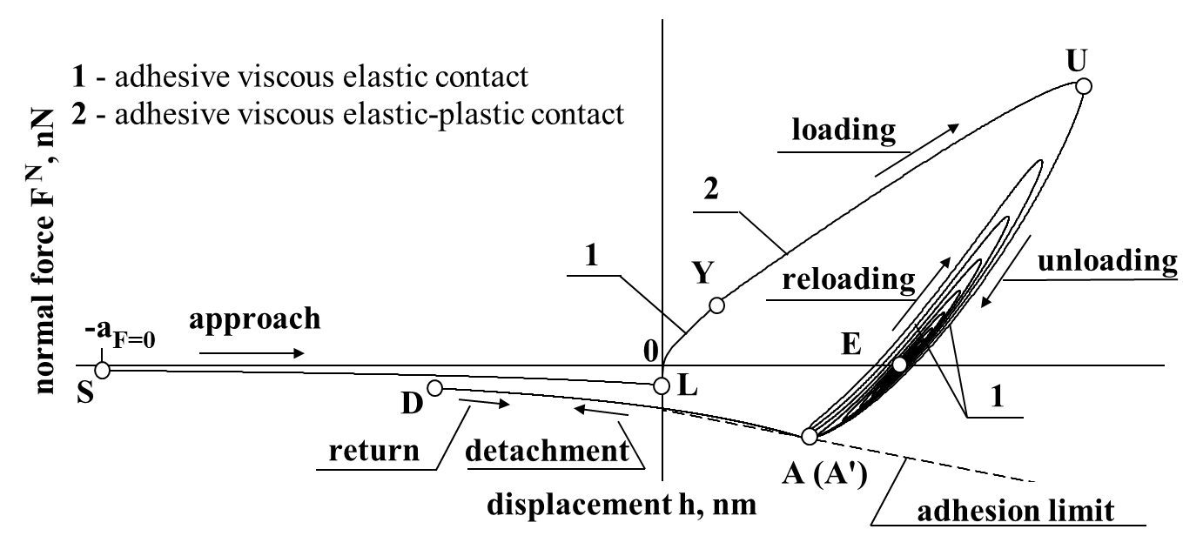
Figure 1: Sticking process of a bacterium. Adhesive viscous elastic-plastic interaction model applied. Considered, that the attractive zone is equal to the distance a_{F=0} = 20 nm, while the bacterium diameter d = 1μm.

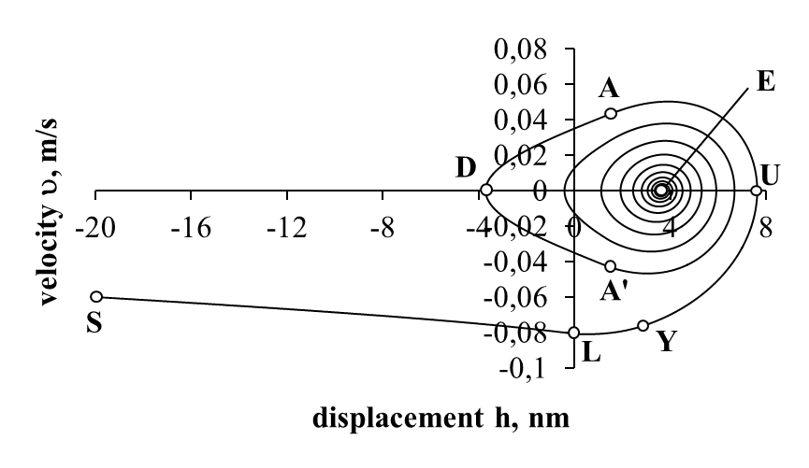
Figure 2: S. aureus bacterium sticking process on a glass surface. Velocity versus displacement.
III. References:
- Jasevičius, R. and H. Kruggel-Emden, 2017. Numerical modelling of the sticking process of a S. aureus bacterium. Int. J. of Adhesion and Adhesives, 77: 15–28.
- Jasevičius, R., H. Kruggel-Emden, P. Baltrėnas, 2017. Numerical simulation of the sticking process of glass-microparticles to a flat wall to represent pollutant-particle treatment in a multi-channel cyclone. Particuol., 32: 1–20.
- Jasevičius, R., R. Baronas, H. Kruggel-Emden, 2015. Numerical modelling of the normal adhesive elastic–plastic interaction of a bacterium. Adv. powder tech., 26: 742–752.
IV. Biography:
Raimondas Jasevičius has completed his PhD in 2011 from Vilnius Gediminas Technical University (VGTU) and win postdoctoral studies from Vilnius University in 2013-2015. Also win DAAD internship at Otto von Guericke University in 2007. Currently, he is the Senior researcher at VGTU. He has built bacterium interaction models for numerical simulations. The models are able to describe the bacterium interaction process. He published more than 18 papers in reputed journals.
V. Presenting author details


Full name: Raimondas Jasevičius
E-mail: raimondas.jasevicius@vgtu.lt
Contact number:
Session name:
Category: (Oral/Poster presentation)

World Congress on Applied Microbiology
Meetings International

