Isolation and characterization of a bacteriophage that hosts on Avian-pathogenic Escherichia coli (APEC)
Murad Ishnaiwer^{2*}, MSc, Palestine Polytechnic University, Palestine
Fawzi Alrazem³. PHD. Palestine Polytechnic University, Palestine
Haya Fakhouri¹, Orjowan Juneidi¹, Hanaa Mohtaseb¹, BSc. Palestine Polytechnic University, Palestine

Abstract (300 word limit)

Infectious Colibacillosis disease caused by Avian-pathogenic Escherichia coli (APEC) commonly threatens poultry flocks worldwide. It limits productivity and causes severe economic losses to poultry sector.

In addition, the emergence of multidrug resistance among APEC is an increasing concern since these resistant bacteria can infect humans and develop mechanisms that enable them to resist the commonly used antibiotics. The use of phages in treating pathogenic bacteria is considered a possible alternative to the conventional use of antibiotics. This study describes the isolation and characterization of a bacteriophage with broad lytic spectra against the APEC E. coli. It was isolated using soft agar overlay method and through monitoring the formation of clear zones on a lawn culture of APEC host bacterium. The isolated phage apparently has a small genome size and with small number of multiple copies of same proteins as revealed by SDS-PAGE. The quantification of infectious viruses in bacterial suspension was further determined through a one-step growth curve analysis using double layer test. It revealed a latent period of about 24 h, burst period of 70 h and a burst size of about 24×103 plaque forming units (PFU) per plaque. The host range of the bacteriophage was determined by performing spot tests with four APEC bacterial strains. The phage was capable of lysing all tested strains, an indicative of wide host range for this isolated bacteriophage. We conclude that bacteriophages can be used to eliminate or reduce the scope of APEC infection in poultry and possibly used as an alternative to antibiotics.

Image

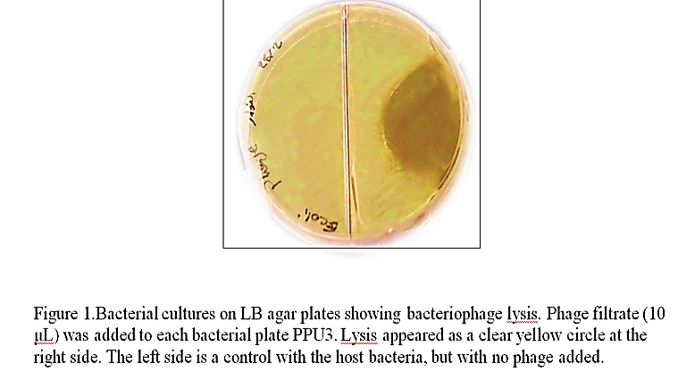

Recent Publications (minimum 5)
- Ishnaiwer, M and Al-Razem,F 2013. Isolation and Characterization of Bacteriophages from Laban Jameed. Food and Nutrition Sciences, Vol: 4, No (11): 56-66.

Biography (150 word limit)
Murad Ishnaiwer has quiet good experience in isolation and characterization of bacteriophages, his master thesis was rely on isolation of two new bacteriophages host on Bacillus amyloliquefaciens and Lactobacillus helveticus, these bacteriophages model are extremely being used as potential source in treating pathogenic bacteria as a possible alternative to the conventional use of antibiotics..
Email: mishnaiwer@ppu.edu

Notes/Comments:

