Thermomechanical Processes and Lattice Reactions in Memory Behavior of Shape Memory Alloys

Osman Adiguzel

University of Firat, Department of Physics, 23169 Elazig, Turkey

Keywords: Shape memory effect, martensitic transformation, lattice twinning and detwinning.
I. Abstract
A series of alloy systems take place in a class of adaptive structural materials called intelligent materials by giving stimulus response to changes in the external conditions. Shape memory alloys take place in this group by exhibiting a peculiar property called shape memory effect, which is characterized by the recoverability of two certain shapes at different temperatures. These alloys are cooled deformed plastically and recover the original shape after these processes, and cycle between the deformed and original shapes on cooling and heating, respectively. The strain energy is stored with plastic deformation, and released on heating, by means of reverse austenite transformation. These alloys are used as functional materials in many fields from biomedical to the aeronautical industry. In particular, they are used as deformation absorbent materials in control of civil structures subjected to seismic events. Shape memory effect is initiated by successive cooling and deformation processes and performed thermally by heating and cooling, shape of materials cycle between original and deformed shapes in bulk level, whereas the crystal structure cycles between the twinned and ordered parent phase structures, by means of forward martensitic and reverse austenitic transformations. This behaviour is called thermoelasticity. Shape memory effect is governed by two crystallographic transformations, thermal and stress induced martensitic transformations. Thermal induced transformation occurs along with lattice twinning on cooling and ordered parent phase structures turn into twinned martensite structures. Twinned martensite structures turn into detwinned martensite structures by means of stress induced transformation by deforming plastically in martensitic condition. Thermal induced martensitic transformation is lattice-distorting phase transformation and occurs as martensite variants with the cooperative movement of atoms in <110>-type directions on {110}-type planes of austenite matrix by means of shear-like mechanism. Martensitic transformations occur by two or more lattice invariant shears on {110}-type planes of austenite matrix which is basal plane or stacking plane for martensite. In the martensitic transformation, the lattice of high temperature austenite phase has greater crystallographic symmetry than that of the low-temperature product phase.
Copper based alloys exhibit this property in metastable β-phase region, which has bcc-based structures at high temperature parent phase field. Lattice invariant shears are not uniform in copper based shape memory alloys, and the ordered parent phase structures martensitically undergo the non-conventional complex layered structures on cooling. The long-period layered structures can be described by different unit cells as 3R, 9R or 18R depending on the stacking sequences on the close-packed planes of the ordered lattice. The unit cell and periodicity is completed through 18 layers in direction z, in case of 18R martensite, and unit cells are not periodic in short range in direction z. In the present contribution, x-ray diffraction and transmission electron microscope studies were carried out on two copper based CuZnAl and CuAlMn alloys. These alloy samples have been heat treated for homogenization in the β-phase fields. X-ray diffraction profiles and electron diffraction patterns reveal that both alloys exhibit super lattice reflections inherited from parent phase due to the displacive character of martensitic transformation. X-ray diffractograms taken in a long time interval show that diffraction angles and intensities of diffraction peaks change with the aging time at room temperature. In particular, some of the successive peak pairs providing a special relation between Miller indices come close each other, and this result refers to the rearrangement of atoms in diffusive manner.
II. References
- Adiguzel O., Phase Transitions and Microstructural Processes in Shape Memory Alloys, Materials Science Forum 2013; 762, 483-486, Trans Tech Publications, Switzerland
- Li Z. Gang S, Wang M.P., Macroscopic Shape Change of Cu13Zn15Al Shape Memory Alloy on Successive Heating, Journal of Alloys and Compounds 2008, 452, 307-311.
- De Castro F., Sade M., Lovey F., Improvements in the Mechanical Properties of the 18R ↔ 6R High-hysteresis Martensitic Transformation by Nanoprecipitates in CuZnAl Alloys, Materials Science and Engineering A 2012, 543, 88-95.

III. Biography
Dr Adiguzel graduated from Department of Physics, Ankara University, Turkey in 1974 and received PhD- degree from Dicle University, Diyarbakir-Turkey. He has studied at Surrey University, Guildford, UK, as a post doctoral research scientist in 1986-1987, and studied on shape memory alloys. He worked as research assistant, 1975-80, at Dicle University and shifted to Firat University, Elazig, Turkey in 1980. He became professor in 1996, and he has already been working as professor. He published over 60 papers in international and national journals; He joined over 120 conferences and symposia in international and national level as participant, invited speaker or keynote speaker with contributions of oral or poster. He served the program chair or conference chair/co-chair in some of these activities. In particular, he joined in last seven years (2014 - 2020) over 70 conferences as Keynote Speaker and Conference Co-Chair organized by different companies. He supervised 5 PhD- theses and 3 M.Sc- theses. Dr. Adiguzel served his directorate of Graduate School of Natural and Applied Sciences, Firat University, in 1999-2004.
He received a certificate awarded to him and his experimental group in recognition of significant contribution of 2 patterns to the Powder Diffraction File – Release 2000. The ICDD (International Centre for Diffraction Data) also appreciates cooperation of his group and interest in Powder Diffraction File.
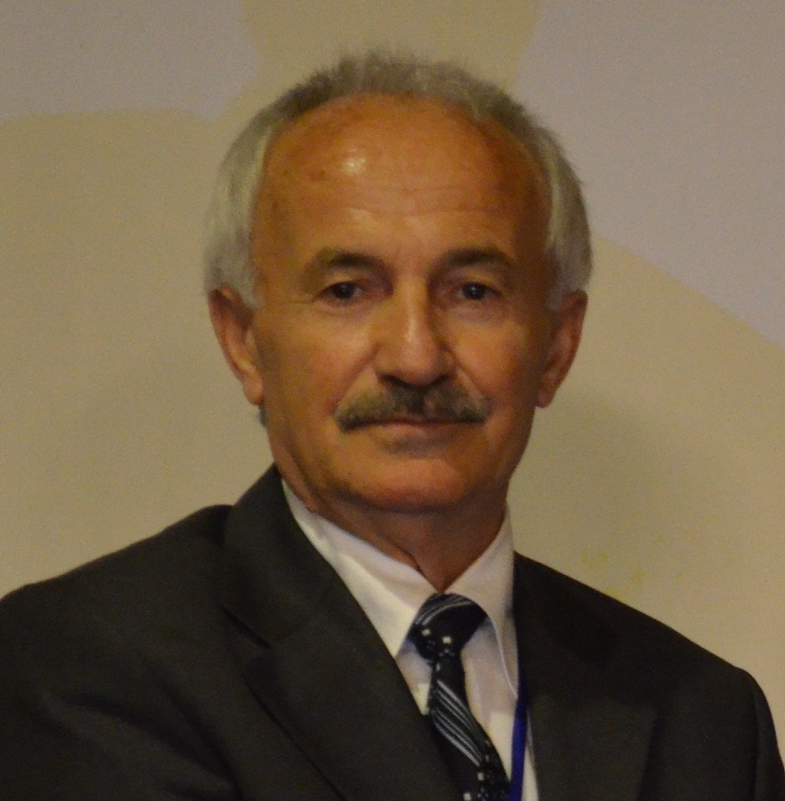
Full Name: Osman Adiguzel
Contact Number: +90 536 5638403
Twitter Account: -
Linked In Account: -
Session name/number:
Advanced Materials/6
Category: Oral presentation
Passport Number: S02514240
Email: oadiguzel@firat.edu.tr
oadiguzel@hotmail.com

