Ultraviolet Laser Lithography of Photonic Crystals with Micro Dielectric Lattices for Terahertz Wave Control in 5G Engineering

Soshu Kirihara
Joining and Welding Research Institute, Osaka University, Japan

Keywords: Stereolithography, Additive Manufacturing, Dielectric Material, Micro Patterning, Laser Processing

Abstract
In stereolithographic additive manufacturing, two dimensional cross sections are created through photo polymerization by UV laser drawing on spread resin paste including ceramic nanoparticles, and three-dimensional composite models are sterically printed by layer lamination. An automatic collimeter was equipped with the laser scanner to adjust beam diameter. Fine or coarse beams could realize high resolution or wide area drawings, respectively. As the row material, nanometer sized ceramic particles were dispersed in to photo sensitive liquid resins at 50 % in volume fraction. These materials were mixed and deformed to obtained thixotropic slurry for 15 min at 700 and 300 rpm of rotation and revolution speeds, respectively. The resin paste was spread on a glass substrate at 100 μm in layer thickness by a mechanically moved knife edge. An ultraviolet laser beam of 355 nm in wavelength was adjusted at 50 μm in variable diameter and scanned on the spread resin surface. Irradiation power was increased at 1 W for resin dewaxing and powder sintering through heating by ultraviolet ray propagations, resonations and absorptions in the paste materials. In this investigation, micro lattice patterns composed of titania were fabricated to modullate electromagnetic waves in terahertz frequency range. The components especially called photonic crystals as artificial materials to exhibit bandgaps in transmission spectra through wave diffractions in electromagnetic fields.

Biography:
Soshu Kirihara is a doctor of engineering and a professor of Joining and Welding Research Institute (JWRI), Osaka University, Japan. In his main investigation “Materials Tectonics” for environmental improvements of “Geotechnology”, multi-dimensional structures were successfully fabricated to modulate energy and materials flows effectively. Ceramic and metal components were fabricated directly by smart additive manufacturing, design and evaluation (Smart MADE) using high power ultraviolet laser lithography. Original stereolithography systems were developed, and new start-up company “SK-Fine” was established through academic-industrial collaboration.

Presenting author details

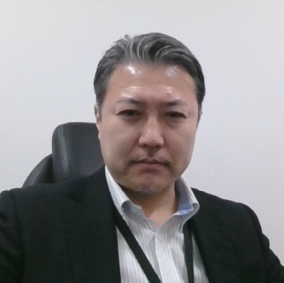
Full Name: Soshu Kirihara
Category: Plenary Talk

