Antimicrobial properties of wood material: opportunities and challenges for hygienically sensitive places
Muhammad Tanveer Munir, DVM, MS, Ecole Superieur du Bois, Nantes, France

Abstract
Problem: Wood is an ecofriendly material that is traditionally used in hygienically sensitive places in the food industry and the healthcare buildings. However, the porous and organic nature of this material is questioned with a fear of supporting microbial growth and harming the human and animal health. Therefore the aim of our investigation was to study the antimicrobial properties of solid wood material.
Methodology & Theoretical Orientation: We tested the antimicrobial properties of solid wood material by a direct diffusion method (antiboisgram, ‘bois’ in French means ‘wood’). Different variables of wood sterilization, species, tree, cutting methods were tested.
Findings: It was observed that the antimicrobial properties of wood were influenced by tested variables. Mainly, the autoclaving reduced the antimicrobial activity of solid wood material. The antimicrobial resistance status of bacterial strains and origin of tree did not affect the microbial susceptibility to the tested material.
Conclusion & Significance: Solid wood has antimicrobial properties which could counter the growth of many bacteria responsible for foodborne and healthcare associated infections. This investigation provided the bases for future studies for safely using wood material in hygienically sensitive places.
As the wood material is used in various sectors, a cross disciplinary research (OneHealth) could provide a win-win solution as presented in the image.



Image
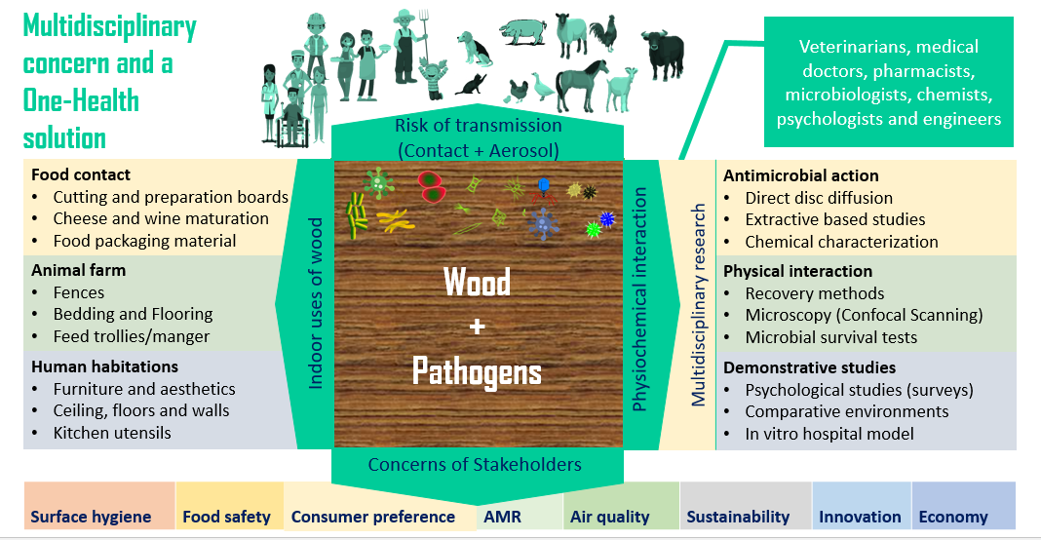
Recent Publications
- Munir et al. (2020) Wood materials for limiting the bacterial reservoir on surfaces in hospitals: would it be worthwhile to go further? Future Microbiology ; doi.org/10.2217/fmb-2019-0339
- Munir et al. (2020) Experimental Parameters Influence the Observed Antimicrobial Response of Oak Wood (Quercus petraea). Antibiotics 9(9): 535; https://doi.org/10.3390/antibiotics9090535
- Chen J-C et al. (2020) Survival of bacterial strains on wood (Quercus petraea) and other materials. Antibiotics 9(11) 804.
- Munir et al. (2019) Direct screening method to test antimicrobial properties of untreated wood. European Journal of Wood and Wood Products 77(2): 319-322.
- Munir et al. (2019) Antimicrobial Characteristics of Untreated Wood: Towards a Hygienic Environment. Health 11(2): 152-170.

Muhammad Tanveer Munir has expertise in the indoor hospital hygiene. He is interested in application of OneHealth approach to tackle the antimicrobial resistance in the healthcare settings. His recent discoveries of variables influencing the antimicrobial properties of wood material against multiple nosocomial infection are multidisciplinary investigations realized by the collaboration of veterinarians, microbiologists, engineers and medical doctors.
Email: mtmunir@outlook.fr

Notes/Comments: The results presented here are already published.

