Characterize the outer membrane vesicles of Elizabethkingia anophelis under the stress of antibiotics
Fang-Ju Chang, MS, Department of Biology and Anatomy, NDMC, Taiwan
Ya-Sung Yang, MD, Department of Internal Medicine, TSGH, Taiwan
Shu-Wei Huang, PhD, Institute of Preventive Medicine, NDMC, Taiwan
Te-Li Chen, MD PhD, Graduate Institute of Life Sciences, NDMC, Taiwan
Ming-Hsien Chiang, PhD, MS, Department of Biology and Anatomy, NDMC, Taiwan

Abstract
Antimicrobial-resistant (AMR) bacterial infections, including those caused by Elizabethkingia anophelis (EA), have emerged as a clinical crisis worldwide. With the increased reports of outbreak and its extensive-antibiotic resistant isolates, the treatment of diseases is challenging. Outer membrane vesicles (OMVs) are purposely secreted by Gram-negative bacteria and contain materials derived from their parent bacterium. OMVs specialize and tailor their functions by carrying different components to challenging environments and communicate with other microorganisms or hosts.
In this study, we sought to understand the characteristics of EA OMVs under different antibiotics stress. The two clinical isolated strains against seven commonly used antibiotics (Amikacin, Ampicillin, Polymyxin B, Colistin, Chloramphenicol, Minocycline, Meropenem and Imipenem) were analyzed. The growth culture medium was centrifuged and filtered. OMVs were recovered by ultracentrifugation and quantified the protein concentration, particle size, and concentration per CFU of OMVs. Disk diffusion assay was evaluated whether OMVs packaged anti-antibiotic substances.
The results indicated that Imipenem and Chloramphenicol would lead to more OMVs production with about 110-145 nm particle size. Its OMVs seem not contain the anti-antibiotic substance compared to bacteria lysate. This study offers important insights for understanding the characteristics of EA OMVs and worth to further investigation.

Image
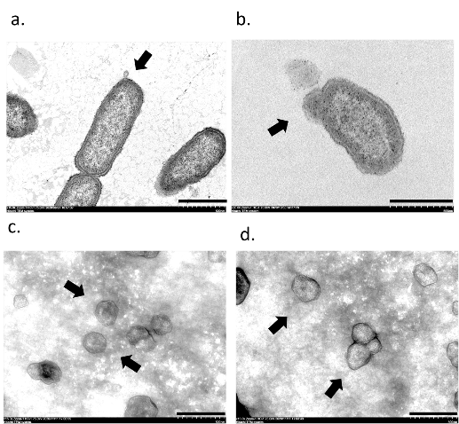
Figure. Transmission electron micrograph of EA.
(a)(b) OMVs released by EA after imipenem treatment. (arrows)
(c)(d) The nanomorphology EA OMVs. (arrows)
(scale bar: 500 nm)

Recent Publications
- Ruei-Chang Huang, Tsung-Ta Chiang, Ming-Hsien Chiang, Ya-Sung Yang. First case report of persistent Streptococcus mitis bacteremia caused by prosthesis-induced esophageal rupture. (2021). J Formos Med Assoc, 120(5):1274-1275.
- Shu-Wei Huang, Ming-Tsung Sun, Wen-Sen Lee, Ying-shih Su, Yi-Tzu Lee, Ming-Hsien Chiang, Yung-Chih Wang, Ya-Sung Yang, Shian-Chiuan Tzeng, Tien-Yuan Wu, Jui-Sheng Sun, Feng-Huei Lin. (2021). Cancer as an Infectious Disease: A Different Treatment Alternative Using a Combination of Tigecycline and Pyrvinium Pamoate. Journal of Microbiology, Immunology and Infection, 13;S1684-1182(21)00006-2.
- Yung-Chih Wang, Shu-Wei Huang, MH Chiang, I-Ming Lee, Shu-Chen Kuo, Ya-Sung Yang, Chun-Hsiang Chiu, Ying-Shih Su, Te-Li Chen, Fu-Der Wang, Yi-Tzu Lee (2020). In vitro and in vivo activities of imipenem combined with BLI-489 against class D b-lactamase-producing Acinetobacter baumannii. Journal of Antimicrobial Chemotherapy, 76(2), 451-‌459.
- MH Chiang, Ya-Sung Yang, Jun-Ren Sun, Yung-Chih Wang, Shu-Chen Kuo, Yi-Tzu Lee, Yi-Ping Chuang, and Te-Li Chen. (2020). Confronting Tigecycline-Resistant Acinetobacter baumannii via Immunization Against Conserved Resistance Determinants. Frontiers in Microbiology,11(536).

 Biography
Ming-Hsien Chiang has his expertise in evaluation and passion in improving the nanoparticle and vaccinology. Our research focused on the identification of vaccine candidates against antimicrobial-resistant bacteria via bioinformatic tools and study the host-pathogen interaction in animal models.
Email: ph870101@mail.ndmctsgh.edu

