Molecular Epidemiology of Carbapenem-Resistant Acinetobacter baumannii from Khartoum State, Sudan

Leena Al-Hassan PhD, UK, Hana Elbadawi,PhD, Sudan Einas Osman PhD, Sudan, Sara Ali PhD, Sudan, Kamal Elhag Prof, MD, FRSpath, Sudan, Daire Cantillon PhD,UK, Julia Wille Germany, Harald Seifert,Prof, Germany,Paul G. Higgin PhD, Germany.

Abstract

Carbapenem resistant Acinetobacter baumannii (CRAb) is an important global pathogen contributing to increased morbidity and mortality in hospitalized patients, due to limited alternative treatment options. Nine international clonal (IC) lineages have been identified in many countries worldwide, however data still lacks from some parts of the world, particularly in Africa. We hereby present the molecular epidemiology of MDR A. baumannii from four hospitals in Khartoum, Sudan, collected from 2017-2018. Forty-two isolates were whole-genome sequenced, and subsequent molecular epidemiology was determined by core genome MLST (cgMLST), and their resistomes identified. All isolates had an array of diverse antibiotic resistance mechanisms conferring resistance to multiple classes of antibiotics. We found a predominance (88%) of IC2 (with the intrinsic OXA-66 and acquired OXA-23), and some with NDM-1. IC2 isolates were sub-divided into 4 STs separated by 5 to 431 allelic differences, and with evidence of seven transmission clusters. Isolates belonging to IC1, IC5 and IC9 were also identified. These data illustrate that MDR IC2 A. baumannii are widely distributed in Khartoum hospitals and are in possession of multiple antibiotic resistance determinants.


Image
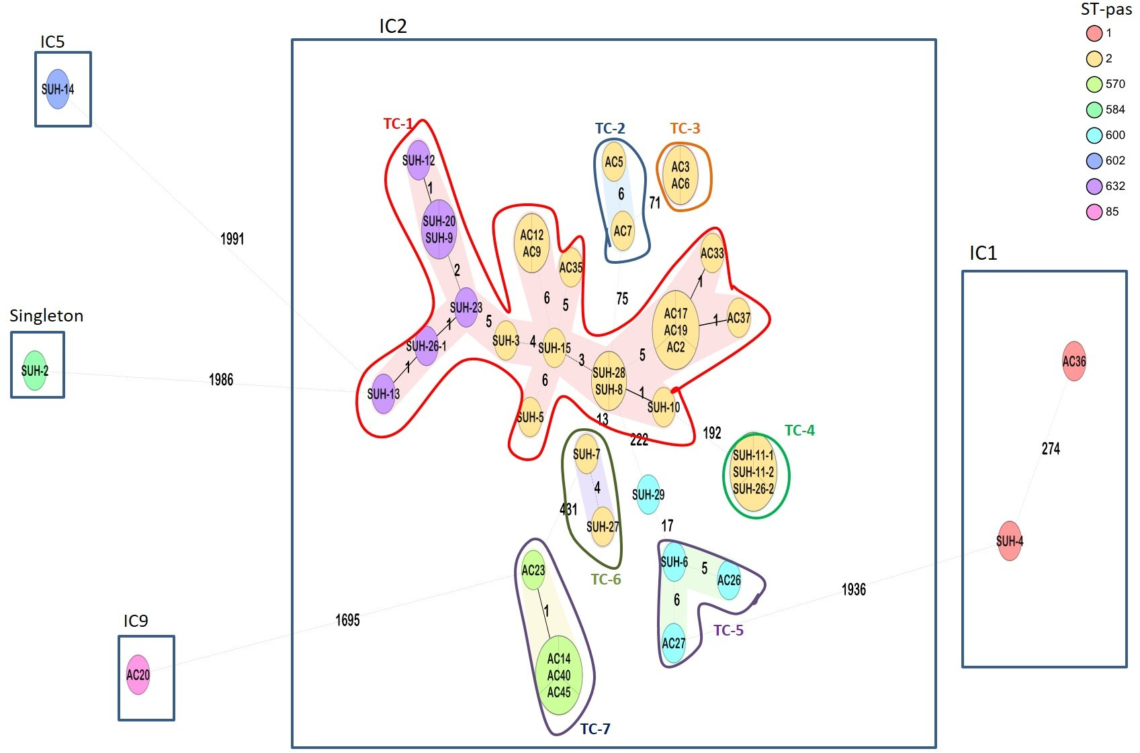

Figure 1: Ridom SeqSphere+ minimum spanning tree (MST) for 42 samples based on 2390 alleles. Isolates grouped by colour indicating the different STs (Pasteur scheme). Eight different STs were identified, belonging to IC1, IC2, IC5, IC9 and a singleton. Numbers between the nodes indicate the number of allelic differences. Shaded nodes represent transmission clusters (TC), and are numbered TC1-7.

Recent Publications
- Use of immunoblotting in testing Madurella mycetomatis specific antigen. Trans R Soc Trop Med Hyg. 2016 May;110 (5):312-6
- Inducible clindamycin resistance and nasal carriage rates of Staphylococcus aureus among healthcare workers and community members, African Health Sciences 09/2015; 15(3):861-7
- Antimicrobial resistance surveillance among gram-negative bacterial isolates from patients in hospitals in Khartoum State, Sudan *version 1; referees: awaiting peer review+ f1000Research. 05 Feb 2019, 8:156
- Use of 16s rRNA to identify non-lactose-fermenting bacilli and molecular detection of ESBL resistance genes associated with hospital-acquired infection in Soba University Hospital, Sudan. F1000Research 2020, 9:1311

Biography
Hana Elbadawi, posdocrol research fellow at IEND, University of Khartoum, her research interest on antimicrobial resistance, bacterial genomics and infection prevention control. She has experience on studying phenotypic and genotypic characterization of resistance mechanisms and molecular epidemiology of Gram negative bacteria, a strong research and scientific background with ten years’ experience working in research and lab setting.
Email: hanasalah200@gmail.com

Notes/Comments:

