Abstract

Title: Tridecaptins: An undershadowed class of antibiotics to combat colistin- and multidrug-resistant Enterobacteriaceae

Manoj Jangra¹, Vrushali Raka, Hemraj Nandanwar^{1#},
¹Clinical Microbiology and Bioactive Screening Laboratory, CSIR-Institute of Microbial Technology, Sector 39A, Chandigarh-160036, India
#Presenting author in Webinar

Keywords: Antibiotic-resistance, tridecaptin M, colistin-resistance, Enterobacteriaceae, natural products, antimicrobial peptides

- Abstract Body
The emergence of extremely drug-resistant and pan drug-resistant strains of Enterobacteriaceae worldwide demands the immediate discovery and development of new antibiotics. The present study discusses the antimicrobial potential of tridecaptin M, a new member of this old family of antibiotics, isolated from a mud bacterium Paenibacillus sp. M-152. Tridecaptin M displayed strong antibacterial activity (MICs of 2 to 8 µg/ml) against clinical strains of Klebsiella pneumoniae (which were resistant to colistin, carbapenems, third- and fourth-generation cephalosporins, fluoroquinolones, fosfomycin, and other antibiotics) and mcr-1-positive Escherichia coli strains. The compound exhibited negligible acquired resistance, low in vitro cytotoxicity and hemolytic activity, and no significant acute toxicity in mice. It also showed promising efficacy in a thigh infection model of colistin-resistant K. pneumoniae. The in vitro kinetic studies revealed that tridecaptin M at a concentration of 16 µg/ml eradicated the bacteria completely in high cell-density culture. This class of antibiotics possesses a distinct mechanism of action than polymyxin or other antibiotics in the market; hence the chances of cross-resistance are negligible. Altogether, the study demonstrated that tridecaptins are an excellent drug candidate against drug-resistant bacteria. Further studies on safety assessment and PK/PD analysis are required. The study also explains how microbial metabolites could provide a solution to tackle the antibiotic-resistance in superbugs.

- Image:

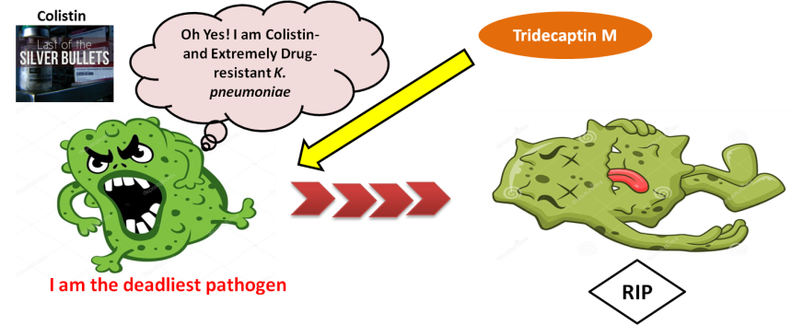

- Reference:
- Jangra, Manoj, et al. "Tridecaptin M, a new variant discovered in mud bacterium, shows activity against colistin-and extremely drug-resistant Enterobacteriaceae." Antimicrobial agents and chemotherapy 63.6 (2019): e00338-19
- Jangra, Manoj, et al. "Purification and biological activity of natural variants synthesized by tridecaptin M gene cluster and in vitro drug-kinetics of this antibiotic class." Scientific reports 9.1 (2019): 1-10.
- Biography:
Dr. Nandanwar has completed his PhD in 2008 from Panjab University, Chandigarh (India) and continued his research in antibiotic discovery from bio-diversity. He is actively working on management of antibacterial resistance through alternative approach as well as discovering new antibiotics. He is the Senior Principal Scientist, at a premier Indian institute, CSIR-Institute of Microbial Technology, Chandigarh.. He has published more than 25 papers in reputed journals and also filed patent applications for translation of technology.

- Presenting author details


Full Name: Dr. Hemraj Nandanwar
Contact number: +91-9417871474
Twitter account: https://twitter.com/drhemraj1?lang=en
Linked In account: https://www.linkedin.com/in/dr-hemraj-nandanwar-bb30ba21/?originalSubdomain=in
Email: hemraj@imtech.res.in
Session name/ number:
Category: (Oral presentation): as a Speaker
Passport Number:H4404427

