Detection of a novel mutation G511T in the 530 loop in 16S rRNA in multi drugs resistant Mycobacterium tuberculosis isolated from Sudanese patients

Yousif Mohammed Alfatih ^{1,} Abeer Babiker Idris^{2,} Mohamed Ahmed Salih³
¹ Department of Microbiology, Faculty of medical laboratory Science, Sudan international University, Khartoum-Sudan
²Department of Medical Microbiology, Faculty of Medical Laboratory Sciences, University of Khartoum, Khartoum-Sudan
³Department of Bioinformatics, Africa city of technology, Khartoum-Sudan

Keywords: Tuberculosis (TB), Multidrug-resistant TB (MDR-TB), 16S rRNA, in silico tools.

Abstract
Background:
Tuberculosis (TB) is a bacterial disease considered as a global public health emergency by the World Health Organization (WHO) since 1993. In Sudan, MDR-TB represents a growing threat and one of the most important challenges that faced national tuberculosis program to establish a comprehensive multidrug-resistant tuberculosis management system.
Objective:
To characterize the diversity and frequency of mutations in Sudanese MDR-TB strains isolated from Wad Madani, Al-Gadarif and Khartoum using 16S rRNA and phylogeny approach.
Material and Methods:
A descriptive cross-sectional study was carry on total of 60 MDR-TB isolates from Wad-Madani, Al-Gadarif and Khartoum were tested with molecular LPA (Genotype MTBDR plus) and GeneXpert MTB/RIF assay and Spoligotyping to confirm their resistance to RIF and INH. Sequencing and phylogenetic analysis was carried out using in silico tools.
Result:
This study revealed the circulation of different Sudanese MDR-TB strains isolated from Wad Madani and Al-Gadarif belonging to two distinct common ancestors. Two isolates from Wad Madani (isolate3 and isolate11) found in one main group which characterized by a novel mutation G511T in the 530 loop.
Conclusion:
The recurrence of C217A mutation in Al-Gadarif (isolate11) indicates the spread of this mutation in Sudanese MDR-TB strains and the diversity of this inheritance leading to generate new G511T novel mutation. So, understanding the molecular characterization of resistance mechanisms in MD-TB can facilitate the early detection of resistance, the choice of appropriate treatment and ultimately the management of MD-TB transmission. Bioinformatics approaches provide helpful tools for analyzing molecular mechanisms of resistance in pathogens.

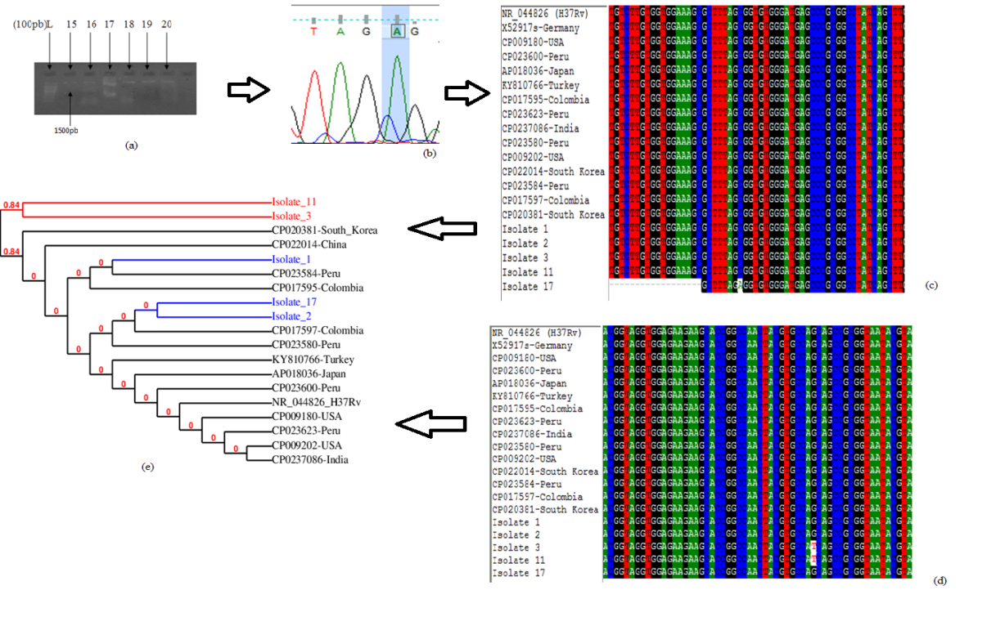

Reference:
- Sabeel SM, Salih MA, Ali M, El-Zaki SE, Abuzeid N, Elgadi ZA, et al. Phenotypic and Genotypic Analysis of Multidrug-Resistant Mycobacterium tuberculosis Isolates from Sudanese Patients. Tuberc Res Treat. 2017;2017:8340746.
- WH.; O. Global tuberculosis report Geneva, Switzerland WHO Report]. Available from: http://wwwwhoint/tb/publications/global_report/en/2017 .
- Muataz M. Eldirdery IEA, Mona OA. Awad ElkareIm. Genotyping of Pulmonary Mycobacterium tuberculosis Isolates from Sudan Using Spoligotyping. American Journal of Microbiological Research. 2015;3(4):125-8.

Biography:
1-Yousif Mohammed Alfatih has completed his Bsc from University of science and Technology, Khartoum-Sudan, and Msc at the age of 25 years from, Sudan international University, Khartoum-Sudan.
3-Mohamed Ahmed Salih has completed his PhD in Molecular Genetics, from TUBINGEN UNIVERSITY, Institute of Human Genetics, Tubingen, German, and Postdoctoral Studies from HARVARD UNIVERSITY, Cambridge, MA. One Training fellowship Cancer Biology and Therapeutics Program (HMS-CBT), Harvard Medical School-USA.


- YOUSIF MOHAMMED AL FATIH YOUSIF MHAMMED
- +249917766613 / +96893837881
- Linked In account: Yousif Mohammed
- Category: Poster presentation
- Passport Number: P06155091

