Activity of antibiotics against dormant Mycobacterium tuberculosis
Lanfranco Fattorini¹, Angelo Iacobino¹, Giovanni Piccaro², Federico Giannoni¹. ¹Istituto Superiore di Sanità, Dept of Infectious Diseases¹ and Notified Body², Rome, Italy.
Abstract: (300/300 words)
Statement of the problem. Tuberculosis (TB) is an infectious disease caused by Mycobacterium tuberculosis (Mtb). Furthermore, about 2 billion people are latently infected with Mtb, with 10% of them reactivating to active disease. Antibiotic treatments require 6 months of combination therapy with isoniazid (INH)+rifampin (RIF)+pyrazinamide+ethambutol for active TB, and 9 months of INH or 3 months of rifapentine (RFP)+INH for latent TB. In the lungs of active and latent TB patients, cellular and caseous granulomas coexist, with Mtb ranging from aerobic actively replicating (AR) to anaerobic nonreplicating (NR), dormant, cells. Low oxygen pressure restricts growth of aerobic to anaerobic Mtb in cholesterol/triacylglycerol-rich, low-vascularized, caseous granulomas, allowing bacilli to transit into a dormant, drug-refractory, state. In cellular granulomas, AR cells are killed by current therapy, while in caseous granulomas NR bacilli persist in a dormant state. New research approaches to eliminate NR Mtb surviving after therapy need to be developed, to shorten therapy of active TB below 6 months, and reduce the reservoir of latently infected individuals. Methodology & Theoretical Orientation. Dormant cells were obtained by the Wayne model of hypoxia at pH 5.8 and 7.3 (mimicking cellular and caseous granulomas, respectively). AR and NR cells were treated with hydrophilic (logP≤0) and lipophilic (logP>0) drugs to find combinations sterilizing both cells, as determined by colony-counts and day-to-positivity (DTP >100 days) in MGIT960 system. Findings. At pH 5.8, lipophilic drugs were more active than hydrophilic agents against NR Mtb, and RIF+moxifloxacin+amikacin+pretomanid sterilized AR+NR cells after 14 days of exposure. At pH 7.3 (pH of caseum), out of 12 antibiotics tested, only RIF and RFP killed NR cells; the search for sterilizing low-lipophilic drug containing combinations is ongoing. Conclusion and Significance. Overall, Wayne models can be useful for testing drug activity against dormant Mtb to guide the selection of future, shorter, rifamycin-containing therapies.

Recent Publications (minimum 5)
- Iacobino A, Giannoni F, Fattorini L, Brucoli F (2018). Activity of DNA-targeted C8-linked pyrrolobenzodiazepine(PBD)-heterocyclic polyamide conjugates against aerobically and hypoxically grown M. tuberculosis under acidic and neutral conditions. J Antibiotics. doi: 10.1038/s41429-018-0068-5
- Lohrasbi V, Talebi M, Bialvaei AZ, Fattorini L, Drancourt M, Heidary M, Darban-Sarokhalil D (2018). Trends in the discovery of new drugs for M. tuberculosis therapy with a glance at resistance. Tuberculosis (Edinb). 109:17-27. doi: 10.1016/j.tube.2017.12.002.
- Iacobino A, Piccaro G, Giannoni F, Mustazzolu A, Fattorini L (2017). Fighting tuberculosis by drugs targeting nonreplicating M. tuberculosis bacilli. Int J Mycobacteriol. 6:213-221.
- Iacobino A, Piccaro G, Giannoni F, Mustazzolu A, Fattorini L (2017). M. tuberculosis is selectively killed by rifampin and rifapentine in hypoxia at neutral pH. Antimicrob Agents Chemother. 61(3). pii: e02296-16. doi: 10.1128/AAC.02296-16
- Piccaro G, Poce G, Biava M, Giannoni F, Fattorini L (2015). Activity of lipophilic and hydrophilic drugs against dormant and replicating M. tuberculosis. J Antibiot (Tokyo). 68:711-4.
- Piccaro G, Pietraforte D, Giannoni F, Mustazzolu A, Fattorini L. (2014). Rifampin Induces Hydroxyl Radical Formation in M. tuberculosis. Antimicrob Agents Chemother. 258:7527-33.
- Piccaro G, Giannoni F, Filippini P, Mustazzolu A, Fattorini L (2013). Activity of drug combinations against M. tuberculosis grown in aerobic and hypoxic acidic conditions. Antimicrob Agents Chemother. 40:1428-33.

Image

Wayne dormancy culture model. Mtb was grown in screw-cap tubes containing Dubos Tween-albumin broth. Aerobic, AR Mtb, was obtained by incubation at 37°C with loosened screw caps. For preparation of dormant, NR bacilli, tight-fitting red rubber caps were put under the screw caps. Means of optical density are shown.

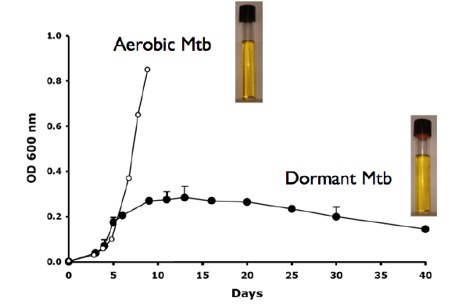

Biography (101/150 words)
Lanfranco Fattorini is responsible of the WHO Supranational Reference Laboratory of Rome for surveillance of drug-resistant TB, and is ECDC contact point for TB in Italy. In 2006 he set up the Wayne model of Mtb dormancy, and participated to the European FP6 project MILD-TB (Immunogenicity of Mtb lipids in the non replicating status of latency) and FP7 project STOPLATENT-TB (Latent tuberculosis: New tools for the detection and clearance of dormant Mtb). Presently, he is focussing the search of low-lipophilic drug containing combinations sterilizing dormant Mtb in hypoxia at pH 7.3, the pH of caseous granulomas, which is the hallmark of TB.

