Establishing a protocol for the handling of Neisseria gonorrhoeae at Nottingham Trent University, and observations of antibiotic susceptibility
Estelle Caine Nottingham Trent University

Abstract (300 word limit)
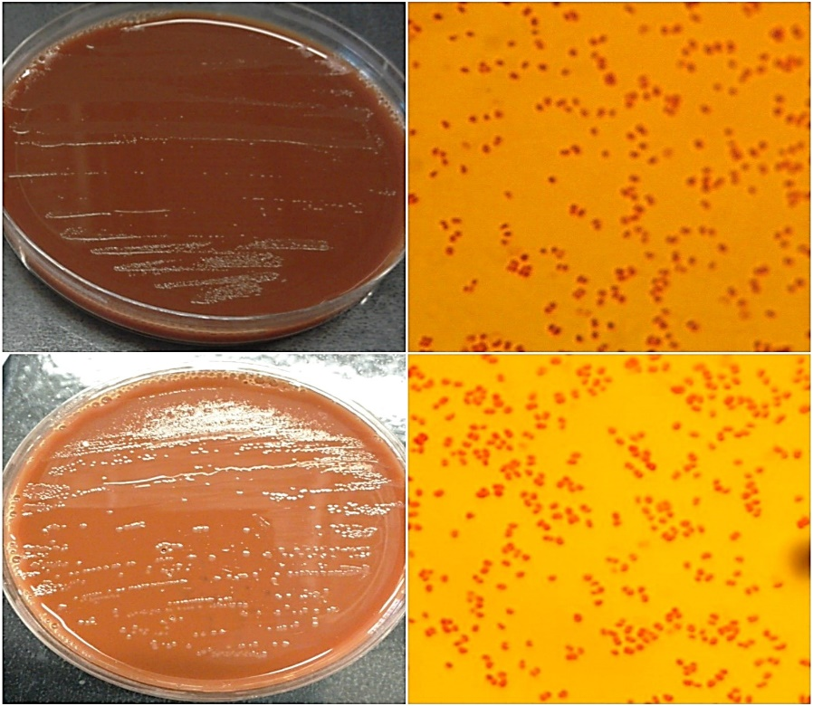
Neisseria gonorrhoeae is the etiological agent of gonorrhoea, a prevalent sexually transmitted disease (STI), which is rapidly becoming untreatable. N. gonorrhoeae is fastidious, and samples become less viable during transport and cultivation, often causing false-negative diagnosis. In this study: growth, identification, viability and antibiotic susceptibility of N. gonorrhoeae were investigated. Various agar and broth media were modified to suit the nutritional requirements of the gonococcal isolate under different environmental conditions. Antibiotic disc diffusion was completed to observe the interaction between N. gonorrhoeae and antibiotics: penicillin, doxycycline and ceftriaxone.
Fig. 1. N. gonorrhoea NCTC 8375 grown on mTM agar incubated at 37°C and 5% C02 with a water tray in the incubator to provide humidity. A) Small sized pinprick, white/ translucent, moist colonies after 24 hours of growth B) Corresponding Gram stain of N. gonorrhoeae after 24 hours of growth magnified under 100x oil immersion. Cells are Gram negative diplococci, measuring 0.5µm width and 0.8µm in length. C) Medium sized, translucent, moist, viscous colonies after 48 hours of growth. D) Corresponding Gram stain of N. gonorrhoeae after 48 hours of growth magnified under 100x oil immersion. Cells are gram negative diplococci, 0.5 µm in depth and 0.8µm in length.
A
C
D
B
Results: N. gonorrhoeae grew successfully on chocolate (CHOC) agar and modified Thayer-Martin agar (mTM). Limited growth occurred on modified Iso-Sensitest agar (mISA), whilst Brain heart infusion (BHI) broth and agar contained no gonococcal growth. N. gonorrhoeae showed susceptibility to penicillin concentrations 0.1unit/disc – 1unit/disc and resistance to 30µ/disc ceftriaxone. However, when used simultaneously, large key-hole shaped zones of inhibition surrounded both doxycycline and ceftriaxone.
Conclusion: Growth of N. gonorrhoeae in vitro is possible on selective (CHOC) and non-selective (mTM) agar containing lysed defibrinated horse blood, under strict growth conditions. The viability of isolates was longer than suggested in literature, however sub-culture of samples is recommended every 48 hours. Isolation of N. gonorrhoeae using traditional culture methods is unpredictable and research into rapid testing is required. N. gonorrhoeae susceptibility varies between strains however the pathogen is rapidly becoming untreatable and novel therapeutics or alternative prevention methods are required.
Image

Biography
A dedicated undergraduate microbiology student at Nottingham Trent University with extensive work experience, good teamwork skills and a special interest in antibiotic resistance, sexually transmitted infections and control of infectious diseases. Currently studying the different growth requirements, antibiotic susceptibility of N. gonorrhoeae as a final year project.
Email: estellecaine@hotmail.co.uk

