Antimicrobial Use in Aquaculture: patterns and current knowledge on its contribution to the emergence and spread of antimicrobial resistance
Lúcia Santos, PharmD, MsD, REQUIMTE/LAQV, Pharmacy Faculty, University of Coimbra
Fernando Ramos, PhD, Associate Professor, REQUIMTE/LAQV, Pharmacy Faculty, University of Coimbra

Abstract
Aquaculture is a fast-growing industry accounting nowadays for almost half of the fish supplies for human consumption, worldwide. The intensive and semi-intensive practices used to produce large stocks of fish, in small spaces, originate frequent disease outbreaks and, to control it, the use of antimicrobials, for prophylactic and therapeutic purposes, is a customary practice. The selective pressure exerted by these drugs – usually present in sub-therapeutic doses for prolonged periods, in water and sediments – represent the ideal framework for the emergence and selection of resistant bacterial strains, promoting and stimulating horizontal gene transfer. Passage of antimicrobial resistant genes and antimicrobial-resistant bacteria from aquatic to terrestrial animal husbandry and to human environments, and vice versa, with detrimental eﬀects on both human and animal health, and also in aquatic ecosystem, is now largely recognised. A global effort must be developed in order to cease antimicrobial overuse in aquaculture, encouraging stakeholders to adopt other disease preventive measures, such as adequate hygiene standards, vaccines or probiotics, among others. Shaping a new path is crucial, in order to contain the increasing threat of antimicrobial resistance.
Being antimicrobial resistance a global ecological event, the One Health strategy is the most appropriate way to address and tackle it. As postulated by One Health principle we must recognize that human, animal and environmental health are interconnected, that diseases are transmitted from humans to animals, and vice versa, and must therefore be tackled in both.

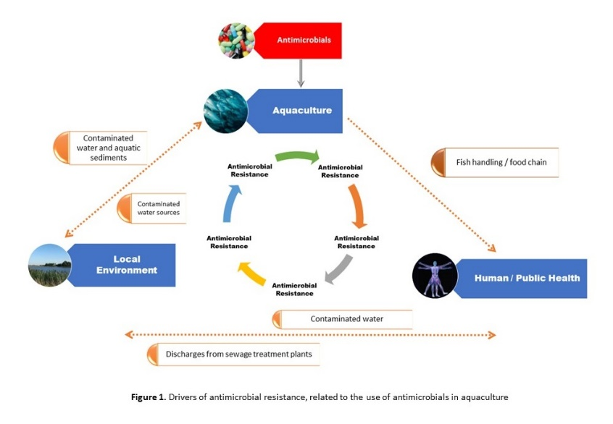

Recent Publications
- Santos L, Barbosa J, Castilho MC, Ramos F, Ribeiro C, Silbeira MI (2005) Determination of chloramphenicol residues in rainbow trouts by gas chromatography–mass spectometry and liquid chromatography–tandem mass spectrometry. Analytica Chimica Acta 529: 249-256
- Santos L and Ramos F (2006) Analytical Methodologies for Chloramphenicol Residues Determination in Food Matrixes: A Brief Review. Current Pharmaceutical Analysis 2: 53-57.
- Santos L, Soares B, Rosa J, Freitas A, Leston S, Barbosa J, Ramos F (2016) Detection and Quantification of 41 Antibiotic Residues in Gilthead Sea Bream (Sparus aurata) From Aquaculture Origin Using a Multiclass and Multi-residue UHPLC-MS/MS Method. Food Anal. Methods 9:2749–2753.
- Santos L, Ramos F (2016) Analytical strategies for the detection and quantification of antibiotic residues in aquaculture fishes: A review. Trends in Food Science & Technology 52: 16-30.
5. Ramos F, Santos L, Barbosa J (2017) Nitrofuran Veterinary Drug Residues in Chicken Eggs. In: Patricia Hester, editors: Egg Innovation and Strategies for Improvement, Oxford: Academic Press; 2017, p. 457464


Biography (150 word limit)
Lúcia Santos, pharmacist, Master in Public Health, presently finishing her PhD degree in Food Security in Coimbra University – Portugal. Her investigation work has been focusing on food security, essentially related to the presence of antimicrobial residues in fish and related consequences on public health. Special focus is being given on the impact of antibiotic use in aquaculture on the global health crisis of antimicrobial resistance.

Deanna
Email: luciamlsantos@gmail.com
Notes/Comments:

