Title: Medical Devices in Support of Infection Control: Surgical Gloves

Catherine Voo WP¹

¹Kossan International Sdn Bhd, PT 7836, Jalan Haji Abdul Manan/ KU8, Kawasan Perindustrian Meru Selatan, 41050 Klang Selangor, Malaysia.

Keywords: Endotoxin, non-pyrogenic, gram-negative bacteria, surgical gloves, infection.

- Abstract Body (up to 250 words)

Medical devices are divided into two categories, which are disposable and non-disposable. These medical devices are usually sterile by the manufacturer and hospital, respectively. However, sterile products do not mean they are safe to use and may cause post-surgery infection due to other contamination that cannot be removed by the sterilization process. For an instant, endotoxin is being released by dead and disintegrated gram-negative bacteria after the sterilization process. Endotoxin is a pyrogen that highly associated with sepsis infection, which has no direct cure and biomarker. According to the European EN 455-3 standard, an upper limit of 20 endotoxin unit (EU) per device has been set for a medical device to be classified as non-pyrogenic where an insufficient toxin is available to induce fever or inflammation. Medical device manufacturers play an important role in supporting infection control by setting up a stringent manufacturing environment to produce non-pyrogenic medical devices or medical devices with low endotoxin content (<20 EU/device).

- Image:

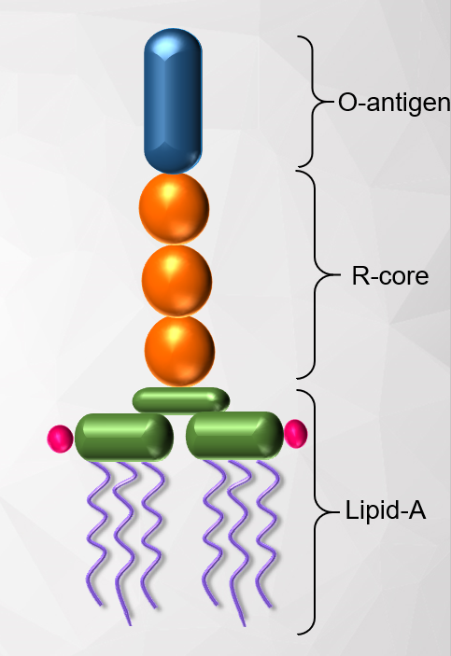

  - Reference:

- Morrison, D. C. & Ryan, J. L., 1987. Ann. Rev. Med., 38, 417 – 432.
- Kulkarni, V. S. & Shaw, C., 2016. Miscellaneous physical, chemical, and microbiological test methods. Pg193 – 221.
- Giacomini, M. G. et al., 2015. Revista Brasileria de Terapia Intensiva, 27, 51 – 56.
- Felts, S. K. et al., 1972. Annals of Internal Medicine, 77, 881 – 890.
- Silverman, M. H., Ostro, M. J., 1998. Bacterial endotoxin in human disease. Princeton, NJ.

IV. Biography:

Dr. Catherine Voo WP holds a Ph.D in Chemical Engineering, graduated from Monash University, specializing in biopolymer delivery devices made of alginate for bioactive compounds delivery (probiotic) and drugs delivery. Currently, she is the Technical Product Specialist at Kossan International Sdn. Bhd. She leads projects on new surgical gloves development and quality improvements; focusing on establishing technical support and solutions to the healthcare markets within Malaysia and all regional countries.

  - Presenting author details


Full Name: Catherine Voo Wan Ping
Contact number: +603-3392 3013 ext.645
Twitter account:
Linked In account:
Session name/ number:
Category: Oral presentation
Passport Number:

