Bile acids and lipase in broiler nutrition for better nutrient utilization and performance
Institute of Animal and Dairy Sciences, Faculty of Animal Husbandry, University of Agriculture, Faisalabad-38040, Pakistan

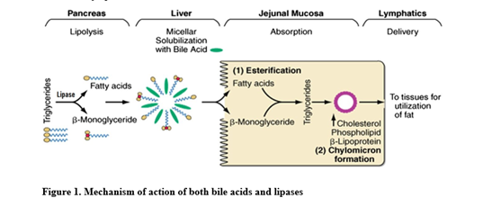
Abstract

Bile acids are used for better emulsification, digestion and absorption of dietary fat in chicken especially in early life. Similarly, exogenous lipases have also been used for improvement of physiological limitation of chicken digestive system. Owing to potential of both bile acids and lipases, their use has been increased in recent years, for better emulsification of dietary fat and enhance growth performance in broilers. In past, pancreatic lipases were used for supplementation, but recently, microbial lipase is getting attention in poultry industry as hydrolysis catalyst. improving effects of dietary supplementation with bile acids and lipase are partially associated with increased fat digestibility probably due to improved pancreatic lipase activity. However, due to the wide variety of available products, the recommended effective dosage varies. Furthermore, some studies revealed that bile acids can enhance digestive enzymatic activity and absorption capacity through improving intestinal morphology. Many studies reported better efficiency of cholic acid than combination of different bile acids. Nevertheless, available data support the idea of supplementing bile acids and lipase enzyme may have potential to promote growth performance and fat utilization in broiler. Although bile acid and their derivatives appear to have positive effects of fat digestion and birds performance it must be noted that the extent of improvement would be different for different bile salts. In past they were expensive, but at the present time, their use in poultry diets is cost effective and practical interest. However, further investigations are required to critically evaluate the potential of bile acids and lipase enzyme in broiler nutrition with specific focus on improving intestinal morphology, gut microbiome and meat quality.

Image

Recent Publications (minimum 5)
- LAI, W., CAO, A., LI, J., ZHANG, W. and ZHANG, L. (2018a) Effect of high dose of bile acids supplementation in broiler feed on growth performance, clinical blood metabolites and organ development. The Journal of Applied Poultry Research 27: 532-539.
- LAI, W., HUANG, W., DONG, B., CAO, A., ZHANG, W., LI, J., WU, H. and ZHANG, L. (2018b) Effects of dietary supplemental bile acids on performance, carcass characteristics, serum lipid metabolites and intestinal enzyme activities of broiler chickens. Poultry Science 97: 196-202.
- LAMMASAK, K., KIJPARKORN, S. and ANGKANAPORN, K. (2018) Porcine bile powder supplementation of a high fat broiler diet in relation to growth performance and nutrient digestion. Animal Production Science https://doi.org/10.1071/AN18190_CO.
- HU, Y., LAN, D., ZHU, Y., PANG, H., MU, X. and HU, X. (2018) Effect of diets with different energy and lipase levels on performance, digestibility and carcass trait in broilers. Asian-Australasian journal of animal sciences 31: 1275-1284.
5. WANG, Y., YAN, J., ZHANG, X. and HAN, B. (2018) Tolerance properties and growth performance assessment of yarrowia lipolytic lipase in broilers. Journal of Applied Animal Research 46: 486-491.

Biography (150 word limit)
Muhammad Adeel Arshad has his expertise in evaluation and passion in improving the feed efficiency and wellbeing of animals. His master research about lipase enzyme and bile acids supplementation in low-energy diets. This is a new approach for all nutritionist and has a different way of focusing.
Email: adeel.2203@gmail.com

Notes/Comments:

