

Abstract Template

Title: Non-Genetic Factors Affecting Reproduction Traits of Indonesian Brahman Cross (BX)

Kurniawan FA1, Jakaria1, Priyanto R1
1Department of Animal Production and Technology, Faculty of Animal Science, Bogor Agricultural University (IPB), Bogor, Indonesia

Keywords: Brahman Cross, Non-Genetic factors, Production traits, Reproduction traits, Cattle breeding

- Abstract Body (up to 250 words)
Cattle breeding in the beef industry in Indonesia generally use imported Australian heifer Brahman Cross (BX) which is still productive (where previously intended as a need for fattening). The performance data of BX cattle with crossbreeding schemes from 2011 to 2016, collected from a private company in Serang, Banten Province of Indonesia and only 71 head used for evaluating non-genetics factors affecting the production and reproduction traits which they have up to second generation (filial 2). A General Linear Model (GLM) was used to analyzed the non-genetic factors (breed, generation, sex, year, parity, and season). The Result showed that type of breed had very significant differences (P<0.01) for final weight (W540) and average daily gain (ADG) while year of birth also presented very significant differences (P<0.01) for almost all production traits such as weaning weight (WW), final weight (W540), and average daily gain (ADG) but except for the birth weight (BW). Differences showed in year of birth interpreted as there are lower performance on ADG recorded for the second generation (filial 2) especially in the year after 2013 . Sex and season only presented significant differences (P<0.05) on average daily gain (ADG). The result also showed no significant differences on the reproduction traits. Results indicated that would be best to use Bos Taurus sire (Simmental and Brahman) to be inseminated (cross) with BX dam since there are very significant diffrences (P<0.01) on the production traits which are final weight (W540) and average daily gain (ADG) with the Bos Indicus (Brahman), and the female can be used until second generation (filial 2), since there are also no significant differences in all of the reproduction traits.

Image:
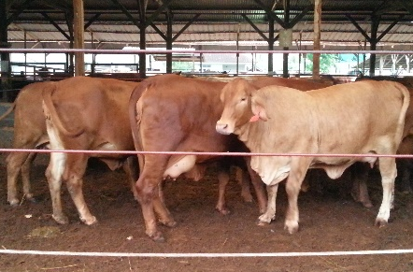
- Reference:

- BIF (Beef Improvement Federation). 2002. Guidelines for Uniform Beef Improvement Programs. 8th ed. Kansas (USA): Kansas State Univ.
- Field TG and Taylor RE. 2012. Scientific Farm Animal Production: an Introduction to Animal Science. 10th ed. Upper Saddle Rive, NJ (USA): Pearson Prentice Hall
- Gunawan A, dan Jakaria. 2011. Genetics and non-genetics effect on birth, weaning, and yearling weight of Bali cattle. Jurnal media peternakan. Hlm: 93-98. DOI: 10.5398/medpet.2011.34.2.93

Biography:
Fariz Am Kurniawan has completed his Master degree at the age of 32 years old from Bogor Agricultural University (IPB) and join Vocational School of Bogor Agricultural University (IPB) as a Vocational Lecturer in 2012. He did colaborated research with Science Lecturer from Bogor Agricultural University (IPB) which has published many papers in reputed journals (Dr Jakaria and Dr Rudy Priyanto). Researcher was attend the 18th Tri-University International Joint Seminar and Symposium in 2011, at Jiangsu University, China with proceeding publication. International experience also in Training of Trainer (TOT) and Pilot Training in Poutry Abattoir Hygiene and Broiler Management 2018, colaboration between Bogor Agricultural University (IPB) and Aeres Training Center Netherland (PTC +) as Participant and also Trainer.

Presenting author details
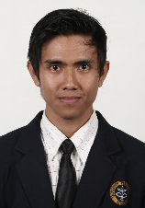

Full Name: Fariz Am Kurniawan
Contact number: +62 856123 5795
Twitter account: fariz_am
Linked In account: Fariz Kurniawan
Session name/ number: Animal Husbandry/ track 25-1
Category: (Oral presentation)
Passport Number: A0728649

Copyright © 2016-2018 Meetings Int PTE Ltd, All Rights Reserved.
Meetings Int.Pte Ltd

Company Registration No: 201524282R,28 MAXWELL ROAD, #03-05 RED DOT TRAFFIC, SINGAPORE (069120)
Tel: +1-302-231-6756 ; +6531080483| Toll Free no. +800-852-6126
Web: https://www.meetingsint.com/conferences/orthopedics | E-mail orthopedics@meetingsintl.net

