Title: The efficacy of passive surveillance for HPAI H5N1 in Nigeria: Practices that affect early detection of disease outbreaks in poultry.

Ojimelukwe, A.E.¹, Prakarnkamanant, A.² Rushton, J.²
¹Department of Animal and Environmental Biology, Faculty of Science, University of Port Harcourt, Rivers State, Nigeria.
²Royal Veterinary College, University of London.

Keywords: Passive surveillance, Highly Pathogenic Avian influenza HPAI, H5N1, Poultry.

- Abstract Body
This study identified characteristics of poultry farming with a focus on practices that affect the detection of HPAI; and estimated the system sensitivity of passive surveillance for HPAI H5N1 in chicken farms of Bayelsa-State, Nigeria. Field studies were carried out in Yenegoa and Ogbia local government areas in Bayelsa state. A total of 26 poultry farmers were surveyed. The sensitivity of passive surveillance for HPAI was assessed using scenario tree modelling. A scenario tree model was developed and applied to estimate the sensitivity, i.e. the probability of detecting one or more infected chicken farms in Bayelsa state at different levels of disease prevalence. Willingness to report HPAI was highest in commercial poultry farms (13/13) than in Backyard farms (8/13). Poor means of dead bird disposal was common to both farm types. Administering some form of treatment to sick birds without prior consultation with a professional was higher in backyard farms (8/13) than in commercial farms (4/13). Consumption of sick birds was reported in 4/13 backyard farms and sale of dead birds was recorded in one commercial farm. The model showed a median sensitivity of 100%, 67% and 23% for detecting HPAI by passive surveillance at a disease prevalence of 0.1%, 10 and 3 infected poultry farms respectively. Passive surveillance system sensitivity at a design prevalence of 10 infected farms is increasable up to 86% when the disease detection in backyard chicken farms is enhanced. The present surveillance system is limited in its ability to detect HPAI at the early stages when one to ten farms are infected.
- Image:
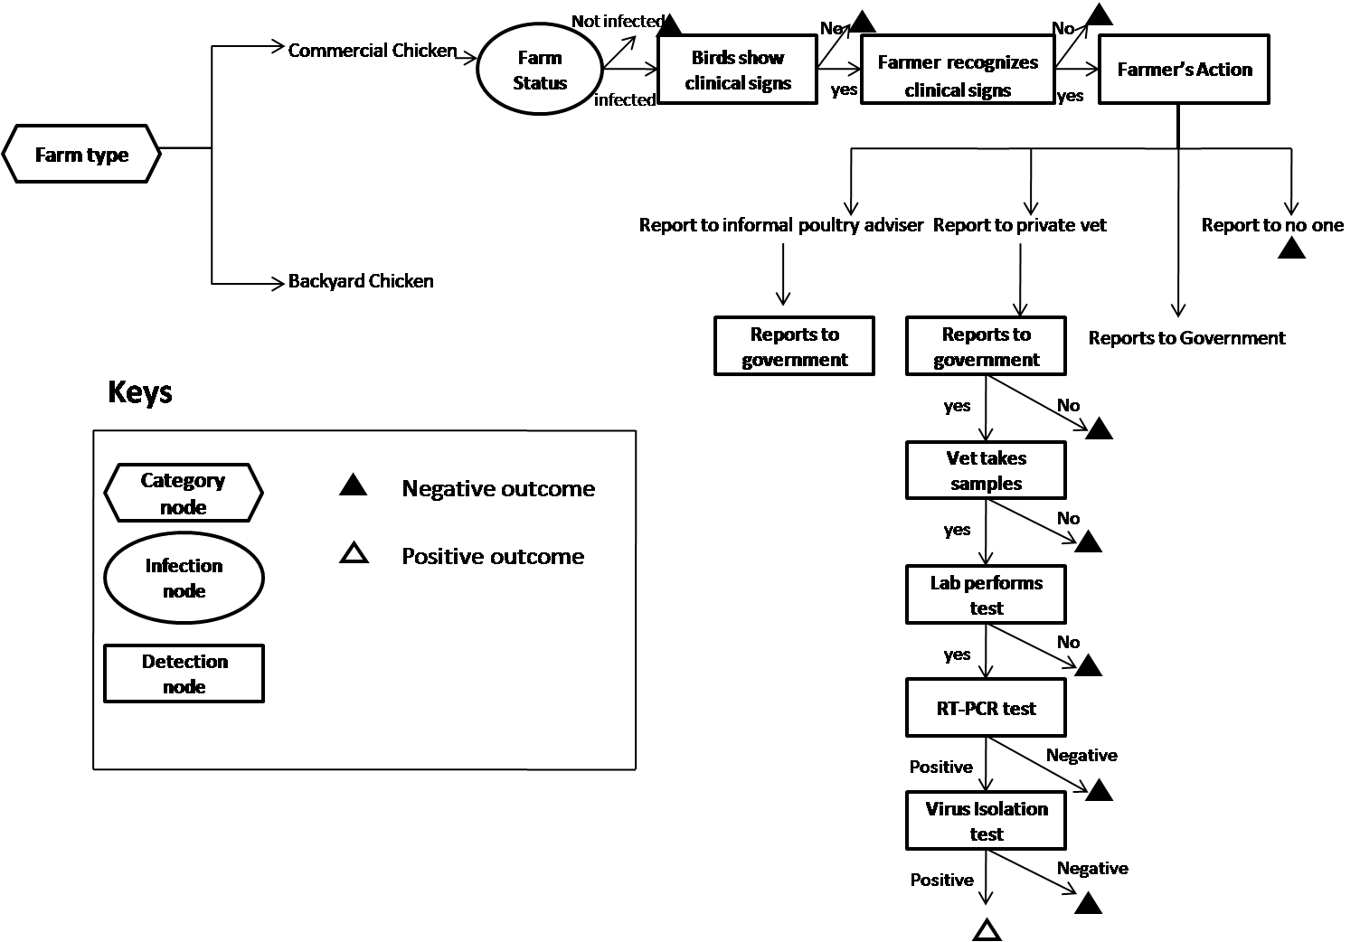

- Reference:
- MARTIN, P. A., CAMERON, A. R. & GREINER, M. 2007. Demonstrating freedom from disease using multiple complex data sources 1: a new methodology based on scenario trees. Preventive Veterinary Medicine, 79, 71-97.
- Biography:
Ojimelukwe, Agatha has completed her M.Sc. in the Control of Infectious Diseases in Animals from the Royal Veterinary College, University of London and is at the final stages of her Ph.D. in Animal Health at the University of Port Harcourt, Nigeria. She is a lecturer at the Department of Animal and Environmental Biology, University of Port Harcourt and has published 3 papers in reputed journals.
- Presenting author details


Full Name: Ojimelukwe, Agatha Ebicaelar
Contact number: +2347061507378
Twitter account: @gatsy_oneal
Linked In account: agatha-ojimelukwe
Session name/ number: Surveillance of Animal Health/Track 24–1
Category: Oral presentation
Passport Number: A06801452

