Title: Molecular characterization of chicken Eimeria species in River State, Nigeria.

Ojimelukwe, A.E.¹, Agu, G.O.¹, & Abah, A.E.¹
¹Department of Animal and Environmental Biology, Faculty of Science, University of Port Harcourt, Rivers State, Nigeria.

Keywords: Eimeria, Chicken, Live bird markets, Molecular characterization, SCAR DNA

- Abstract Body
Coccidiosis is considered as one the most economically important parasitic diseases of poultry and has tremendous socio-economic impact in Nigeria, where family incomes rely heavily on poultry farming. The molecular characterization and preponderance of chicken Eimeria spp. in Rivers State was determined in this study. Live bird markets (LBM) in Port Harcourt city (the state capital) were targeted so as to obtain holistic epidemiological data on Eimeria spp. in the state. Faecal samples were collected from bird cages and pooled per LBM. Eimeria oocysts were isolated and identified using oocysts morphology and species-specific multiplex PCR amplification using SCAR primers. The overall prevalence of chicken Eimeria was 77.8% (7 of 9). Four Eimeria species were confirmed with preponderance of E. tenella: 77.8%, E. necatrix: 55%, E. acervulina: 44% and E. mitis: 11%. Mixed Eimeria infections were common with an overall prevalence of 55%. The findings from this study has emphasized the importance of E. tenella, E. necatrix, and E. acervulina in the epidemiology of poultry coccidiosis in the state. The markedly high preponderance of E. tenella is an indication that this specie remains highly invasive amongst others. The findings from this research should inform coccidiosis monitoring and surveillance programmes.

- Image:

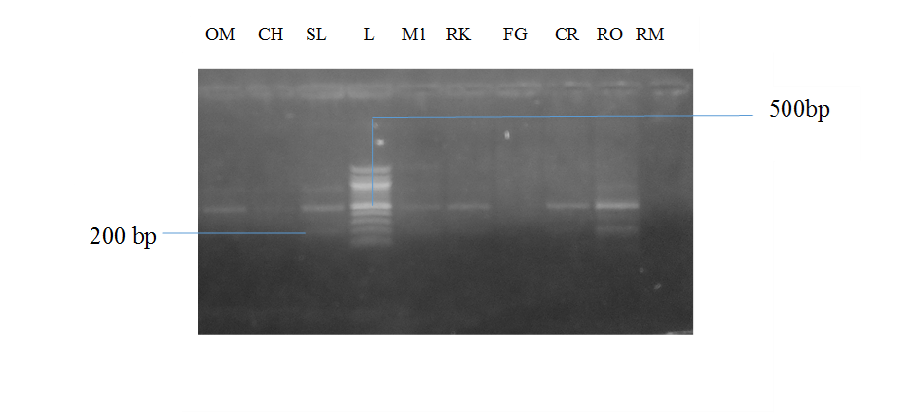

- Reference:
- Fernandez, S., Pagotto, A.H., Furtado, M.M., Katsuyama, A.M., Madeira, A.M., Gruber, A.A. (2003). A multiplex PCR assay for the simultaneous detection and discrimination of the seven Eimeria species that infect domestic fowl. Parasitology Research, 127:317 – 325.
- Jatau, I.D., Lawal, I.A., Kwaga, J.K.P., Tomley, F.M., Blake, D.P. Nok, A.J. (2016) Three operational taxonomic units of Eimeria are common in Nigerian chickens and may undermine effective molecular diagnosis of coccidiosis. BMC Veterinary Research 12:86 DOI 10.1186/s12917-016-0713-9
- Jordan, F.T.W. and Pattison, M. 1998. Poultry diseases, 3rd ed. Cambridge Univ. Press, pp: 260-262.
- Biography:
Ojimelukwe, Agatha has completed her M.Sc. in the Control of Infectious Diseases in Animals from the Royal Veterinary College, University of London and is at the final stages of her Ph.D. in Animal Health at the University of Port Harcourt, Nigeria. She is a lecturer at the Department of Animal and Environmental Biology, University of Port Harcourt and has published 3 papers in reputed journals.
- Presenting author details


Full Name: Ojimelukwe, Agatha Ebicaelar
Contact number: +2347061507378
Twitter account: @gatsy_oneal
Linked In account: agatha-ojimelukwe
Session name/ number: Veterinary Parasitology/Track 7 – 5
Category: Oral presentation
Passport Number: A06801452

