Abstract

Title: Clinical and Radiographic Diagnosis of Developmental Orthopedic Disease and Bone Lesions Determined in Thoroughbred Arabian Foals in Turkey*

Şengöz Şirin Ö¹, Sen Y², Özgermen B³, Bumin A²
¹Department of Surgery, Faculty of Veterinary Medicine, University of Mehmet Akif Ersoy, Burdur, Turkey
² Department of Surgery, Faculty of Veterinary Medicine, University of Ankara, Ankara, Turkey
³ Department of Surgery, Faculty of Veterinary Medicine, University of Aksaray, Niğde, Turkey

Keywords: Bone lesion, developmental orthopedic disease, foal, osteochondrosis, radiography.

- Abstract Body
In this study, Thoroughbred Arabian foals in the Anatolia Tigem Farm Foundation were examined to determine the presence and prevalence of developmental orthopedic diseases and bone lesions which causes huge economical looses in the purchasing of foals was aimed.
The materials for this study are Thoroughbred Arabian foals in Tigem Anatolia Farm foundation that were born on the same season. In total 50 foals were evaluated with clinical, radiographical examination, nutrition, water, soil and blood analysis findings.
In clinical, radiographic examination, nutrition, water, soil and blood analysis results a variety of bone lesions were observed in 25 of 50 foals that are involved in the study. Hindlimb and / or forelimb sesamoiditis, osteochondrosis dissecans, physitis, subchondral cystic lesion was observed alone or together.
As a result of the study, we concluded that clinical examinations are inadequate and radiographic examinations are necessary for definitive diagnosis of developmental orthopedic diseases and bone lesions that are affecting horses’ future race performance. We also concluded that blood parameters change during foal’s physical development, but these changes don’t affect developmental orthopedic diseases. To reduce the economic losses caused by the orthopedic developmental diseases in foals involved in this study that are raised in Tigem Anatolia Farm Foundation; the composition of pasture must be regulated, animal nutrition must be analysed carefully and exercise programes must be under control.
- Images
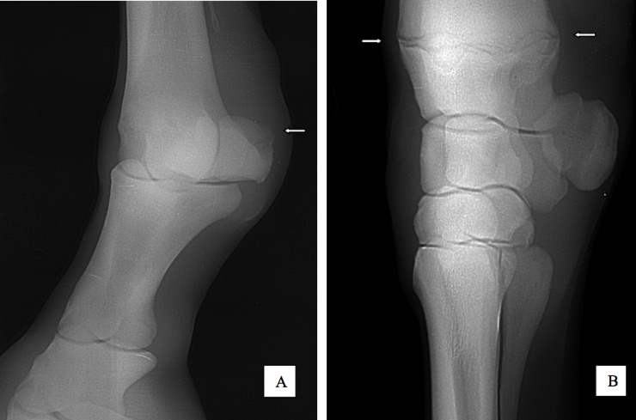

Case 32: A, Sesamoiditis in the right frontal heel (white arrow)
B, Phisytis in the right anterior radial distal growth plate (white arrows)

- Reference:
- Mitten, L.A., Bertone, A.L. Angular limb deformities in foals. Journal of the American Veterinary Medicine Association 204, 717-720, 1994.
- LEWIS, L.D. Developmental orthopedic diseases in horses. In: Equine Clinical Nutrition: Feding and Care;Chapter 18, 1995.
- Vasey, J.R., Hazard, G.H., McKinnon, A.O. Orthopaedic disorders of foals–conservative vs surgical management. Equine Stud Management. 283-288, 1996.

- Biography:
Özlem Şengöz Şirin has completed his PhD in 2008 from Ankara University and postdoctoral studies from Mehmet Akif Ersoy University School of Veterinary Medicine. She was the coordinator and instructor of the first AOVET course in Turkey. Additionaly, she is working in group of TINNET as a delegate of Turkey (TINNET is a European research network funded by the COST program under the Action number BM1306). She finished six important projects in her country and still she is dealing with two projects. She gives orthopedic trainings in her country. She is married and she has two children.

- Presenting author details
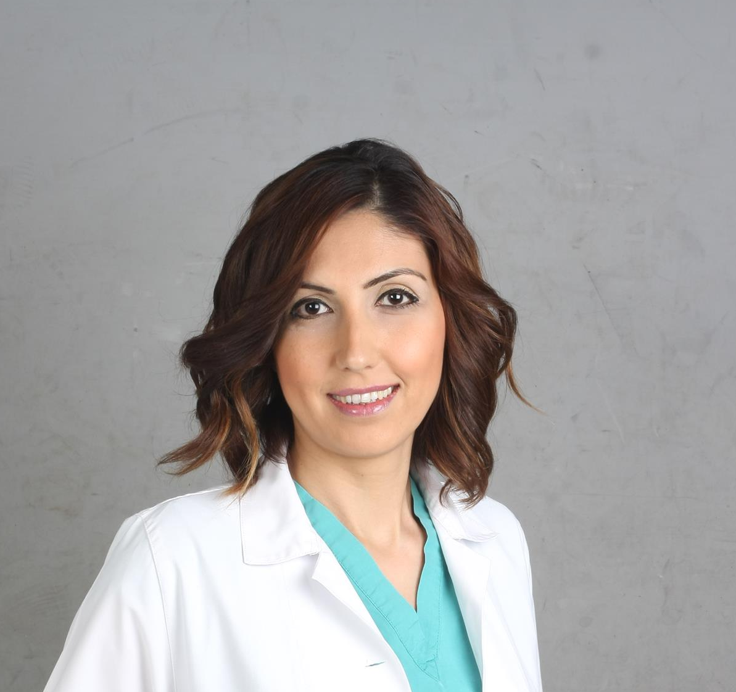
Full Name: Assist.Prof.Dr.Özlem ŞENGÖZ ŞİRİN
Contact number:+90 5306121621
Twitter account: https://twitter.com/ozlem_sengoz
Linked In account: https://www.linkedin.com/in/ozlem-sengoz-7180b310/
Session name/ number: Veterinary Surgery
Category: Oral presentation
* This study was supported by Ankara University Scientific Research Projects Commission (Project number: 10 B 33 38 001).

